3D Printed Spectroelectrochemical Cell for in situ and in operando Measurements

Maria E. B. Cardoso, Mariana B. Silva, Juliano A. Bonacin
Institute of Chemistry, University of Campinas - UNICAMP
270 Monteiro Lobato Street, Campinas – São Paulo, Brazil
jbonacin@unicamp.br

Spectroelectrochemistry is a powerful tool that allows scientists to observe the details and changes in electrogenerated species on the electrode surface, contributing to a deeper understanding of electrochemical processes^{1,2}. The combination of electrochemical techniques and Raman spectroscopy provides important information about formation of films on an electrode, changes of oxidation states, the formation or breaking of a bond, and even help unravel a reaction mechanism². However, commercially available spectroelectrochemical cells (SEC) have some limitations, such as high cost and limited working electrodes options. Commercial cells strongly rely on circular flat electrodes, which are usually platinum, gold or glassy carbon electrodes. Electrochemical studies, however, use a variety of electrodes, both in size and material, where these characteristics may play important roles in the reaction studied. Therefore, the ability to perform spectroelectrochemical measurements in a cell where the working electrode can be adapted for the experiment is an essential feature. Additive manufacturing, also known as 3D printing, is a versatile and low-cost method for producing tailored objects designed according to application and user needs². In this sense, we propose the design of a 3D printed SEC for confocal Raman spectroscopy, where parameters such as the printing material and working electrode (WE) type and size can be easily adjusted. The cell uses a modular design with four main parts (Figure 1), where the WE platform can be easily adapted to meet the user’s needs. The designed cell was printed using both fused deposition modelling (FDM) and digital light processing (DLP), demonstrating the versatility of the printing technique and material. Its application was successfully evaluated for well-known electrochemical systems, such as Prussian blue electrodeposition via chronoamperometry (Figure 2(a)) and probing of Prussian blue changes (Figure 2(b)).

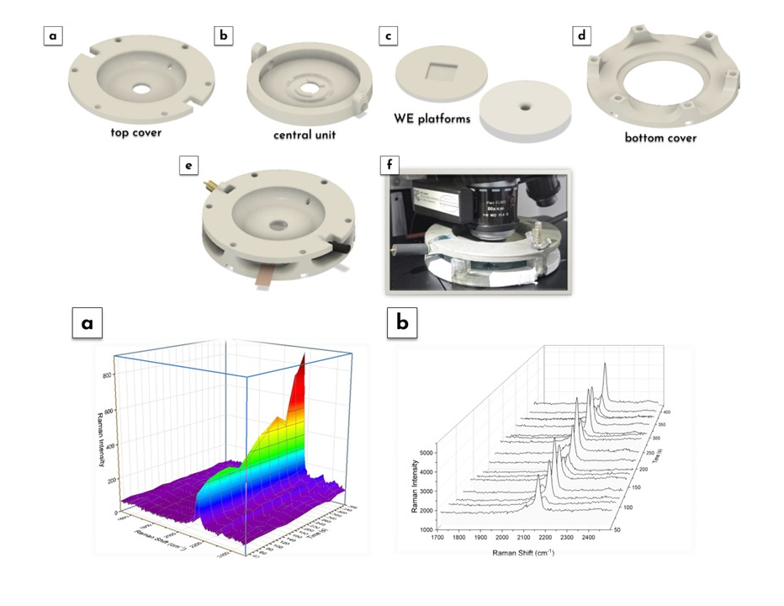

Figure 1: (a-e) SEC design and (f) SEC in use.

Figure 2: Time-resolved Raman spectra for (a) electrodeposition and (b) CV of the Prussian blue.

References
1. Zhai, Y., Zhu, Z., Zhou, S., Zhu, C. & Dong, S. Nanoscale 10, 3089–3111 (2018).
2. Pereira, M. V., Datti, E., Alvarenga, G. R., Janegitz, B. C. & Bonacin, J. A. Microchemical Journal 183, 108083 (2022).

Acknowledgements
This study was financed in part by the Coordenação de Aperfeiçoamento de Pessoal de Nível Superior, Brasil (CAPES) - Finance Code 001. CNPq: 303605/2024-3, FAPESP: 2025/03058-7 and 2024/09666-6,

