Interlayer Engineering for Controlled Ion Storage in Hydrated Vanadium Bronzes

Marta Kamińskaª, Andrzej Paweł Nowak^{b}, Marta Prześniak-Welencª
ª Institute of Nanotechnology and Materials Engineering, Gdansk University of Technology, Poland
^{b} Faculty of Chemistry, Gdansk University of Technology, Poland
s189549@student.pg.edu.pl

Hydrated sodium–potassium vanadium bronzes, Na_{x}K_{2-x}V₆O₁₆·nH₂O, represent an attractive class of layered electrode materials owing to their open framework and tunable interlayer region, which can accommodate different charge carriers during electrochemical cycling. The presence of both Na⁺ and K⁺ ions within the structure is particularly important, as it enables regulation of the interlayer spacing and creates diffusion pathways suitable not only for small Li⁺ ions, but also for larger alkali ions such as Na⁺ and K⁺. During cycling, the pre-intercalated Na⁺ and K⁺ ions can be partially released from the structure and exchanged with incoming charge carriers, making these materials especially interesting for comparative studies in Li-, Na- and K-ion systems. At the same time, their hydrated layered framework further extends their potential application to aqueous Zn-ion batteries, which are particularly attractive due to the use of low-cost zinc metal, high theoretical capacity, improved safety and environmentally friendly aqueous electrolytes. In Zn-ion systems, structural water and pre-intercalated alkali ions may facilitate Zn²⁺ transport and help stabilize the host framework, while ion exchange with Zn²⁺ may additionally influence Zn deposition behavior and contribute to reducing dendrite growth and interfacial instability at the zinc electrode. Here, we investigate interlayer engineering in hydrated sodium–potassium vanadium bronzes, Na_{x}K_{2-x}V₆O₁₆·nH₂O, where the Na⁺/K⁺ ratio and structural water content enable controlled tuning of the interlayer distance, phase characteristics and ion-storage behavior. The materials were synthesized using the LPE-IonEx approach and characterized to confirm their composition, hydration state, morphology and crystal structure. Structural analysis confirms the formation of layered Na_{x}K_{2-x}V₆O₁₆·nH₂O nanobelts. As illustrated in Figure 1, potassium substitution modifies the crystal structure by driving a transition from a berensite-type to a hewettite-type arrangement and increasing the interlayer distance. Electrochemical performance was evaluated in half-cells using cyclic voltammetry and galvanostatic charge–discharge measurements for monovalent Li⁺, Na⁺ and K⁺ systems, as well as for divalent Zn²⁺ aqueous batteries. The results show that the Na⁺/K⁺ ratio strongly affects charge–discharge behavior, capacity retention and cycling stability. K-rich compositions exhibit the most favorable response in K-ion systems, whereas Na-rich and mixed Na/K materials perform more effectively in Li- and Na-ion cells. The same materials were further tested as cathodes for aqueous Zn-ion batteries, enabling comparison of composition-dependent electrochemical response across mono- and divalent-ion storage systems. Ex situ post-cycling studies were used to correlate electrochemical behavior with structural evolution, including possible ion-exchange and alkali-ion release processes. Overall, this study highlights interlayer engineering as an effective strategy for tailoring layered vanadium bronzes and understanding their charge-storage behavior across different battery chemistries.
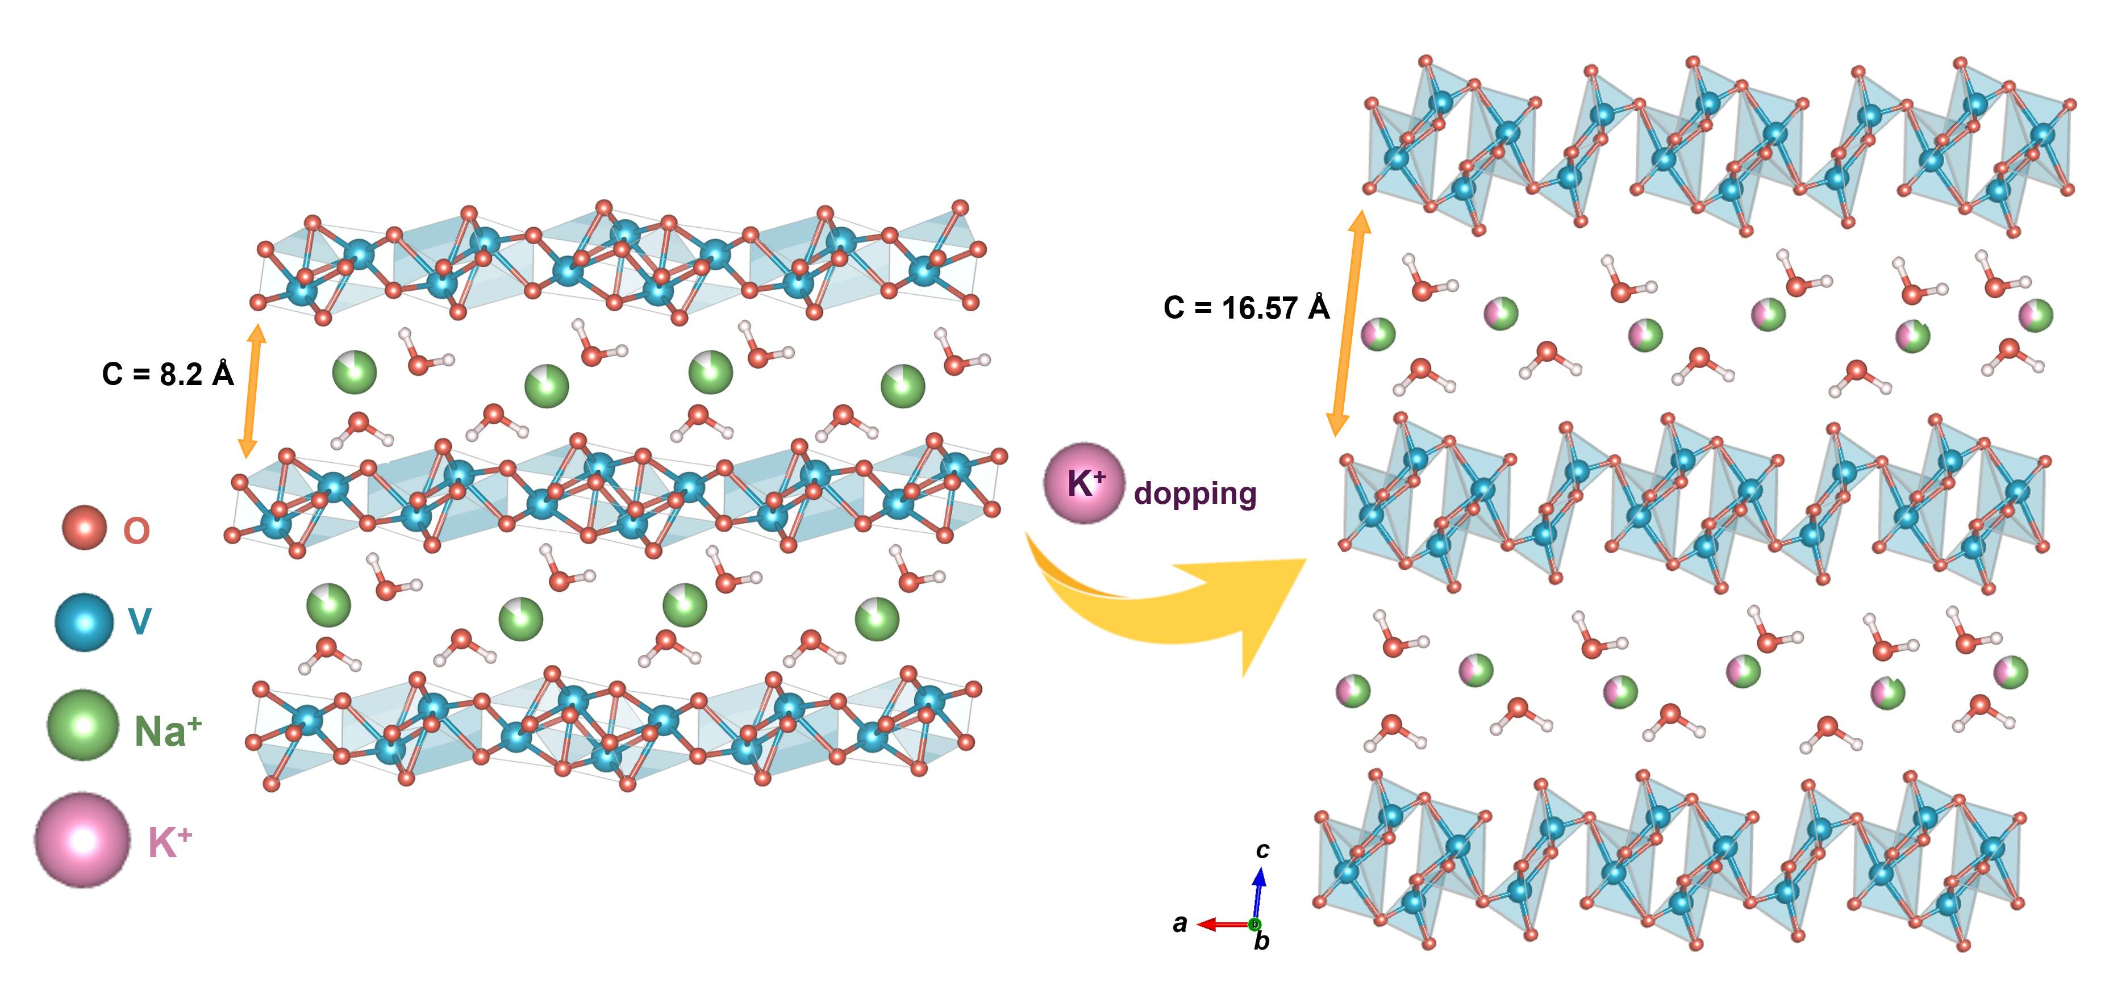

Fig. 1. Influence of potassium substitution on the crystal structure of hydrated sodium vanadium bronze,
Na_{x}K_{2-x}V₆O₁₆·nH₂O. Structural models simulated using VESTA illustrate the transition from the berensite-type structure to the hewettite-type structure.

