Real-world analytical challenges as a basis for sensor development

Emilia Witkowska Nery, , Steven Linfield, Joanna Koprowska, Morel Brinda Ntanhaning Medonjeu, Damian Gierek, Weronika Góral, Wojciech Mazurkiewicz, Martyna Durka
Institute of Physical Chemistry
Polish Academy of Science, Warsaw, Poland
ewitkowskanery@ichf.edu.pl

Efforts to adapt laboratory technologies for real-world use—particularly through simplifying designs and lowering costs—can deliver benefits that go beyond improved accessibility and affordability. Such strategies often uncover novel and unexpected capabilities, as the pursuit of low-cost sensing solutions can enable functionalities not achievable with more complex systems. This work focuses on three key aspects: (1) the advantages of voltammetric ion sensing, (2) the development of portable and cost-effective sensor alternatives, and (3) the application of sensor arrays combined with multivariate data analysis.

This approach supports a wide range of practical applications, including the detection of date rape drugs in real samples, real-time monitoring of bioreactors, quantification of structurally similar compounds such as neurotransmitters, and evaluation of taste masking in pharmaceutical formulations. Beyond their immediate societal and industrial importance, these case studies enhance our understanding of the fundamental factors that enable sensors to become more sensitive, compact, rapid, affordable, and versatile.
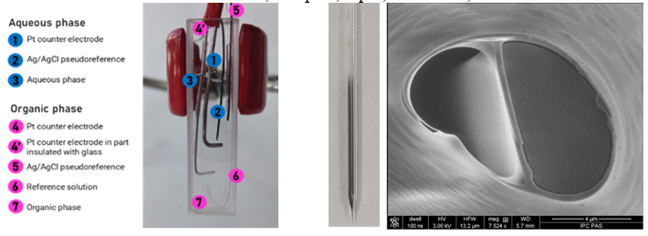
Fig.1 Miniaturized cell for spectroelectrochemical studies of ion-transfer at the liquid-liquid interface | Fig. 2 Double barrel probe for voltammetric sensing of both ionic and electroactive species.

Projects funded by National Science Centre Poland: NCN SONATA SONATA 2020/39/D/ST4/02256, SONATA BIS 2023/50/E/ST4/00639

