Solvation-controlled cation selectivity in hybrid aqueous zinc-sodium batteries
Eric Tröster ^{1,2}, Angelina Sarapulova ^{1,2}, Sonia Dsoke ^{1,2}
¹ Fraunhofer ISE, Heidenhofstraße 2, 79110 Freiburg
² University of Freiburg, Freiburger Materialforschungszentrum, Stefan-Meier-Straße 21, 79104 Freiburg

Aqueous zinc-ion batteries are promising candidates for grid-scale energy storage due to their intrinsic safety, low cost, and environmental compatibility. Prussian Blue Analogues (PBAs) are an attractive class of cathode materials for metal-ion batteries because of their open framework structure, which facilitates transport pathways for various ions. However, when PBAs are applied in aqueous zinc-ion batteries, their long-term stability is often hindered by structural changes and the transition to Zn-based PBA phases during Zn²⁺ insertion, leading to partial electrochemical inactivity and capacity fading [1].
To address these challenges, we introduce a hybrid Na⁺/Zn²⁺ electrolyte system to decouple the redox reactions at the two electrodes. In this configuration, Zn undergoes reversible plating and stripping at the anode, while Na⁺ ions preferentially intercalate into the PBA cathode. As cathode material, sodium–manganese hexacyanoferrate, Na₂MnFe(CN)₆, was synthesized due to its structural robustness, high redox potential, and the abundance of inexpensive precursor materials. The electrolyte was optimized using a water-in-salt approach, in which a high salt concentration reduces the activity of free water molecules and thereby broadens the electrochemical stability window of the aqueous system. The water-in-salt electrolyte was subsequently modified by adding varying amounts of dimethyl sulfoxide (DMSO) as a co-solvent. The highly polar DMSO molecules partially replace H₂O in the primary solvation shells of Zn²⁺ and Na⁺ ions, thereby altering their solvation structures [2]. This modification promotes Na⁺-dominated intercalation in the cathode and enhances the structural stability of the hybrid system. Cycling data confirm that DMSO-containing water-in-salt electrolytes preserve the characteristic two-step Na⁺ intercalation behavior of MnHCF (Fig.1b). Notably, the average charge–discharge potential increases significantly with the addition of DMSO. Operando X-ray diffraction measurements are used to gain further insight into the influence of the co-solvent on the charge-storage mechanism of MnHCF during cycling. Together, these findings indicate that the modified solvation environment affects not only the electrochemical response, but also the cation-selective intercalation processes at the cathode/electrolyte interface.
Overall, the results highlight the crucial interplay between solvation chemistry, interfacial ion selectivity, and charge-storage mechanism in hybrid aqueous systems, providing mechanistic insight for the rational design of stable Zn/Na hybrid-ion batteries.
a) 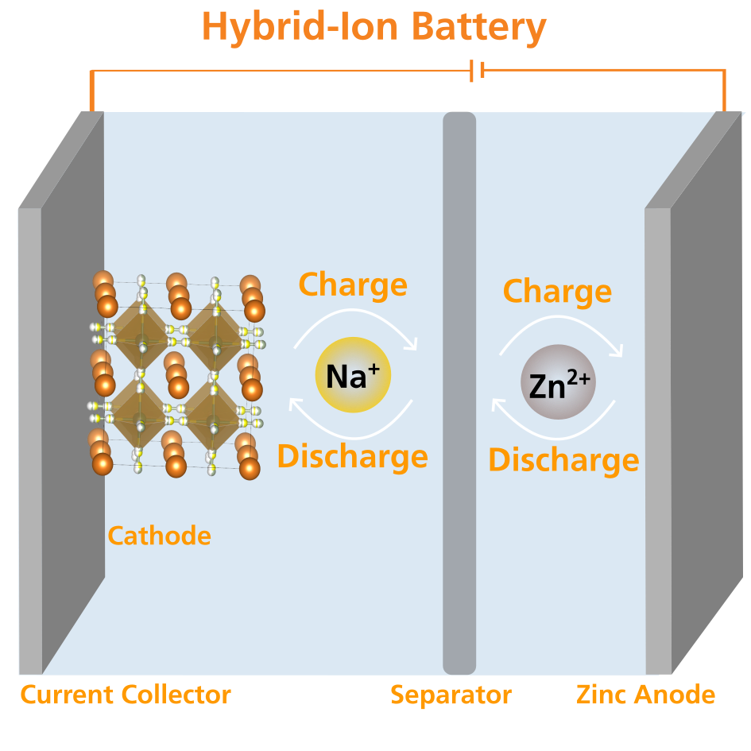 | b)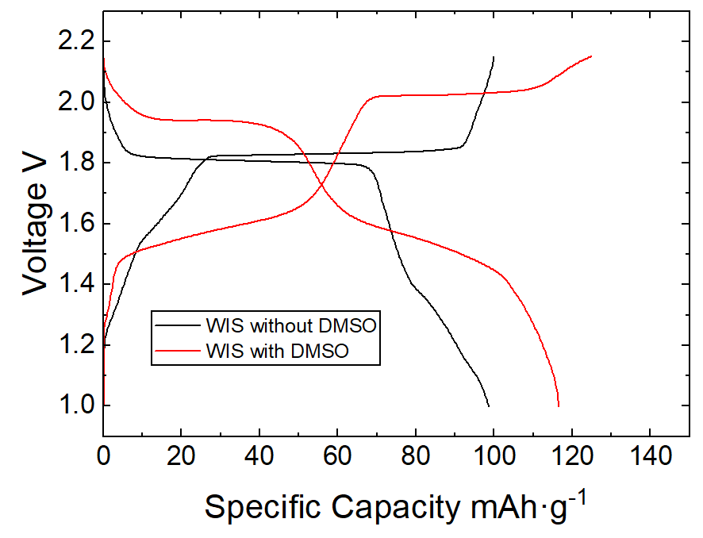
Figure 1a: Schematic of the Zinc Hybrid Ion Battery. 1b: 50th cyle of MnHCF||Zn cells with and without the addition of DMSO in the WIS electrolyte.

Acknowledgements
Financial support from the German Research Foundation (DFG) under the Grant 531067835 (project SENERGY) is gratefully acknowledged.

References
1. W. Deng, Z. Li, Y. Ye, Z. Zhou, Y. Li, M. Zhang, X. Yuan, J. Hu, W. Zhao, Z. Huang, C. Li, H. Chen, J. Zheng and R. Li, Advanced Energy Materials, 11 (2021) 2003639.
2. W. Chen, J. Wu, K. Fu, Z. Deng, X. Chen, H. Cai, X. Wu, B. Xing, W. Luo and L. Mai, Small Methods, 8 (2024) 2300617.

