Operando X-ray Absorption Spectroscopy Reveals V–O–Fe Interfacial Coupling as the Origin of Enhanced Oxygen Evolution in CoFe@V₂CT_{x} MXene Composites
Can Kaplan¹, Bastian Schmiedecke¹, Thorsten Schutz^{1, 2}, Xuyun Guo³, Aline Emerenciano¹, Valeria Nicolosi³, Norbert Koch^{1, 2}, and Michelle P. Browne¹

¹Helmholtz Young Investigator Group Electrocatalysis: Synthesis to Devices, Helmholtz-Zentrum Berlin für Materialien und Energie GmbH, Hahn-Meitner-Platz 1, 14109 Berlin, Germany
²Institut für Physik & CSMB, Humboldt-Universität zu Berlin, 12489 Berlin, Germany
³School of Chemistry, CRANN and AMBER Research Centers, Trinity College Dublin, Dublin 2, Ireland

Can.Kaplan@helmholtz-berlin.de

Developing active and durable non-precious metal catalysts for the oxygen evolution reaction (OER) is central to the viability of anion exchange membrane water electrolysers. MXenes - two-dimensional transition metal carbides - have attracted considerable interest as catalyst supports due to their metallic conductivity and tunable surface chemistry, but the mechanistic role of metal-support interactions in governing catalytic activity has remained poorly understood. Here we report operando X-ray absorption spectroscopy (XAS) at the Co and Fe K-edges, as the primary tool to elucidate the origin of enhanced OER activity in CoFe@V₂CT_{x} MXene composite catalysts with systematically varied vanadium content.
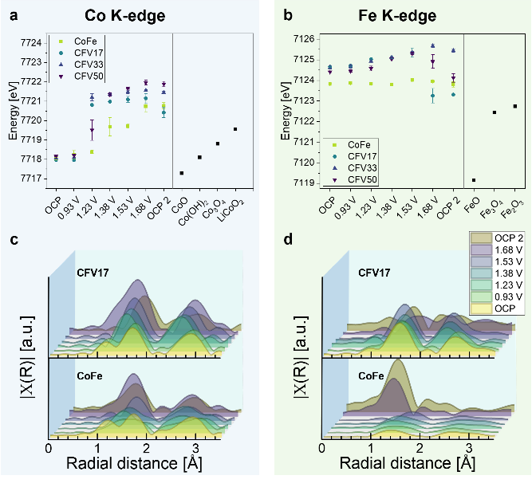
Through combined structural characterisation by XRD, TEM, and STXM, we identify that the optimal composition CFV17 (17 mol% V) promotes the interfacial nucleation of a CoFOH and FeOOH phases at the V₂CT_{x} surface which are absent in pure CoFe and most abundant at CFV17. STXM at the V and Fe L-edges reveals simultaneous oxidation of both V and Fe in the composites relative to their isolated counterparts, with Co remaining invariant, consistent with V–O–Fe bridging coordination at the FeOOH/V₂CT_{x} heterointerface withdrawing electron density from both metal centres through shared interfacial oxygen.

Operando XANES at the Co K-edge demonstrates that CFV17 drives cobalt into oxidation states exceeding the Co³⁺ LiCoO₂ reference at potentials approximately 150 mV lower than pure CoFe (Figure 1). Simultaneously, the Fe K-edge in CFV17 advances to energies 2.7–3.0 eV above the Fe₂O₃ reference under operating conditions - energies inaccessible in pure CoFe - indicating further oxidation of already highly oxidised Fe centres enabled by the V₂CT_{x} support. Operando EXAFS analysis reveals that V₂CT_{x} stabilises the Co–O bond distance and prevents the Fe second coordination shell collapse observed in pure CoFe under prolonged polarisation, providing direct structural evidence that the MXene support protects active site integrity during OER. These findings establish V–O–Fe interfacial coordination as the central mechanistic principle governing OER enhancement in MXene-supported CoFe catalysts and provide operando evidence linking ground-state interfacial electronic structure to active site generation under applied potential.
Figure 1. Operando XAS analysis of CoFe and CFV17-50. a) Co K-edge positions vs. applied potentials and exsitu Co-references. b) Fe K-edge positions vs. applied potentials and exsitu Fe-references. c-d) EXAFS analysis of CoFe and CFV17-50. c) Co fine structure and d) Fe fine structure at different applied potentials vs. RHE.

