Development of sensors for a tongue-inspired, electrochemical array for the real, forensic samples of date-rape drugs

Joanna Koprowska, Emilia Witkowska Nery
Institute of Physical Chemistry, Polish Academy of Science
ul. Kasprzaka 44/52, 01-224 Warszawa
jkoprowska@ichf.edu.pl

The issue of drug-facilitated crimes is underestimated due to the complex intertwining of social taboos, shame, police mistrust, etc. Most commonly, the category is associated with sexual abuse, which resulted in the term date-rape drugs. DRDs are central nervous system depressants used to subdue victims, these might be benzodiazepines, opioids and many other substances. Such psychoactive substances can be, and are used to facilitate a variety of crimes from sexual assaults, through robberies/theft to homicides. The question is, how as scientists can we help it? The project answers two of them — victims seek prevention methods, while the police race to gather and prioritize evidence on a crime scene, both need a sensing, Y/N device, portable, easy-to-use and applicable to unknown, complex samples.
The development is inspired by the tongue, a sensor array built from taste buds, and is imitated using electrochemical sensors. Electrochemistry brings together low-cost materials, applying carbon and paper-based systems to cyclic and analytical methods insensitive to lighting conditions and user skills. Carbon-based working electrodes were manufactured with conductive PLA filaments by 3d printing and melting into silicon molds. Composites were made by blending together PLA filament and carbon black (CB), graphene oxide (G), detonation nano-diamonds (DND) and carbon nanotubes (CNTs). Paper-based graphite working electrodes were hand-drawn with pencils on chromatography paper. Working electrodes were used in two setups — (1) droplet on a working electrode, standard Ag/AgCl reference and Pt wire counter electrode; (2) paper interface wetted with sample solution, screen-printed reference and counter electrodes, using carbon and Ag/AgCl inks.
Promising preliminary results were obtained for benzodiazepines and opioids, alprazolam (Xanax), flunitrazepam (Rohypnol) and codeine phosphate (Antidol15) in electrolyte and vodka solutions(Fig.1). Subsequent experiments were intended to improve the distinction from the background and testing of other interferents (food/drinks). The aim of the study is not to develop a sensor that can distinguish a particular drug, but to find a set of sensors that can provide sufficient information about the sample to detect the drug across different real matrices, such as vodka, juices, beer, and cocktail drinks. For this reason, we are interested in sensors that provide different signatures for different samples, exploring both redox and ionic interactions of the sensor and the sample.
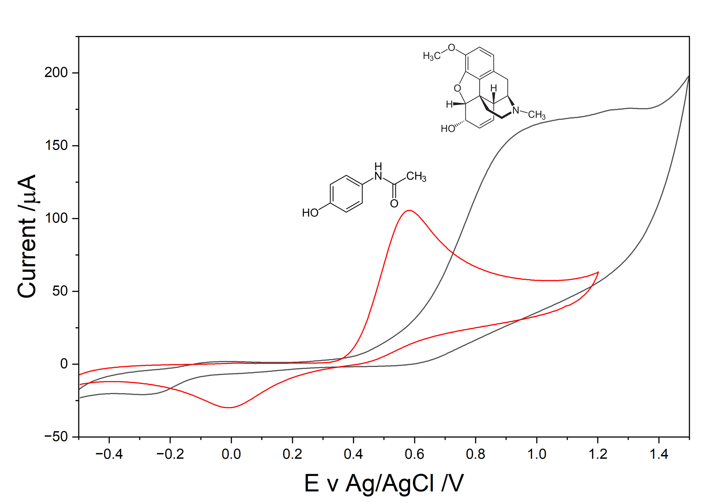
Figure 1 CV (scan 100 mV/s, step 10 mV) comparison of 10 mM paracetamol and codeine phosphate from Antidol15 in 1 mM PBS.
The research was funded by the National Science Centre, NCN, Poland: project Sonata BIS 13: “Unlocking the potential of ion-transfer voltammetry based electronic tongues for date-rape drug detection in real samples” 2023/50/E/ST4/00639 project.

