Visualization of Water Management in a Zero-gap CO₂ Electrolyzer using Neutron Imaging

Järi Van den Hoek, Lieven Hintjens, Sam Van Daele, Clem De Preter, Eric Ricardo Carreón Ruiz,
Pavel Trtik, Daniel Choukroun, and Prof. Tom Breugelmans
Applied Electrochemistry and Catalysis
Universiteitsplein 1 Building B, 2610 Wilrijk, Belgium
Jaeri.VandenHoek@uantwerpen.be
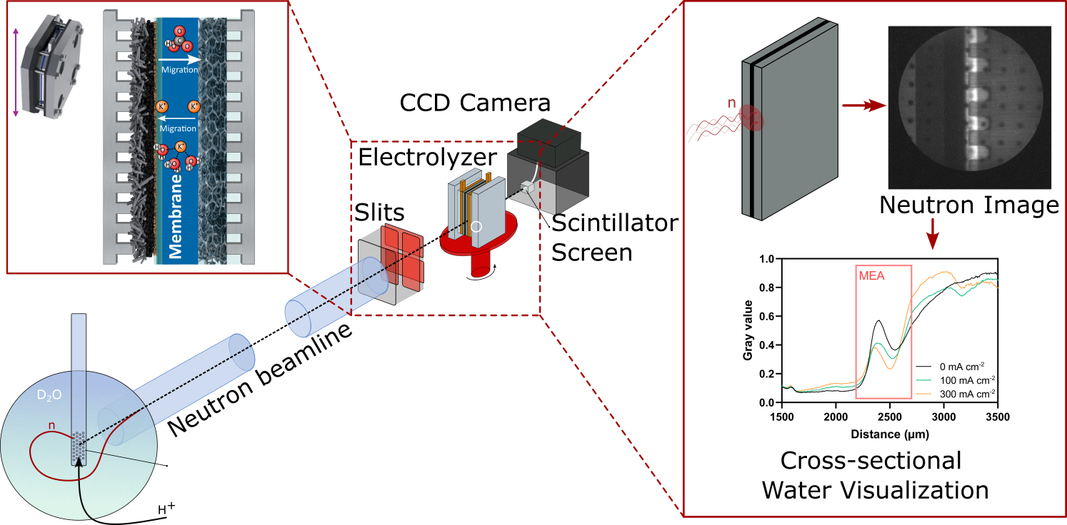
Research on the electrochemical conversion of CO₂ (eCO₂R) to sustainable chemicals and fuels has advanced in both electrocatalyst and reactor engineering, enabling electrolyzers to achieve selectivities exceeding 80% at industrially relevant current densities. Currently, two electrolyzer configurations have demonstrated industrial viability: (i) a three-compartment flow-by electrolyzer and (ii) a two-compartment zero-gap electrolyzer. While the former exhibits greater operational stability, its energy efficiency is limited by the increased cell voltage due to ionic resistance across the three compartments.^{[1]} Consequently, reducing the configuration to a two-compartment zero-gap configuration is a more energy-efficient alternative. However, the long-term stability of zero-gap electrolyzers remains hindered by two major challenges: salt precipitation and insufficient water management at the cathode interface.^{[2]} Water plays a central role in the eCO₂R to formate: (i) it is used as a reactant and (ii) it ensures operational stability by facilitating the dissolution and removal of locally formed (bi)carbonate salts (reaction between formed OH⁻ and CO₂) from the catalyst layer and flow fields. Water is introduced through direct water injection (DWI) into the CO₂ feed stream and, via electro-osmotic drag associated with migrating cations across the Nafion cation exchange membrane (CEM). Understanding these coupled water transport processes is critical for controlling formate production, mitigating salt accumulation, and preventing electrode flooding or dehydration.
To achieve a deeper understanding of these phenomena, cross-sectional neutron imaging was employed as an operando technique to visualize and quantify water transport within the membrane electrode assembly (MEA) of a zero-gap CO₂ electrolyzer under industrially relevant operating conditions. Experiments were conducted at the ICON beamline (PSI) using a custom-designed electrolyzer optimized for neutron transparency. The electrolyzer was systematically investigated under steady-state conditions at current densities from 0 to 300 mA.cm⁻². The neutron imaging results revealed an increase in water crossover with increasing current density, confirming the role of electro-osmotic drag in transporting water across the CEM toward the cathode. Additional investigations examined the influence of membrane thickness using various Nafion membranes (thickness: 25, 50, and 183 μm). Thinner membranes exhibited higher water transport rates and improved resistance against dehydration during extended operation, highlighting the critical interplay between membrane properties and electrolyzer stability. The influence of flow field design (serpentine, interdigitated, and parallel) on water management was further evaluated. While the overall water transport across the membrane remained comparable, the flow field design strongly affected the spatial distribution of injected water within the cathode compartment. The serpentine design promoted enhanced hydration in the upper regions of the electrode, whereas interdigitated and parallel configurations resulted in increased water accumulation near the bottom sections, illustrating the importance of flow distribution in mitigating local dry-out and salt deposition. Overall, this work provides new operando insights into the water management governing the performance, thereby advancing the rational design of stable zero-gap CO₂ electrolyzers.

[1] Duarte M, et al. ‘The importance of target product engineering for long-term operation of CO₂ zero-gap electrolysers.’ Journal of Environmental Chemical Engineering. 2022 Jun;10(3):107836.
[2] Zhang Z, et al. ‘Salt Precipitation in Zero‐Gap CO₂ Membrane Electrode Assemblies: Strategies for Long‐Term Operation.’ ChemElectroChem. 2026 Jan;13(2).

