Operando Raman Spectroelectrochemical Investigation of Permanently Cationic Molecules at Cu-Based Substrate in Alkaline Medium

Katarzyna Szwabińska¹, Martin Perez-Estebanez², Aranzazu Heras², Alvaro Colina², Lukasz Poltorak¹
¹University of Lodz, Electrochemistry@Soft Interfaces Team, Faculty of Chemistry, Department of Inorganic and Analytical Chemistry, Tamka 12, 91-403 Lodz, Poland
²Universidad de Burgos, Department of Chemistry, Pza. Misael Bañuelos s/n, E-09001 Burgos, Spain
katarzyna.szwabinska@chemia.uni.lodz.pl

The combination of cyclic voltammetry and operando Raman spectroscopy (λ_{exc} = 785 nm) was employed to investigate the Cu-based substrate in an alkaline medium (1 M NaOH). The oxidation-reduction cycles of the electrode were performed in the presence of several organic molecules. Interesting results have been recorded for methylene blue and thionine acetate. These molecules remain cationic even at pH 14 because their charge is structural, not protonation-dependent, as shown in Figure 1.

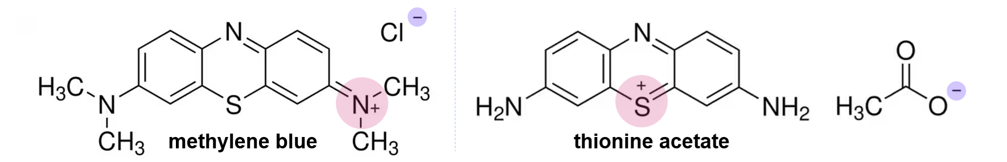

Figure 1. The structures of methylene blue and thionine acetate.

Strong and well-defined Raman peaks originating from tested organic molecules were recorded only at very narrow potential ranges. As shown in Figure 2, Raman intensity for thionine acetate reached the maximum at ~ -0.35 V vs. Ag, in close agreement with the oxidation peak position. The same trend was observed for structurally similar methylene blue.

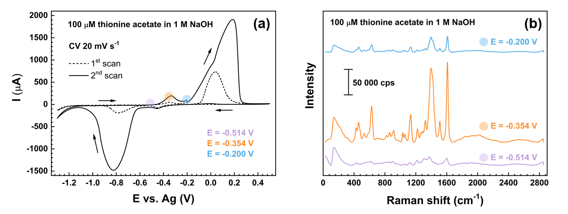
Figure 2. (a) CVs and (b) corresponding Raman spectra recorded at the Cu-based substrate for 100 μM thionine acetate in 1 M NaOH.

The observed Raman enhancement likely arises from the combined effect of several simultaneously occurring processes, involving not only the surface chemistry of Cu-based substrate (adsorption of OH⁻ ions $\left(Cu+OH^{-}→CuOH_{ads}+e^{-}\right)$ and formation of Cu₂O) but also the electroactivity of tested organic molecules (reoxidation of leucothionine/leucomethylene blue to thionine/methylene blue).

Acknowledgments
K.S. acknowledges support from the Polish National Agency for Academic Exchange (NAWA) under the Bekker NAWA Programme, project no. BPN/BEK/2024/1/00200.

