Activated Carbon Fibers for Understanding Charge Storage in Aqueous Zinc-Ion Hybrid Capacitors
Sara González-Martínez, Alberto Castro-Muñiz, Silvia Villar-Rodil, Teresa A. Centeno, Fabián Suárez-García and Juan I. Paredes
Instituto de Ciencia y Tecnología del Carbono, INCAR-CSIC
C/Francisco Pintado Fe 26, 33011, Oviedo, España
Sara.gonzalez@incar.csic.es

Porous carbons are widely studied as cathode materials for aqueous zinc-ion hybrid capacitors (AZICs) due to their high surface area and tunable pore structure. However, the minimum pore size effectively involved in charge storage and the influence of pore size on ion transport remain insufficiently understood.

To address this issue, we synthesized and characterized a series of porous carbons with pore structures within the relevant microporous range and investigated their performance as AZIC cathodes. Combined N₂/CO₂ adsorption and dual NLDFT analysis enabled accurate determination of their pore size distributions, from which the surface area associated with different cut-off pore widths was calculated.
Capacities measured at very low current densities, where the influence of ion transport and electrical conductivity is minimized, were correlated with the surface area associated with pores above progressively increasing cut-off widths. Since charge storage is expected to be proportional to the accessible surface area under these conditions, the correlation should reach a maximum when the cut-off width matches the minimum pore size involved in charge storage. The highest Pearson correlation coefficient was obtained for a cut-off pore width of ~0.65 nm (p < 0.05), identifying this value as the minimum pore size accessible to charge storage in AZIC carbon cathodes [1].

This value is consistent with the dimensions of hydrated ions in aqueous ZnSO₄ electrolytes and suggests that hydrated protons can readily participate in the storage process, while Zn²⁺ and SO₄²⁻ ions may access the narrow porosity through partial dehydration or structural distortion. Post-mortem analyses further supported the participation of proton-related processes during cycling.
The study also revealed that pore size distribution strongly affects rate capability. Supermicropores (0.7–2 nm) contributed to charge storage only at moderate current densities, whereas the presence of small mesopores was necessary to maintain significant capacity retention at high currents. In contrast, the hydrophilicity of the carbons showed little influence on electrochemical performance within the investigated range.

These results provide fundamental insight into ion confinement and charge storage mechanisms in nanoporous carbons and establish a general methodology that can be extended to other capacitor systems and electrolytes.

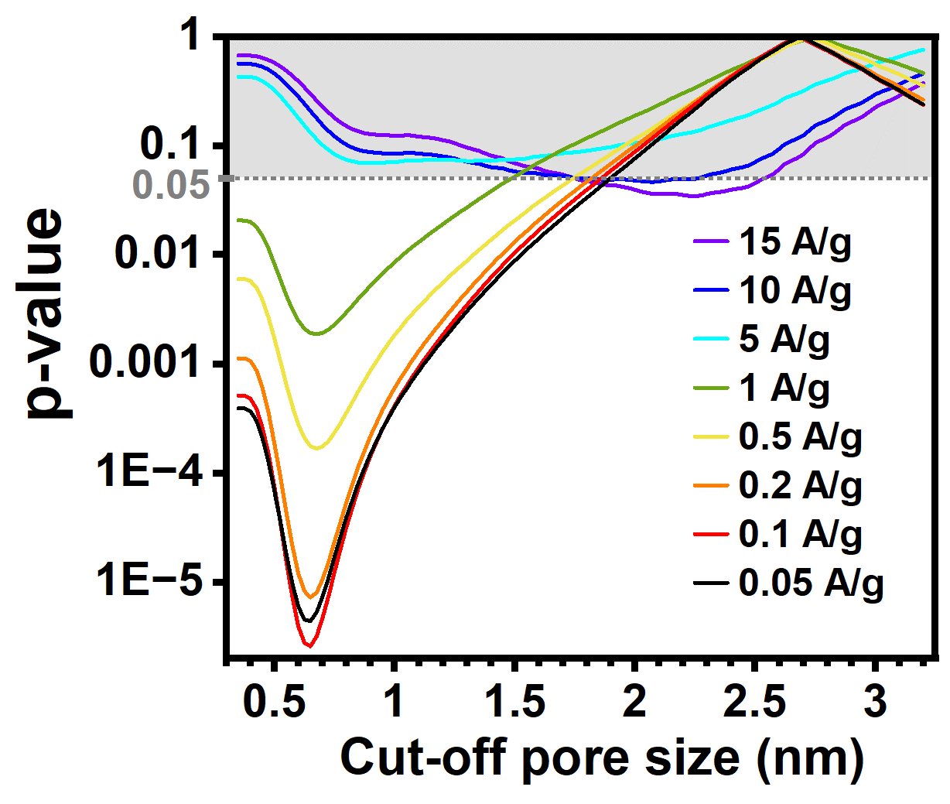
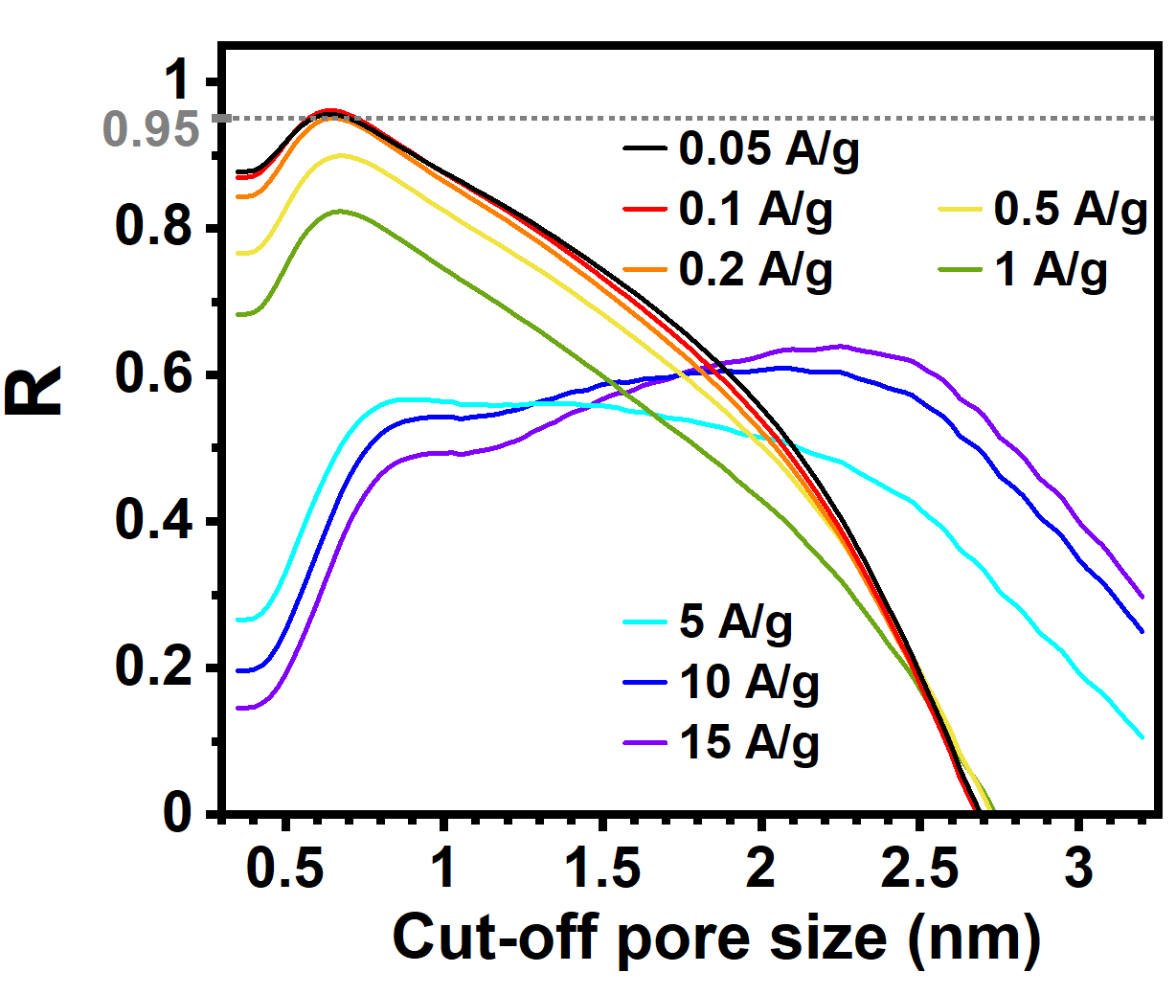
[1] S. González-Martínez, A. Castro-Muñiz, S. Villar-Rodil, T. A. Centeno, F. Suárez-García, and J. I. Paredes, “Evaluating the influence of physicochemical characteristics of porous carbons on their cathode performance in aqueous zinc-ion hybrid capacitors,” Carbon N Y, vol. 237, p. 120123, Apr. 2025, doi: 10.1016/J.CARBON.2025.120123.
Figure 1. (a) Values of Pearson’s correlation coefficient (R) vs. different cut-off pore sizes for linear correlation between the capacities of the AZIC cathodes and their surface areas above those cut-off pore sizes. R=0.95 has been added as reference (dotted line). (b) p-values corresponding to the previous correlations. The area for p-values above 0.05 (non-significant correlation) has been shadowed in gray.

b)
a)

