The Carbonate Conversion Layer in Amine-Based Electrolytes for Direct CO₂ Electrolysis

¹Raffael Niess, ¹Mehmet Coskun, ¹Christoph Griesser, ¹Thomas Mairegger, ¹Julia Kunze-Liebhäuser
¹Department of Physical Chemistry, University of Innsbruck
Raffael.Niess@uibk.ac.at

Reactive CO₂ capture and conversion offers a sustainable route to valuable chemical feedstocks bypassing the energy intensive thermal desorption step of conventional carbon capture. However, overcoming severe interfacial mass-transport and kinetic limitations that occur during the direct electrocatalytic reduction of CO₂ from the absorber medium remains a challenging barrier to industrial feasibility.^{[1]}

In this work, a strategic blend of potassium hydroxide (KOH) and the sterically hindered amine 2-amino-2-methyl-1-propanol (AMP), which provides accelerated capture kinetics toward bicarbonate (HCO₃⁻), was utilized for direct CO₂ electro-reduction at a silver (Ag) nanoparticle catalyst in an electrolyzer cell. Intriguingly, this industrially relevant absorber medium was found to enable high-rate electrochemical conversion to CO for direct syngas generation. The direct CO₂ reduction reaction was enhanced through the use of a TiO₂-based diffusive interlayer positioned between the Cation Exchange Membrane (CEM) and the catalyst. This film transforms into a highly active interface that we define as the Carbonate Conversion Layer (CCL).^{[2]} Through a combination of electrochemical product quantification via online gas chromatography (GC) and quantitative ¹³C NMR spectroscopy, we elucidate the underlying function of this interlayer, explaining the increased CO₂ conversion rate at industrially relevant current densities of 200 mA cm⁻² compared with single component electrolytes. The CCL is crucial for in-situ CO₂ regeneration from (bi)carbonate species, which is essential as only molecular CO₂ can be electrocatalytically converted.^{[3]} In addition, bicarbonate acts as a highly mobile interfacial pH buffer to neutralize excess alkalinity generated during electrolysis, a process mediated by protons provided through the CEM. Within this buffer region, the protonation of the amine (AMPH⁺) locally blocks the nitrogen lone pairs, deactivating CO₂ recapture in the CCL, which leads to an effective increase of the local CO₂ concentration.
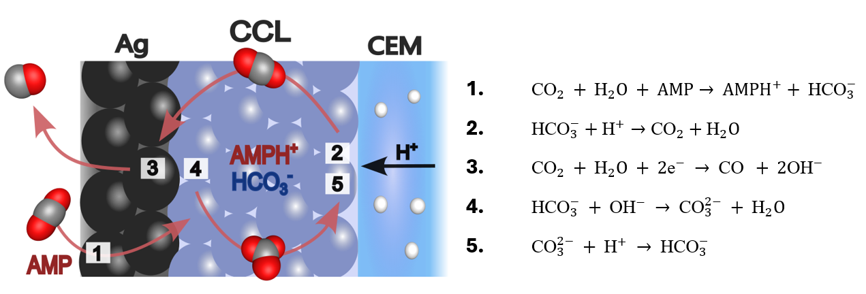

Figure 1: Schematic of the proposed mechanism within the CCL. Bicarbonate acts as an interfacial pH buffer and regenerates CO₂, effectively increasing its local concentration at the Ag catalyst surface. The numbered reactions illustrate: (1) Amine mediated fast CO₂ capture and transport, (2) molecular CO₂ regeneration via protonation, (3) electrocatalytic conversion of CO₂ to CO on Ag and (4–5) the interfacial buffering of the (bi)carbonate.

References:

[1] Zhu, X., & Liao, Q. et.al. (2021). Life cycle and economic analysis of chemicals production via electrolytic (bi)carbonate and gaseous CO₂ conversion. Applied Energy, 304, 117768.
[2] J., Sargent, E. H., & Sinton, D. et.al. (2023). Direct carbonate electrolysis into pure syngas. EES Catalysis, 1, 54-61.
[3]. Aroua, M. K., & Gallant, B. M. et.al. (2023). Uncovering the active species in amine-mediated CO2​ reduction to CO on Ag. ACS Catalysis, 13, 18, 12322–12337.

