Building Material Libraries for IPA Oxidation Catalysts via Scanning-Flow-Cell Electrodeposition
Anna-Lena Heß,^{a, b} Karl J.J. Mayrhofer, ^{a, b} Dominik Dworschak ª
a) Helmholtz Institute Erlangen-Nürnberg for Renewable Energy (IET-2), Forschungszentrum Jülich, Cauerstr. 1, 91058 Erlangen, Germany
b) Department of Chemical and Biological Engineering, Friedrich-Alexander-Universität Erlangen Nürnberg, Cauerstr. 1, 91058 Erlangen, Germany.
a.hess@fz-juelich.de

As the transition to renewable energy accelerates, the need for efficient seasonal energy storage solutions continues to grow. Isopropanol (IPA) and acetone represent a promising, cost-effective, and non-toxic redox couple for electrochemical hydrogen storage. In this cycle, acetone is reduced to IPA to store hydrogen, which is then released on demand via the oxidation of IPA back to acetone.¹
However, the efficiency of this cycle is currently limited by the oxidation of IPA to acetone. While Platinum-Ruthenium (PtRu) alloys are the state-of-the-art catalysts for this reaction², they suffer insufficient activity from severe self-poisoning caused by the adsorption of the reaction product acetone onto the catalyst surface³, blocking active sites and degrading system performance within minutes.

The addition of a third element to PtRu catalysts could mitigate the self-poisoning observed during IPA oxidation. To investigate this hypothesis, we utilize a scanning-flow-cell (SFC) electrodeposition setup for the medium-throughput synthesis of ternary alloy libraries (PtRu with Au, Sn or Co as the third element). Beyond performance optimization, this approach systematically varies composition to uncover how the addition of a third element modulates catalytic activity, acetone adsorption and surface cleaning strategies. Additionally, the integration of online ICP-MS enables the quantification of metal dissolution to assess catalyst stability.

By linking composition to both performance and mechanistic insights, this work seeks to identify robust catalyst compositions and clarify the effects of a third element on the IPA oxidation reaction, enabling a faster deployment of IPA-based seasonal energy storage.

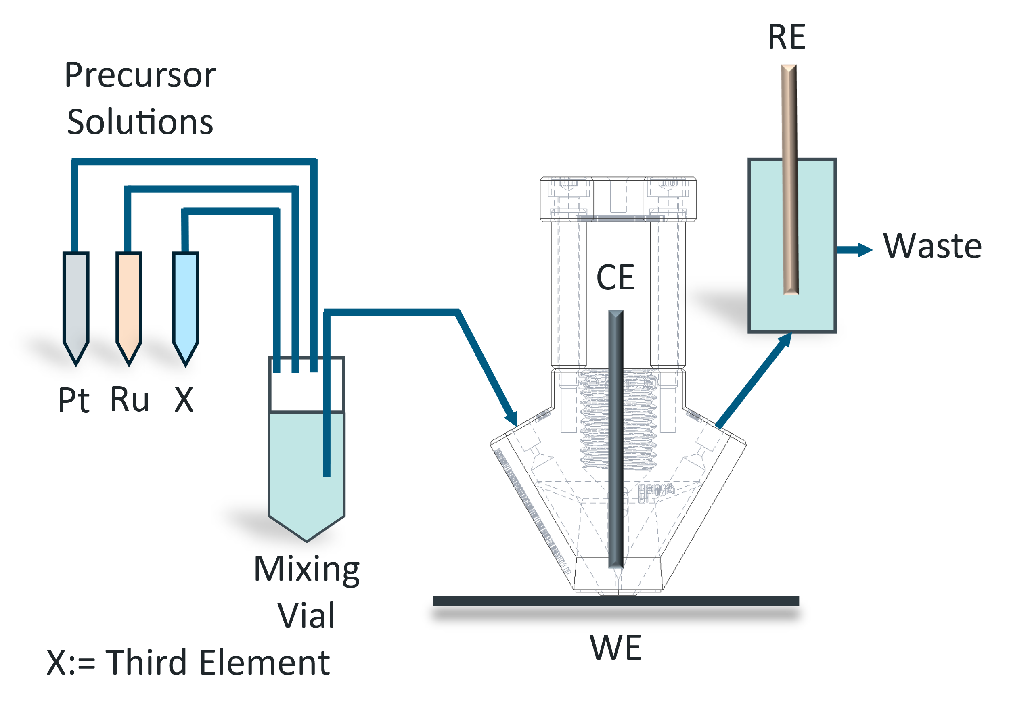
Figure 1: Schematic of the SFC electrodeposition setup

[1] Venus, D. et al. Advanced Energy Materials 2025, 15 (12), 2403824
[2] Hauenstein et al. Journal of Power Sources Advances 2021, 10, 100064
[3] Waidhas, F. et al. ACS Catal. 2020, 10 (12), 6831–6842

