Single-chirality single-walled carbon nanotubes for electrochemical co-detection of serotonin and dopamine

Salli Valkama, Juyeon Seo, Bahar Mostafiz, Naela Delmo, Han Li, Emilia Peltola
Materials engineering, University of Turku
Vesilinnantie 5, 20014 Turku
sasval@utu.fi
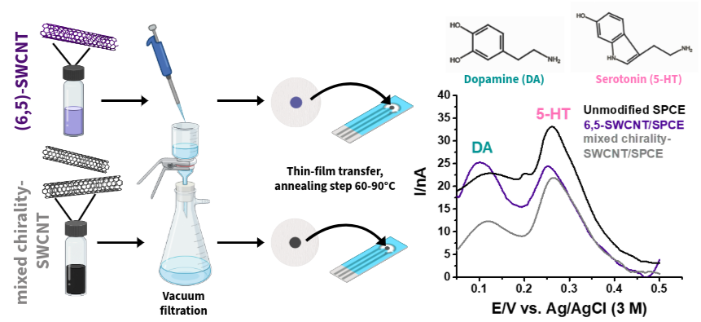
Dopamine (DA) and serotonin (5-HT) are closely interacting neurotransmitters whose dysregulation is linked to neurodegenerative diseases, such as Parkinson’s and Alzheimer’s disease [1]. Reliable, real-time detection of these analytes is therefore essential for advancing neurochemical research. Electrochemical sensing offers a promising approach due to its sensitivity, low cost, and rapid measurement [2]. However, the similar chemical structure of DA and 5-HT results in overlapping oxidation potentials [2], complicating their simultaneous detection. This work builds on a previous study from our research group by exploring the role of single-walled carbon nanotube (SWCNT) chirality in improving the electrochemical co-detection of DA and 5-HT [3]. While SWCNTs are widely used in sensing applications, the impact of chirality is often overlooked, with most studies relying on mixed-chirality materials that may limit reproducibility and accuracy [4,5]. Electrodes were fabricated by depositing thin films of semiconducting (6,5)-SWCNTs and mixed chirality-SWCNTs onto screen-printed carbon electrodes (SPCEs). Surface morphology was characterized using scanning electron microscopy (SEM), and sensing performance was evaluated using differential pulse voltammetry (DPV). The results demonstrate that SWCNT chirality significantly influences sensor performance. The (6,5)-SWCNT-modified electrodes showed improved peak separation and sensitivity compared to both unmodified SPCE and mixed chirality-SWCNT/SPCE. Notably, effective co-detection of DA and 5-HT was achieved even when the other neurotransmitter was present in excess. These findings highlight the importance of chirality-controlled SWCNTs in enhancing electrochemical sensor performance and provide a pathway toward more selective and reproducible platforms for neurotransmitter detection.

[1] Y. Xu, … & Q. Wang, Neurotransmitter receptors and cognitive dysfunction in Alzheimer’s disease and Parkinson’s disease, Prog. Neurobiol. (2012). https://doi.org/10.1016/j.pneurobio.2012.02.002.
[2] N. Delmo, … & E. Peltola, Developing an electrochemical sensor for the in vivo measurements of dopamine, Sens. Diagn. (2023). https://doi.org/10.1039/D2SD00230B.
[3] J.-Y. Seo, … & E. Peltola, Single-chirality single-wall carbon nanotubes for electrochemical biosensing, Phys. Chem. Chem. Phys. (2025). https://doi.org/10.1039/D4CP04206A.
[4] R. Kour, … & A. Khosla, Review—Recent Advances in Carbon Nanomaterials as Electrochemical Biosensors, J. Electrochem. Soc. (2020). https://doi.org/10.1149/1945-7111/ab6bc4.
[5] D.C. Ferrier, & K.C. Honeychurch, Carbon Nanotube (CNT)-Based Biosensors, Biosensors (2021). https://doi.org/10.3390/bios11120486.

