TiO₂-Modified PEO Coatings on Aluminium AW 1050 with Enhanced Photocatalytic Performance
Agata Kołkowska, Stevan Stojadinovic, Maciej Sowa, Joanna Michalska-Serwin, Wojciech Simka
¹Department of Inorganic Chemistry, Analytical Chemistry and Electrochemistry, Faculty of Chemistry, Silesian University of Technology, Gliwice, Poland
² Faculty of Physics, University of Belgrade, Belgrade , Serbia
agata.kolkowska@polsl.pl

The presence of pharmaceutical residues in aquatic environments has become a significant environmental concern due to their persistence and potential adverse effects on ecosystems and human health. Conventional wastewater treatment plants are unable to effectively remove contaminants present at trace concentrations, resulting in the continuous release of pharmaceutical compounds into the environment. Therefore, the development of efficient and industrially applicable water treatment technologies is urgently needed. Among advanced wastewater treatment methods, photocatalysis is considered one of the most promising approaches.

Photocatalysis is a process in which a photocatalyst activated by light of an appropriate wavelength generates reactive oxygen species capable of degrading organic pollutants, including antibiotics and dyes commonly found in contaminated water. One of the most widely studied photocatalysts is titanium dioxide, which exhibits the highest activity under ultraviolet irradiation. Most photocatalytic systems are based on suspensions of TiO₂ nanoparticles; however, their practical application is limited by the need to separate the photocatalyst from the treated solution after the process, resulting in additional operational costs.

A promising solution is the immobilization of the photocatalyst within a solid coating. Such an approach can be achieved using the plasma electrolytic oxidation (PEO) process. During PEO treatment, a porous ceramic oxide layer with strong adhesion to the substrate is formed on the surface of valve metals, particularly aluminium and titanium. Moreover, species present in the electrolyte can be incorporated into the growing oxide layer during the process.

In the present study, oxide coatings were fabricated on AW 1050 aluminium using a bipolar pulsed PEO process in a silicate-based electrolyte containing TiO₂ particles. Scanning electron microscopy (SEM) observations confirmed the formation of a highly porous surface morphology. X-ray diffraction (XRD) analysis verified the presence of both anatase and rutile phases within the coatings. Furthermore, photoluminescence spectroscopy and UV–Vis diffuse reflectance spectroscopy (UV–Vis DRS) were employed to investigate the influence of the applied processing parameters on the optical and photocatalytic properties of the obtained coatings.

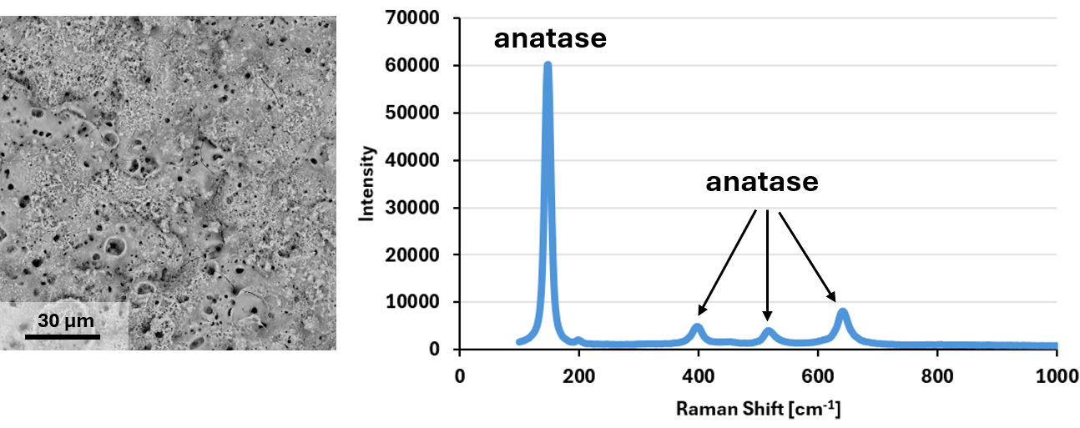
Figure 1 SEM image and Raman spectra of PEO coating produced on aluminium AW 1050.

