Au@Ag Core-shell Nanostructures for Enhanced Nitrate
Electroreduction to Ammonia
Jian Zhou,a Qingdian Liao,a Elena Gubanova,a Aliaksandr Bandarenkaa,b*Affiliation
ªPhysics of Energy Conversion and Storage, Technical University of Munich, James-Franck-Str. 1, 85748 Garching, Germany
^{b}Catalysis Research Center TUM, Ernst-Otto-Fischer-Str. 1, 85748 Garching, Germany
Jian.zhou@tum.de

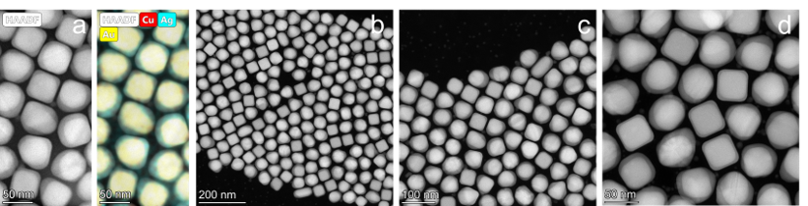
Ammonia (NH₃), an efficient carbon-free energy carrier with high energy density, also serves as a vital nitrogen source in agriculture, textiles, pharmaceuticals, and plastics.^{[1]} The electrochemical reduction of nitrate to ammonia (NO₃⁻RR) provides a promising approach for efficient nitrate removal and the sustainable generation of valuable nitrogen-based compounds.^{[2]} However, its efficiency is significantly limited by the complicated eight electron transfer process involving the formation of nitrite, nitric oxide, nitrous oxide, dinitrogen, and hydrogen, as well as ammonia.^{[3]} This complexity makes the identification of active sites highly challenging, which in turn hampers the elucidation of the explicit structure-activity relationship (SAR) in catalyzing NO₃⁻RR. Therefore, developing efficient NO₃⁻RR catalysts with well-defined structure and active unit to understand the reaction mechanism is of ongoing interest. Here, we propose a seed-mediated method to fabricate monodisperse Au cubes and Au octahedra with the size of 40 nm through adjusting the concentration of KBr.^{[4]} Subsequently, the desired Au@Ag core-shell structures with tunable shell thickness can be correspondingly synthesized through epitaxial growth of Ag on facetted Au nanoparticles. The combination of HRTEM and EDX mapping clearly demonstrates the successful formation and uniform distribution of Ag shell on the whole surface of Au nanoparticles (Figure 1). Finally, Au@Ag nanoparticles were immobilized on the Vulcan carbon with 20-wt.%. Electrochemical results indicate that the Au@Ag core-shell nanoparticles efficiently convert stable nitrate into nitrite in NO₃⁻RR.
Figure 1. STEM study of Au@Ag core-shell nanoparticles: a) HAADF STEM images and corresponding EDXS elemental maps. b-d) HAADF STEM images of nanoparticles.
Acknowledgement: Financial support from the German Research Foundation (DFG, No. BA 5795/8-1) and the EU project (ICONIC, No. 101115204) is gratefully acknowledged.
[1] Z. Fan, C. Cao, X. Yang, W. Yuan, F. Qin, Y. Hu, X. Sun, G. Liu, Y. Tian, L. Xu, Angew. Chem. Int. Ed. 2024, 63, e202410356.
[2] S. Sun, C. Dai, P. Zhao, S. Xi, Y. Ren, H. R. Tan, P. C. Lim, M. Lin, C. Diao, D. Zhang, C. Wu, A. Yu, J. C. J. Koh, W. Y. Lieu, D. H. L. Seng, L. Sun, Y. Li, T. L. Tan, J. Zhang, Z. J. Xu, Z. W. Seh, Nat. Commun. 2024, 15, 260.
[3] F. Calle-Vallejo, M. Huang, J. B. Henry, M. T. Koper, A. S. Bandarenka, Phys. Chem. Chem. Phys. 2013, 15, 3196-3202.
[4] F. Kirner, P. Potapov, J. Schultz, J. Geppert, M. Müller, G. González-Rubio, S. Sturm, A. Lubk, E. Sturm, J. Mater. Chem. C 2020, 8, 10844-10851.

