Chitosan-Based Electrochemical Biosensor for Rapid Detection of Escherichia coli
Sanjana Auditto, Eleonora Monti, Niloofar Paknezhad, Athanassia Athanassiou
Istituto Italiano di Tecnologia
Via Morego 30, 16163 Genova, Italy
Sanjana.auditto@iit.it

Pathogens are infectious agents that include bacteria, fungi, protozoa, viruses, and prions.¹ Among these, Escherichia coli (E. coli) remains one of the most clinically and epidemiologically significant foodborne and waterborne pathogens globally, representing a persistent threat to public health and food safety. Conventional gold-standard detection methods, such as enzyme-linked immunosorbent assay (ELISA) and polymerase chain reaction (PCR), while sensitive and specific, are ill-suited for on-site use as they are time-consuming, costly, and demand specialized instrumentation and trained personnel. These limitations underscore the urgent need for fast, affordable, and miniaturized point-of-care (POC) biosensors capable of in situ pathogen detection. Biosensors transduce biological or chemical recognition events into measurable signals and represent a compelling solution to this challenge. Within the POC landscape, electrochemical biosensors offer advantages such as high sensitivity, low power requirements, miniaturization potential, and compatibility with low-cost fabrication over optical counterparts reliant on noble metal substrates.² To further reduce material costs and broaden accessibility, renewable biopolymer-based and carbon-derived nanomaterials are increasingly explored as electrode modifiers.

In this work, we present a facile, low-cost electrochemical biosensor based on chitosan, a biocompatible, naturally derived polysaccharide for the detection of E. coli. Sensor fabrication was achieved through a layer-by-layer (LbL) drop-casting protocol, enabling straightforward, scalable electrode modification. Detection was performed using differential pulse voltammetry (DPV), a waveform technique that affords enhanced sensitivity and background discrimination relative to conventional linear sweep methods. Upon exposure to increasing concentrations of E. coli, a systematic and inversely proportional decrease in amperometric current response was observed. This signal attenuation is attributed to the physical occlusion of the electrode surface by adsorbed bacterial cells, which impede interfacial charge transfer and restrict electron mobility at the chitosan-modified working electrode. The sensor demonstrates a sensitive, label-free detection strategy with a response that scales with bacterial load, offering a promising platform for rapid, on-site E. coli monitoring in food safety and environmental surveillance contexts.

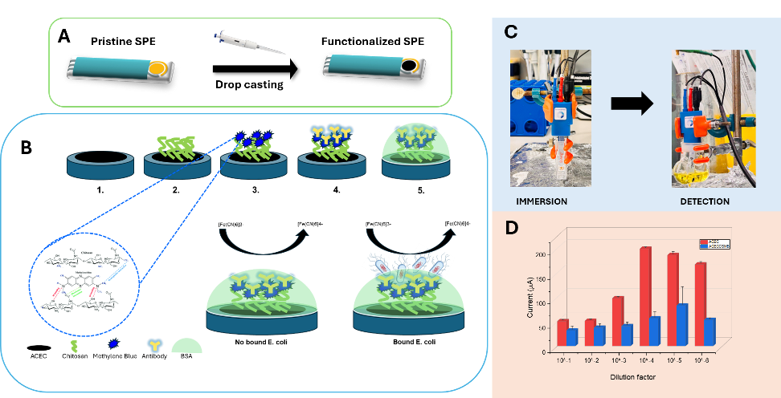

Figure 1. A) Methodology of screen-printed electrode modification B) Schematic representation of the interaction between the active layers and the pathogen C) methodology for E. coli detection via sensor immersion and electrochemical measurement and D) current versus dilution factor obtained via differential pulsed voltammetry

References
^{1.} Environ. Sci.: Nano, 2024, 11, 4449
^{2.} Clinica Chimica Acta, 2025, 565, 119984

