Effect of Imidazole Ionic Liquids and Palladium Nanoparticles on the Long-Term Performance of the Negative Electrode in Ni-MH Batteries

M. Baraniakª, K. Tokarekª, J. Wojciechowskiª, F. Walkiewicz^{b}, M. Pająk^{c}, K. Hubkowska^{c}, D. Monikowska^{c}, A. Czerwiński^{c}, G. Lota^{a,d}

ªPoznan University of Technology, Institute of Chemistry and Technical Electrochemistry, Berdychowo 4, 60-965 Poznan, Poland
^{b}Poznan University of Technology, Institute of Chemical Technology and Engineering, Berdychowo 4, 60-965 Poznan, Poland
^{c}University of Warsaw, Faculty of Chemistry, Pasteur 1, 02-093 Warsaw, Poland
^{d}Łukasiewicz Research Network Institute of Non-Ferrous Metals Division in Poznan Central Laboratory of Batteries and Cells, Forteczna 12, 61-362 Poznan, Poland
marek.baraniak.@put.poznan.pl

The nickel-metal hydride secondary electrochemical cells are one of the most commonly commercially used energy storage systems, alongside lithium-ion and lead-acid batteries. Compared to these two systems, they possess certain advantages, like lower toxicity and higher stability. They do however exhibit some drawbacks, which limit their applicability. One of those drawbacks is the corrosion of negative electrode material (hydrogen-absorbing AB5-type alloy), caused by the presence of highly alkaline electrolyte [1]. The corrosion process, which occurs both during standard cycling of the battery, as well as during its storage at open circuit conditions, impacts such traits as long-term cycling stability, longevity and capacity of the system [1]. Limiting the corrosion processes occurring in the cell could lead to such improvements as longer lifespan and better capacity retention. In order to inhibit the corrosion process in studied energy storage systems, imidazolium-based ionic liquids (ILs) were added to the alkaline electrolyte (0.01 and 0.1 wt%). ILs act as a mixed-type corrosion inhibitors, adsorbing on the surface of the negative electrode material and blocking the anodic and cathodic reactive sites [2]. The electrochemical testing has confirmed a positive impact of studied compounds on corrosion parameters of hydrogen-absorbing alloy. The mechanism of corrosion inhibition provided by ionic liquids leads however to certain drawback, like lower capacity, which is caused by blocking of active sites on the material’s surface [3]. The AB5-type alloy also requires activation in KOH electrolyte environment, which is circumvented by addition of palladium nanoparticles. In this case Pd acts as a catalyst material and improves the kinetic characteristics of hydrogen adsorption and absorption into the AB5-type absorbing alloy, rendering the activation obsolete [4]. Moreover, long-term capacity tests, performed in every single cycle during long-term polarization, revealed that the presence of an ionic liquid in the electrolyte acts synergistically with palladium nanoparticles, thereby increasing the overall and average capacity of the studied systems by enhancing the kinetics of hydrogen absorption and mitigating corrosion of the AB5 alloy (Figure 1).
This work was supported by the National Science Centre, grant number 2021/41/B/ST5/04047 and by Ministry of Science and Higher Education, Poland.

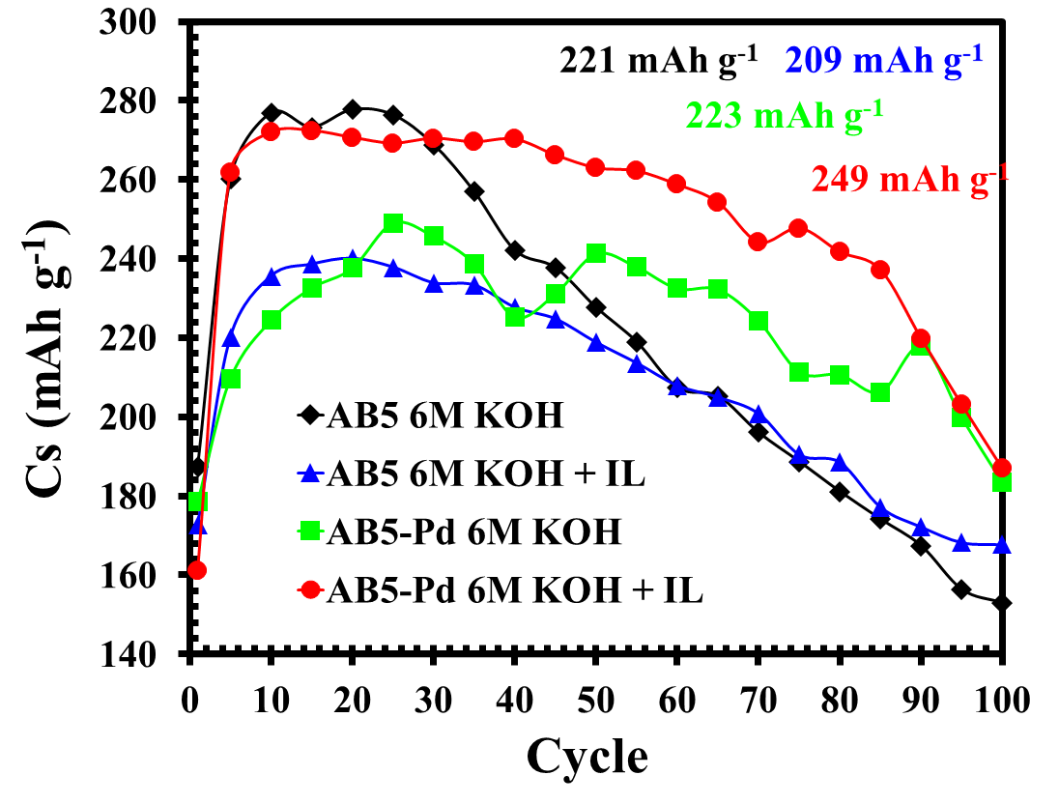
Fig. 1. Specific capacity C_{s} values recorded during long-term capacity studies of unmodified and Pd-modified AB5-type electrodes in various electrolytes.

References:
[1] Wang C. S. et al., J. of Applied Chem. 33 (2003) 325-331
[2] Kumar P. et al., Adv. Colloid Interface Sci. 333 (2024) 103303
[3] Watanabe et al., Chem. Rev. 117 (2017) 7190-7239
[4] Hubkowska K. et al., Electrochem. Commun. 100 (2019) 100-103

