Seeing Biomolecules Electrochemically – The Application of Organogels in ITIES Systems

Julia Maciejewska-Komorowska¹, Angelika Holzinger¹, Damien W. M. Arrigan², Martin Jönsson-Niedziółka¹
¹ Institute of Physical Chemistry, Polish Academy of Sciences, Kasprzaka 44/52, 01-224 Warsaw, Poland
² School of Molecular and Life Sciences, Curtin University, GPO Box U1987, Perth, Western Australia, 6845, Australia.
jmaciejewska@ichf.edu.pl

The investigation of biomolecules using electrochemistry at the interface between immiscible electrolyte solutions (ITIES) offers innovative opportunities to analyze substances that do not exhibit redox activity in conventional electrochemical systems. The use of organogels as the organic phase increases the mechanical stability of the system [1] and expands the possibilities for designing miniature and portable analytical platforms. Such systems include inexpensive and easy-to-use paper-based systems.
In this work, we present the use of organogel-based ITIES systems for the examination of selected biomolecules with varying structures and physicochemical properties. We show the results obtained for proteins in a system using glass membranes and for biomolecules analyzed using a paper-based system, in which both phases are immobilized the paper [2].

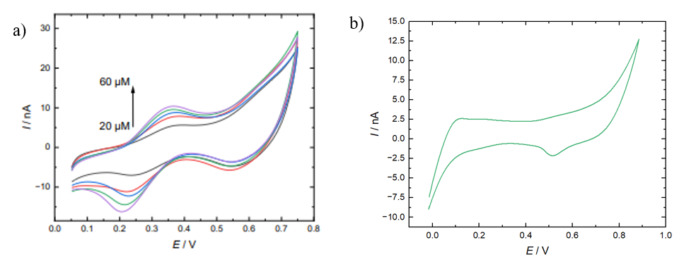a) Cyclic voltammograms for different concentrations (20-60 μM) of TPA⁺ in 10 mM LiCl in a paper-based system; b) Cyclic voltammograms for 6 µM hemoglobin in 10 mM HCl. The organic phase was an organogel with 10 mM BTPPA⁺TPBCl⁻ in NPOE in a glass membrane system.

The results indicate that organogels may be a promising component of ITIES systems designed for biomolecule analysis, combining measurement stability with the ability to integrate with a variety of analytical platforms.

[1] J. Maciejewska-Komorowska, D.W.M. Arrigan, M. Jönsson-Niedziółka, ChemRxiv (2026). https://doi.org/10.26434/chemrxiv.15003001/v1.
[2] J. Maciejewska-Komorowska, M. Jönsson-Niedziółka, ChemRxiv (2026).
https://doi.org/10.26434/chemrxiv.15004103/v1

This work was supported by the National Science Centre, Poland, under grant number 2021/41/B/ST4/01324.

