Operando Photoelectron Spectroscopy Reveals Early-Stage Degradation Pathways in All-Solid-State Batteries
Kataev E.¹, Mazzio K^{1,2,3}, Piccolo F.^{1,3}, Ruske F.¹, Garcia-Diez R.¹, Wilks R.¹, Bär M^{.1,4,5}, Adelhelm P ^{1,3}
¹ Helmholtz-Zentrum Berlin für Materialien und Energie GmbH (HZB), Berlin, Germany
² TU Wien, Vienna, Austria
³ Humboldt University of Berlin, Berlin, Germany
⁴ Helmholtz-Institute ErlangenNürnberg for Renewable Energy, Berlin, Germany
⁵ Friedrich-Alexander-Universität Erlangen-Nürnberg, Erlangen, Germany

elmar.kataev@helmholtz-berlin.de

Solid-state batteries (SSBs) promise improved safety and energy density, but their cycling stability remains limited by interfacial degradation that is difficult to access experimentally under realistic operating conditions. Here, we use operando soft and hard X-ray photoelectron spectroscopy to follow lithiation and degradation processes in TiS₂|Li₃YCl₆ solid-state lithium half cells under applied stack pressure [1]. The measurements were performed at the SISSY endstation located in the Energy Materials In-Situ Laboratory Berlin (EMIL) of the BESSY II electron storage ring operated by HZB.
The operando cell design (Figure 1, left panel) enables direct photon beam access to the composite cathode through a perforated current collector while maintaining a mechanically confined geometry. During discharge, Ti 2p and S 2p photoemission spectra reveal the expected formation of Li_{x}TiS₂, confirming lithiation of the TiS₂ active material. In parallel, changes in the Y 3p and Cl 2p regions show reductive decomposition of the Li₃YCl₆ solid electrolyte.
During the discharge, oxygen-containing species migrate toward the cathode current collector and react with TiS₂ to form TiO_{x} and TiO_{2-x}S_{x} surface species. Depth-dependent photoelectron spectroscopy measurements shows that this oxygen enrichment is concentrated near the probed surface (Figure 1, right panel), with the oxygen-containing overlayer thickness increasing from roughly 2 nm in the pristine state to about 5–6 nm after end of the discharge. Ex situ scanning electron microscopy imaging coupled with energy-dispersive X-ray spectroscopy performed after long cycling of the laboratory cells with equal chemistry confirm continuous oxygen accumulation. These observations show that oxygen-containing Ti species already increase during the first discharge, while longer-term cycling confirms progressive oxygen enrichment near the cathode current-collector side. The spatial localization is consistent with a kinetically favored pathway linked to electron injection from the current collector and thus to a non-uniform electrochemical driving force across the composite cathode. The oxygen migration mechanism identified here is expected to be relevant to sulfide electrode materials more broadly, and since the key mechanistic observations occur within the solid-solution intercalation regime, the conclusions are expected to hold across a range of sulfide-based cathode materials and operating voltage windows, providing a foundation for future studies on higher energy density sulfide systems.

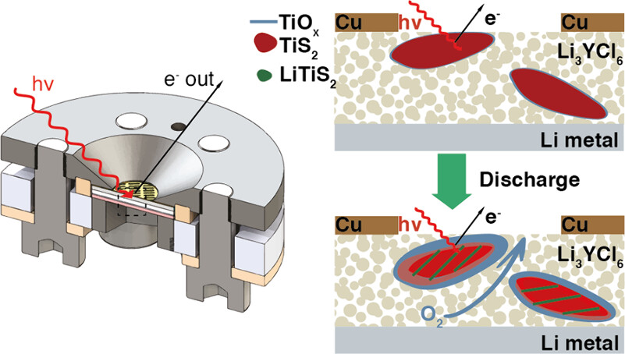
Figure 1, left: Design of the developed solid-state electrochemical cell for operando photoelectron spectroscopy. Right: Schematic mechanism of the revealed degradation pathway in solid-state batteries.

References
1 Mazzio, K. A.; Kataev, E.; Piccolo, F.; Ruske, F.; Garcia-Diez, R.; Wilks, R.; Bär, M.; Adelhelm, P. Early Onset Degradation Mechanism in All Solid-State Batteries Revealed by Operando Photoelectron Spectroscopy. ACS Energy Letters 2026, 11 (5), 4018-4025. DOI: 10.1021/acsenergylett.6c00551.

