Real-Time In Situ Conductance Tracking During Pulsed Electrodeposition of Metallic Nanoparticle Networks on Ultrathin Carbon Films

Laurin Hastreiter, Thomas Hirsch
Institute of Analytical Chemistry, Chemo- and Biosensors, University of Regensburg
Universitätsstraße 31, 93040 Regensburg
laurin.hastreiter@ur.de

Electrodeposited metal nanostructures are key components in microelectronics, sensing, catalysis, and flexible electronic systems. During electrodeposition on carbon-based substrates such as graphite or graphene-derived films, metal growth typically proceeds via nucleation and expansion of isolated nanoparticle islands, followed by the formation of interconnected conductive networks and, ultimately, continuous films. The transition through the percolation regime strongly alters the in-plane electrical conductivity and critically determines the functional properties of the resulting hybrid material. However, identifying this transition during deposition remains challenging and is typically only accessible through ex situ structural characterization or advanced in situ imaging techniques.
Here, we present an operando platform for in-plane conductance tracking for time-resolved monitoring of metallic nanoparticle growth on ultrathin conductive carbon films. By integrating synchronized in situ two- and four-point conductance measurements^{[1]} into pulsed electrodeposition protocols, we directly track the emergence of electrically connected nanoparticle networks in real time (Fig. 1). Initially, isolated nanoparticle domains induce only minor changes in conductance. Upon progressive coalescence, however, the conductance increases sharply as long-range conductive pathways emerge within the growing metal layer. Using two different carbon/metal model systems in combination with scanning electron microscopy, we demonstrate that differences in nucleation density and growth behavior are directly reflected in the pulse number required to reach the percolation threshold.
The methodology provides direct access to dynamic transport properties during nanostructure formation, yielding information otherwise inaccessible without elaborate downstream characterization or advanced operando imaging. A particular advantage of the platform is that the electrical conductance itself can be employed as a real-time process parameter for adaptive deposition control. We demonstrate that feedback from the conductance measurements enables precise tuning of the electrical properties of the evolving hybrid material system and may facilitate future closed-loop electrodeposition strategies with dynamically adjusted pulse parameters.

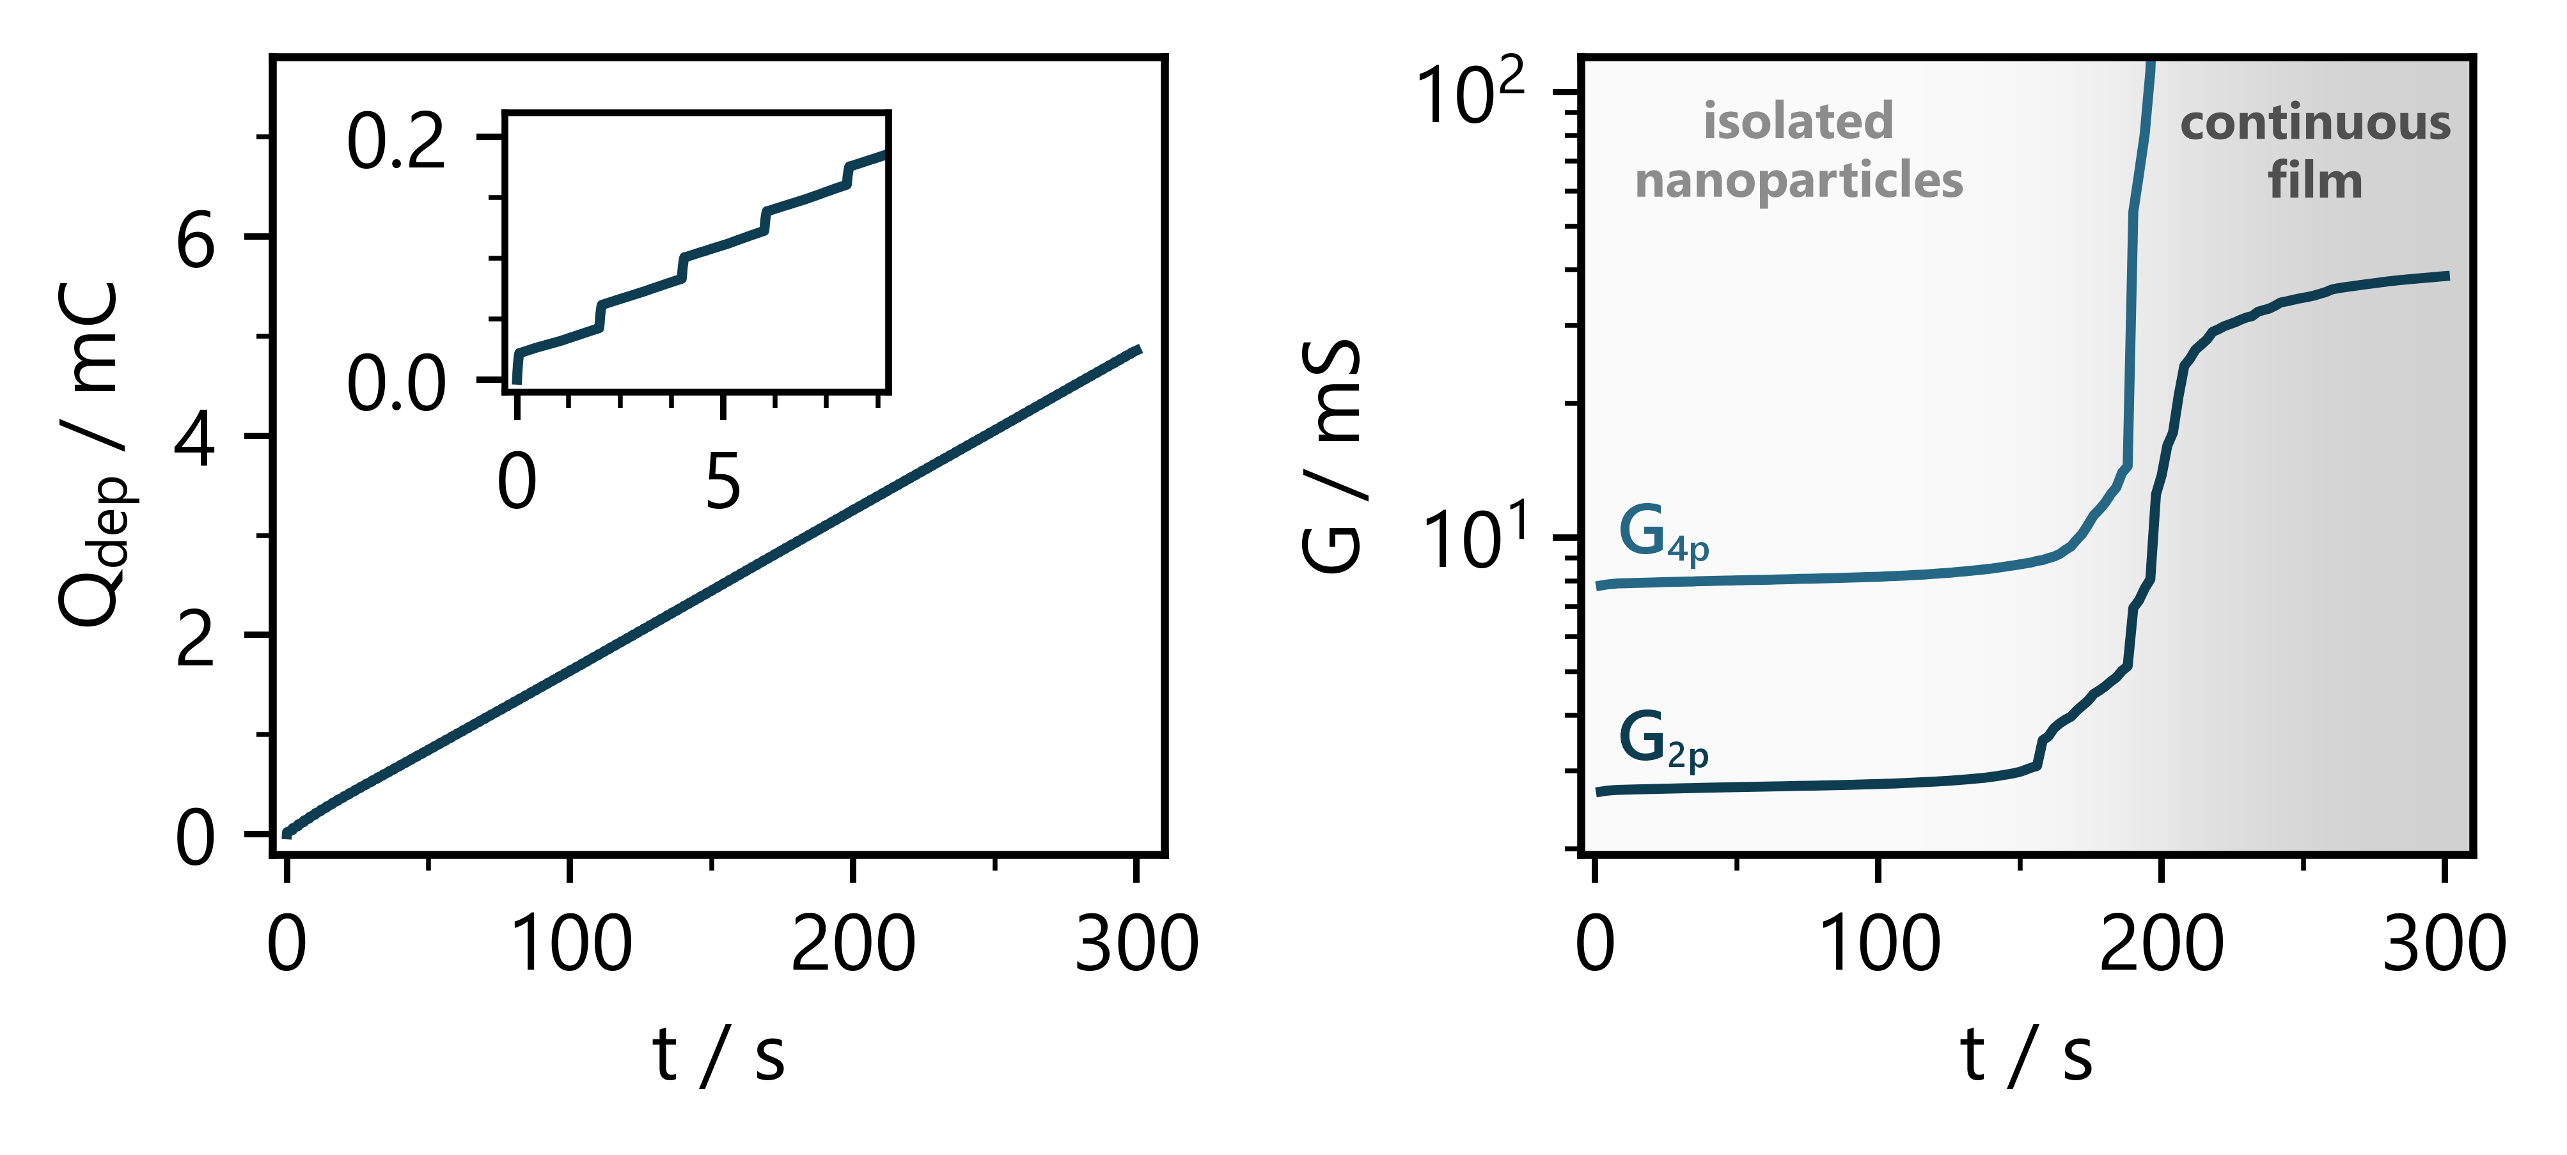
Figure 1: Left: Total charge passed (Q_{dep}) during pulsed electrodeposition of nanoparticulate copper on a thin semiconducting reduced graphene oxide film. Right: Simultaneously recorded two-point (G_{2p}) and four-point (G_{4p}) conductance highlighting the steep increase in in-plane conductivity upon the transition from isolated nanoparticles to a continuous metallic film.

[1] L. Hastreiter; T. Hirsch. ACS Electrochem. 2026, 2(2), 554-565.

