How high-throughput x-ray characterization could solve the dynamic strain in IrO₂ based electrode for oxygen evolution reaction

Florian Chabotª, Jack T. Lang^{b}, Hridya Nedumkulam^{c}, Iryna V. Zenyuk^{b}, Jakub Drnecª
- European Synchrotron Radiation Facility, 38000 Grenoble, France
- Department of Chemical and Biomolecular Engineering, University of California, Irvine, CA 92697, USA
- Faculty of Mathematics and Physics, Department of Surface and Plasma Science, Charles University, V Holešovičkách 2, Prague, 180 00 Czech Republic
e-mail address: fchabot@esrf.fr

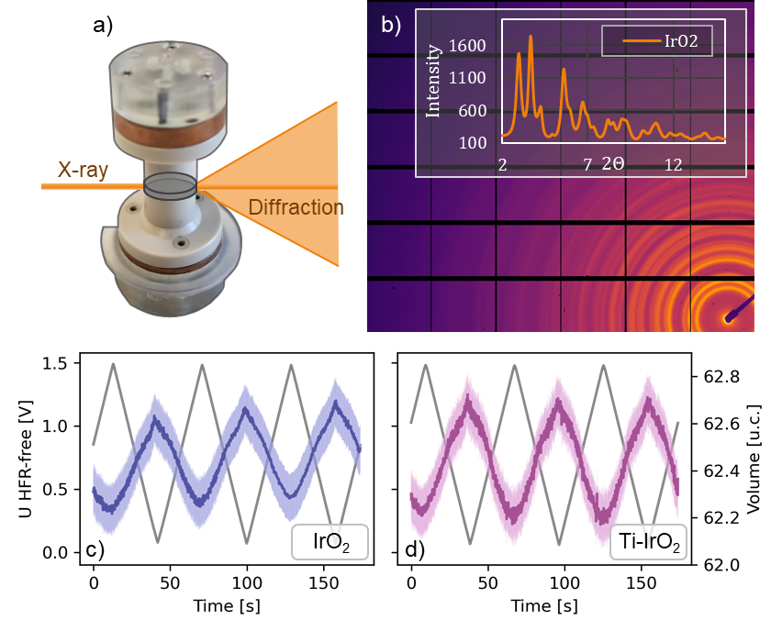
World production of hydrogen still relies on the use of fossil fuels and generates around 980 Mt of CO₂ every year. However, coupling water electrolysis with a clean source of electricity could generate the necessary hydrogen without emitting CO₂. Of the various available technologies, the proton exchange membrane water electrolyser (PEMWE) is one of the best available solution due to its high specific power and ability to operate at high current density and under fluctuating conditions. However, large-scale green hydrogen production remains limited by its high cost. At the heart of the PEMWE operation, the anode catalyst, which is made of IrO₂ rutile nanoparticles, controls the full system efficiency and ultimately the cost of the produced hydrogen. Therefore, a crucial effort is needed to better understand the IrO₂ structure and behavior in order to enhance the oxygen evolution reaction (OER) efficiency. While the reaction mechanism is still in debate in the literature, several studies have shown the operating potential drives surface reconstruction of the IrO₂ catalyst and the modification of its bulk structure. In this context, operando characterizations are essential to unravel the different phenomena taking place during OER. In this work we used x-ray diffraction to probe the evolution of the lattice structure as a function of potential. his study provides new evidence to advance our understanding of the OER mechanism, demonstrating how this research topic could benefit from x-ray-based high-throughput experiments.

Figure 1: a) Operando zero-gap electrolyzer cell. b) IrO₂ rutile diffraction image and integrated 1D pattern. Evolution of the lattice volume due to the variation of potential measured on c) pure IrO₂ and d) Ti doped IrO₂ catalysts.

Uwe Remme, Global Hydrogen Review 2025, 2025.
Sonja van Renssen, “The Hydrogen Solution?,” Nature Climate Change 10, no. 9 (2020): 799–801, https://doi.org/10.1038/s41558-020-0891-0.
Bryan Pivovar et al., “Hydrogen at Scale (H2@Scale): Key to a Clean, Economic, and Sustainable Energy System,” The Electrochemical Society Interface 27, no. 1 (2018): 47, https://doi.org/10.1149/2.F04181if.
Lorenz J. Falling et al., “The Ladder towards Understanding the Oxygen Evolution Reaction,” Current Opinion in Electrochemistry 30 (December 2021): 100842, https://doi.org/10.1016/j.coelec.2021.100842.
Neha Thakur et al., “Identifying Active Sites of IrOx Catalysts for OER: A Combined Operando XAS, SEIRAS, and Theoretical Study,” Journal of the American Chemical Society 147, no. 34 (2025): 30613–25, https://doi.org/10.1021/jacs.4c18510.
Viktoriia A. Saveleva et al., “Operando Evidence for a Universal Oxygen Evolution Mechanism on Thermal and Electrochemical Iridium Oxides,” The Journal of Physical Chemistry Letters 9, no. 11 (2018): 3154–60, https://doi.org/10.1021/acs.jpclett.8b00810.

