IR-drop effects in dip-and-pull electrochemical X-ray photoelectron spectroscopy

Helena Wagner¹, Tove Ericson², Qianhui Liu², Laura King², Chaimaa Fikry¹, Alenka Križan³,
Robert Temperton⁴, Fredrik Björefors², Maria Hahlin^{1,2}
¹Department of Physics and Astronomy, Uppsala University, Uppsala, Sweden
²Department of Chemistry Ångström, Uppsala University, Uppsala, Sweden
³Department of Materials Chemistry, National Institute of Chemistry, Ljubljana, Slovenia
⁴MAX IV Laboratory, Lund University, Lund, Sweden
Department of Physics and Astronomy, Box 524, 75120 Uppsala, Sweden
helena.wagner@physics.uu.se

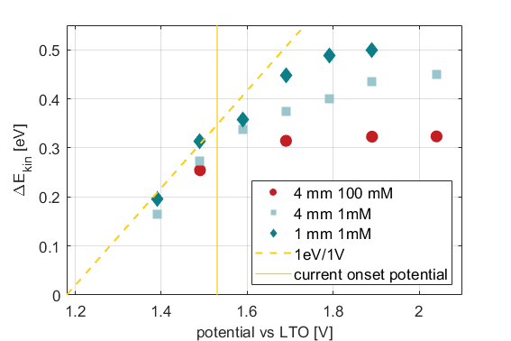
Operando studies of electrochemical systems promise valuable insights into the chemical reactions and physical processes that occur. X-ray photoelectron spectroscopy (XPS) offers chemical sensitivity but probes only a few nanometers into the sample, whereas electrochemical reactions occur at the solid-liquid interface. To access information at the interface, the dip-and-pull method is often used, in which a very thin film of liquid, often called a meniscus, is created on the sample surface.¹ Studies without any redox-active species show that the film can be electrochemically connected to the bulk electrolyte, but limitations arise when a faradaic reaction is present.^{2,3} Because ion transport is forced to proceed along the thin liquid film, mass transport limitations are the dominant factor controlling the electrochemistry within the meniscus.³
Figure 1: Double potential step experiment in a solution of 1 mM ferrocene. The applied potential (red line) should ideally overlap with the measured shift in XPS position (blue).
Figure 2: Measured shift in XPS position compared to the applied potential. The yellow dashed line indicates the expected shift resulting from the applied potential.
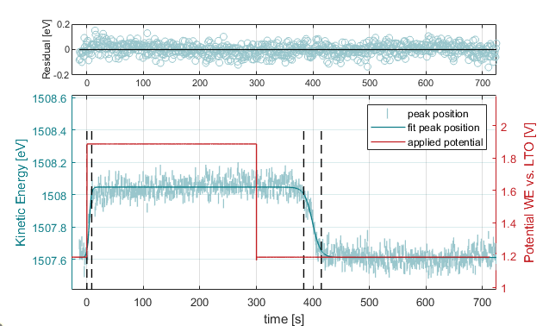
This study shows that the faradaic reaction occurs only, and to a limited extent, in the lowest part of the meniscus. Here, ferrocene is used as a redox-active species and is oxidized during a double-potential step, as shown in Figure 1. The electrochemical potential inside the meniscus is monitored via the C 1s spectrum of the electrolyte, where a 1 eV shift in the XPS spectrum indicates a change in the electrochemical potential of 1 V. We observe that the electrochemical potential in the liquid film is lower than set by the potentiostat (Figure 2), proving the presence of a large IR drop inside the meniscus. X-ray absorption spectroscopy shows no signal of oxidized ferrocene in the higher parts of the meniscus, confirming the lack of faradaic reaction in the meniscus.

1. Favaro, M. et al. Interface Science Using Ambient Pressure Hard X-ray Photoelectron Spectroscopy. Surfaces 2, 78–99 (2019).
2. Ali-Löytty, H. et al. Ambient-Pressure XPS Study of a Ni-Fe Electrocatalyst for the Oxygen Evolution Reaction. Journal of Physical Chemistry C 120, 2247–2253 (2016).
3. Križan, A. et al. Impact of Mass Transport on Meniscus Electrochemistry Determined by Time-Resolved Operando X-ray Photoelectron Spectroscopy. Physical Chemistry Chemical Physics 7456–7466 (2025).

