Graphene-Based Inks for Inkjet Printing and Direct Ink Writing of Electrochemical Devices
Vojtěch Kupka, Martin-Alex Nalepa, Jan Urbánek, Ivan Dědek, Petr Jakubec, David Panáček, Matěj Jendrišák, Michal Otyepka
Czech Advanced Technologies and Reseatch Institute (CATRIN), Palacký University Olomouc, Šlechtitelů 341/27, 779 00 Olomouc, Czech Republic
vojtech.kupka@upol.cz

Printed electronics offer a promising route for the fabrication of low-cost, scalable, and customizable electrochemical biosensors. This contribution presents recent advances in two printing techniques, namely inkjet printing and Direct Ink Writing (DIW). For both printing techniques, we employed graphene derivatives synthesized in-house, nitrogen-doped graphene acid (NGA) for inkjet printing and nitrogen-doped graphene (GN3) for Direct Ink Writing. The developed fabrication process enables the production of complete electrochemical sensors with reduced material consumption and manufacturing costs. The applicability of this approach is demonstrated by fully inkjet-printed sensors for dopamine and imidacloprid detection. In addition, DIW is introduced as a complementary additive manufacturing technique capable of processing highly viscous inks with high particle loading, enabling the fabrication of thick functional layers and three-dimensional electrode architectures, including microsupercapacitors. Together, inkjet printing and DIW provide versatile, and cost-effective tools for the next generation of printed electrochemical biosensors and energy storage devices.

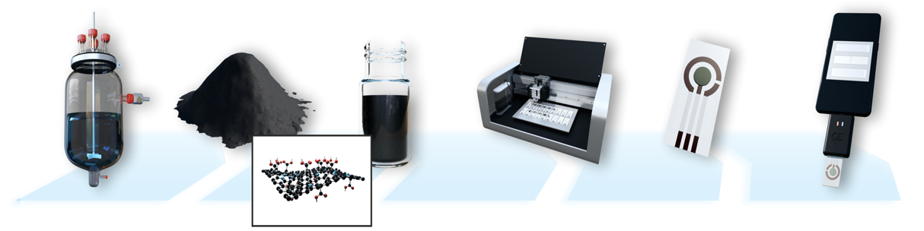
Fig.1: Schematic of the fabrication process for inkjet-printed biosensor electrodes in our laboratory: material synthesis, ink formulation, and biosensor printing.

