Determination of ionic spectra of different salts and their mixtures in an Electrical Double Layer (EDL) using new-ion electroscopic technique

Surbhi Dahiya, Ofer Manor
Technion-Israel Institute of Technology
Haifa, Israel.
19925surbhidahiya@gmail.com ; manoro@technion.ac.il

We study the dynamic properties of the electrolyte/glass surface which is vibrated by the MHz level surface acoustic wave (SAW) (as represented in Figure.1.). The mechanical wave introduced by the SAW actuator in the glass substate vibrates the ions in the nano-meter thick EDL. The leakage of the equilibrium EDL electrical field is studied for understanding the presence of the ions and their dynamic motion through the ionic spectra. The study has been focused on determining the ionic spectrum of salts such as sodium chloride (NaCl), magnesium sulphate (MgSO₄), sodium nitrate (NaNO₃), and their mixtures, as their electrolytic solution in water, placed above the Surface Acoustic Wave (SAW) device. The dynamic study involves vibrating the SAW device within the frequency range of 20-78MHz, to produce SAW wave over the solid surface where the electrolytic solution is placed. Different ionic strength solutions of the salts were prepared, and their ionic spectra within the frequency range from 20-78 MHz has been studied. The calculations incorporated the diffusion coefficient of the different ions (Na⁺, Cl⁻, NO₃⁻, Mg²⁺, SO₄²⁻, NH₄⁺), for estimating the relaxation time of EDL, which is nearly equal to the time-period of the SAW, therefore it a kind of an entanglement. The corresponding frequencies to the relaxation time of the EDL get reflected in the spectra of the ions. We calculate the resonance frequency of each ion in the salt using the diffusion coefficient, and the ionic strength of the salt.
In future, this study can help in understanding the spectra of the electrolytic organic salts and their mixtures in a comprehensive way.

Keywords: electrolyte, spectra, Surface Acoustic waves (SAW), diffusion coefficient, entanglement.

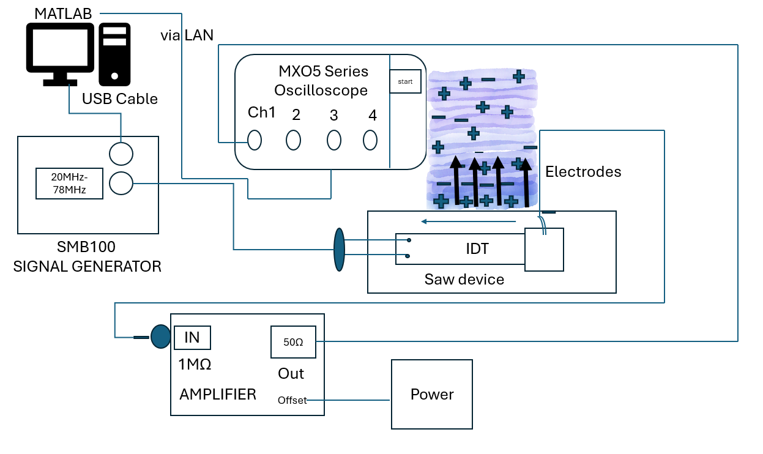

Figure.1. Representation of the setup for determining the ionic spectra of salts and their mixtures using ion-spectroscopy.

