Transient NiFe₂O₄/ZnO Heterojunction Interfaces for Mechanically and Optically Coupled Catalysis

Xinyu Jin¹, Chun-Yi Chen^{1,2}, Tomoyuki Kurioka^{1,2}, Gen Hikosaka^{1,2}, Masato Sone¹, Yung-Jung Hsu^{1,2,3},
Satoshi Okamoto^{1,2}, Tso-Fu Mark Chang^{1,2}
¹ Materials and Structures Laboratory, Institute of Integrated Research, Institute of Science Tokyo, Kanagawa 226-8503, Japan
² Sumitomo Chemical Next-Generation Eco-Friendly Devices Collaborative Research Cluster, Institute of Science Tokyo, Kanagawa 226-8503, Japan
³ Department of Materials Science and Engineering, National Yang Ming Chiao Tung University,
Hsinchu 300093, Taiwan
email：jin@ames.pi.titech.ac.jp

NiFe₂O₄/ZnO was developed as a dual-mode catalytic system to promote interfacial charge separation under mechanical and optical excitation. Pristine NiFe₂O₄ possesses an inverse spinel structure and is generally regarded as centrosymmetric, which limits its intrinsic piezoelectric response. In this work, synchrotron-based structural analysis indicates that the extremely high alkaline condition employed during the hydrothermal process modifies the local coordination environment and cation distribution within the ferrite framework. Such structural modulation can disturb the local symmetry of NiFe₂O₄ and facilitate mechanically induced polarization, enabling the ferrite to function as a piezo-responsive semiconductor while retaining its ferrimagnetic and optical characteristics. Among the prepared samples, the piezo-responsive NiFe₂O₄ (p-NFO) exhibited the strongest mechanically driven oxidation behavior, highlighting the importance of alkaline hydrothermal modulation in activating the piezocatalytic response.
To further enhance charge separation, ZnO was introduced as an intrinsic piezoelectric counterpart. As illustrated in Fig. 1(a), repeated particle collisions can generate transient p–n/type-II-like heterojunctions between the p-NFO and ZnO, promoting electron transfer toward ZnO and hole retention in p-NFO. Under UV-filtered simulated solar irradiation, the p-NFO/ZnO mixed system outperformed either individual component, suggesting that ZnO mainly functions as a dynamic interfacial charge-separation partner rather than an independent UV-driven photocatalyst. The mixed system also exhibited excellent cycling stability over repeated runs. These findings demonstrate that alkaline hydrothermal modulation combined with transient interfacial heterojunction engineering provides an effective strategy for enhancing dual-mode semiconductor catalysis through coupled mechanical and optical activation.
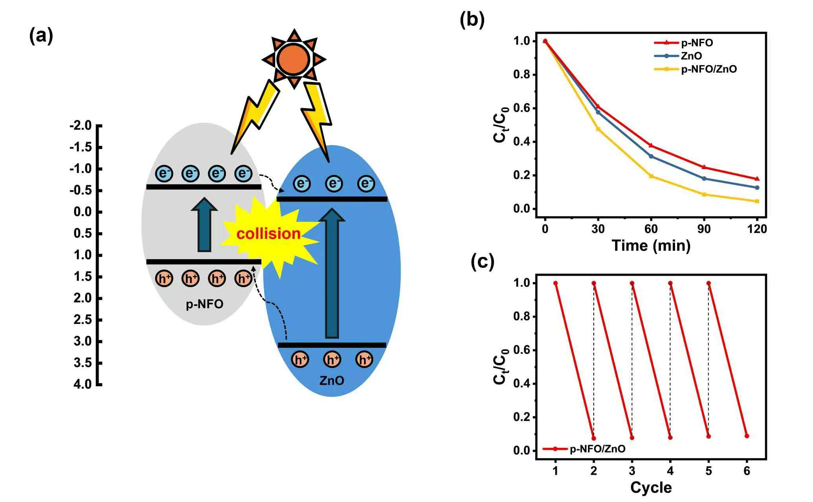
Figure 1. (a) Dual-mode charge separation in the p-NFO/ZnO system. (b) Oxidation performance under UV-filtered simulated sunlight. (c) Cycling stability of the p-NFO/ZnO system.

