Evaluating the Influence of Applied Potential on Sensor Biofouling and Subsequent Performance: A Combined CV, EIS, and EQCM-D Study

Naela Delmo¹, Anna Igual-Muñoz², and Emilia Peltola¹
¹Department of Mechanical and Materials Engineering, Faculty of Technology, University of Turku, 20500 Turku, Finland
²Tribology and Interfacial Chemistry Group, École Polytechnique Fédérale de Lausanne, CH-1015 Lausanne, Switzerland
naela.v.delmo@utu.fi

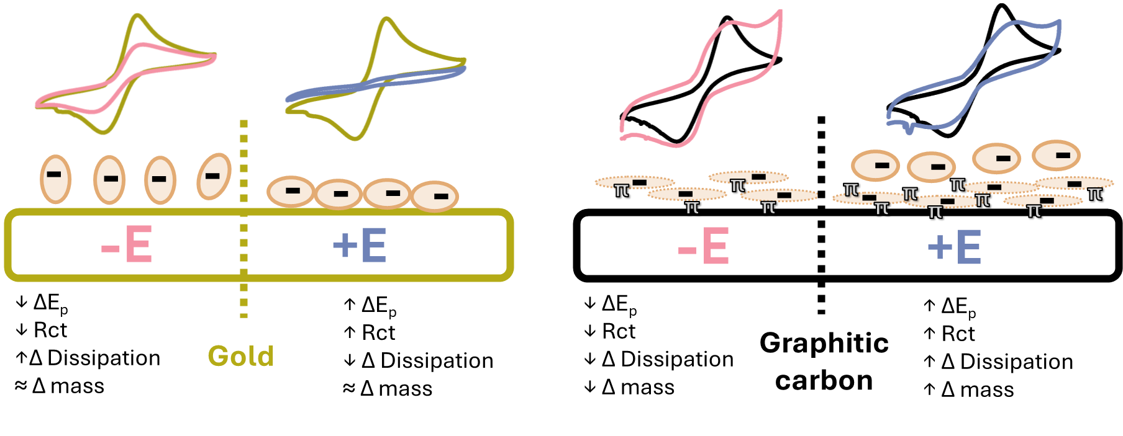
Electrochemical sensors for health monitoring in the form of implantable or wearable devices rely on continuous in vivo measurements. However, the non-specific binding of fouling agents such as proteins onto the sensor surface remains a critical challenge that hinders real-world applications [1]. Extensive efforts have been made towards antifouling strategies like coatings; but electrochemical control presents a dynamic yet under-explored approach to study and modulate biofouling, especially when protein-surface interactions are found to be affected by electric potential [2]. Moreover, because inner-sphere (ISR) and outer-sphere redox (OSR) probes respond differently to biofouling [3], fine-tuning protein adsorption relative to the analyte electron transfer mechanism offers a step towards more robust sensors. Here, we systematically investigate the effect of applied positive (+E) or negative (-E) potential during the adsorption of the negatively charged bovine serum albumin (BSA) at physiological conditions on gold and graphitic carbon surfaces. Cyclic voltammetry demonstrated greater peak-to-peak separation ΔE_{p} at +E fouling conditions than at -E. The electrostatic effect was most pronounced on surface sensitive [Fe (CN)₆]^{3-/4-} and dopamine ISR probes compared to the [Ru (NH₃)₆]^{2+/3+} OSR. In line with this, electrochemical impedance spectroscopy (EIS) revealed larger charge transfer resistance in SPEs fouled at +E, indicating slower kinetics compared to BSA fouling at -E. Lastly, electrochemical quartz crystal microbalance with dissipation monitoring (EQCM-D) showed that the applied potential affects not only the amount but also the arrangement and conformation behavior of adsorbed BSA. Collectively, these results provide insights on how electrochemical techniques can be used to both control and characterize protein adsorption. We use this information to propose a model for BSA adsorption on electrified surfaces.

[1] Rivera, P., Della Pelle, F., Stonyte, J., CMA De Melo W, Abouhagger, A., and Pauliukaite, Rasa. 2025. “Overcoming Challenges in Electrochemical Sensing: Toward Continuous Monitoring.” ACS Sensors 10 (12): 9183–202. https://doi.org/10.1021/acssensors.5c02717.

[2] Benavidez, TE., and Garcia, CD. 2013. “Potential-Assisted Adsorption of Bovine Serum Albumin onto Optically Transparent Carbon Electrodes.” Langmuir 29 (46): 14154–62. https://doi.org/10.1021/la4029657.

[3] Peltola, E., Aarva A., Sainio S., et al. ‘Biofouling Affects the Redox Kinetics of Outer and Inner Sphere Probes on Carbon Surfaces Drastically Differently – Implications to Biosensing’. Physical Chemistry Chemical Physics 22, no. 29 (2020): 16630–40. https://doi.org/10.1039/D0CP02251A.

