Title: Laser Induced Graphene based Flexible Zn-Ion Hybrid Energy Storage Devices
Sameen Anwar, Pawel Jakóbczyk, Abel, Stranak, Robert Bogdanowicz

¹ Department of Metrology and Optoelectronics, Faculty of Electronics, Telecommunications, and Informatics, Gdańsk University of Technology, 11/12 Narutowicza St., 80-233, Gdańsk, Poland
² University of South Bohemia, Institute of Physics, Branisovska 1760, 370 05, Ceske Budejovice, Czech Republic

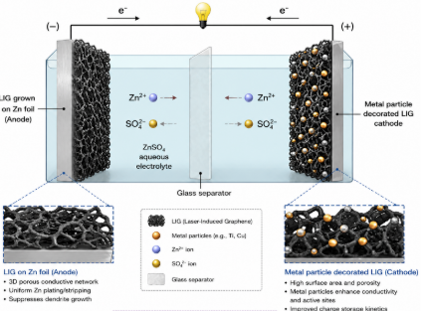
Abstract: Flexible energy storage devices are increasingly important for next-generation wearable and portable electronics, where mechanical flexibility, safety, and electrochemical stability are critical requirements [1]. Zinc-ion hybrid supercapacitors (ZIHSCs) have emerged as promising candidates due to the intrinsic safety, low cost, and aqueous electrolyte compatibility of zinc-based systems. In this work, we aim to bridge the power and energy density gap by merging the high energy density of battery-type anodes with capacitor-type cathodes[2]. A LIG-coated zinc anode (LIG@Zn) was employed to regulate Zn plating/stripping behavior and improve interfacial stability, while LIG cathodes functionalized with Ti based complexes were explored to enhance electrochemical activity and interfacial charge-transfer characteristics[3]. The porous conductive LIG framework provides a high surface area, efficient electron transport pathways, and favorable electrolyte accessibility, making it a suitable platform for hybrid energy storage applications. Electrochemical characterization, including cyclic voltammetry, electrochemical impedance spectroscopy, and galvanostatic cycling, was performed to evaluate the influence of surface functionalization on electrode behavior. The fabricated device demonstrated enhanced electrochemical performance with improved charge-transfer kinetics and reduced interfacial resistance after Ti-based functionalization. The LIG@Zn anode exhibited stable Zn plating/stripping behavior, while the hybrid system maintained good capacitive response and cycling stability under repeated operation.
*Image created using ChatGPT open AI

References:
1- Li, H., Ma, L., Han, C., Wang, Z., Liu, Z., Tang, Z., & Zhi, C. (2019). Advanced rechargeable zinc-based batteries: Recent progress and future perspectives. Nano Energy, 62, 550–587
2- Javed, M. S., Asim, S., Najam, T., Khalid, M., Hussain, I., Ahmad, A., Assiri, M. A., & Han, W. (2023). Recent progress in flexible Zn-ion hybrid supercapacitors: Fundamentals, fabrication designs, and applications. Carbon Energy, 5(1), e271.
2- Ji, Y., Xu, W., Wu, Z., Peng, M., Wang, F., Zhang, X., Chen, A., & Du, J. (2026). Advanced carbon-based electrodes for zinc-ion hybrid supercapacitors enhanced by heteroatom doping. Communications Materials, 7, 103.

