Through X-ray Eyes: Multi-technique Operando Synchrotron Studies of Nanoparticle Electrocatalysts

Rebecca K. Pittkowski
Department of Chemistry, University of Copenhagen
Universitetsparken 5, 2100 Copenhagen, Denmark
Rebecca.pittkowski@chem.ku.dk

Electrocatalysis plays a major role in energy conversion technologies such as electrolyzers and fuel cells. Small nanoparticles, typically less than 10 nm in size, provide a high surface-to-bulk-atom ratio, which is crucial for efficient utilization of the catalyst material, often based on scarce precious metals like Pt[1] and Ir.[2]
However, these small nanoparticles frequently suffer from instability in electrochemical environments, and the underlying degradation mechanisms and structural rearrangements are, so far, not fully understood.[3] In this context, synchrotron X-ray techniques are valuable tools for unraveling the catalyst's structural changes during operation. In-situ and operando experiments enable us to monitor the evolution of atomic structures. With small-angle X-ray scattering (SAXS), changes in size and morphology can be tracked [1] while X-ray total scattering with PDF analysis provides insights into the atomic structure[2], as illustrated in Fig.1
This can provide valuable information on the mechanisms that dominate catalyst degradation and help devise new strategies for stability optimization. I will focus on the strengths and limitations of the different operando scattering techniques, SAXS, XRD, and X-ray total scattering, and how they can be combined with X-ray absorption spectroscopy (XAS). This integration offers a complete picture of the catalyst structure at applied potentials, which is fundamental for establishing structure-property relations.
To allow for high-quality X-ray scattering operando studies under high current densities, we have designed a new operando gas diffusion electrode (GDE) cell, allowing the collection of PDF, XRD, and SAXS data for both gas-consuming and gas-evolving reactions in acid and alkaline media[4].
Through the use of combined X-ray scattering techniques, structural information can be obtained across length scales for electrocatalysts of high interest for energy applications, including Pt/C stability in accelerated stress tests as ORR catalysts, as well as oxygen evolution reaction on Ir and NiFe state-of-the-art electrocatalysts [1], [2], [5].

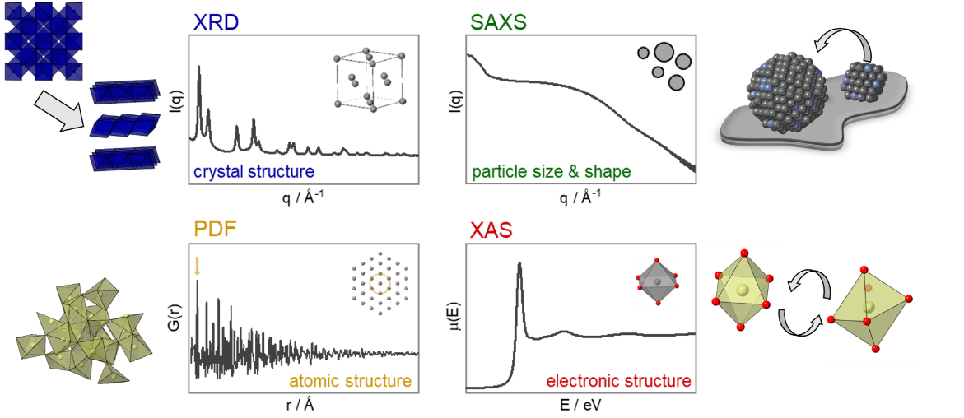
Figure 1. Toolbox of X-ray techniques used for the operando characterization of electrocatalysts for energy conversion reactions, with corresponding relevant restructuring mechanisms that can be probed.

[1] J. Schroeder, R. K. Pittkowski et al. ACS Catalysis (2022). 12, 2077-2085.

[2] R. K. Pittkowski et al. J. Am. Chem. Soc. (2024). 146,27517-27527.

[3] R.K. Pittkowski, ChemElectroChem. (2024). e202400171

[4] G.K.H. Wiberg, R.K.Pittkowski et al. Chimia. (2024). 78, 344-348.

[5] O. Aalling-Frederiksen et al. Small (2025) 21, 2411211.

