Revisiting the Glassy Carbon Electrified Interface: Unraveling Conductive Phase Growth in Oxyanion Media

Jorge Martínez Guerra*^{(a)}, Manuel Eduardo Palomar Pardavé^{(a)}, María Teresa Ramírez Silva^{(b)}, Alberto Rojas Hernández^{(b)}.

ª Universidad Autónoma Metropolitana-Azcapotzalco, Departamento de Materiales, Av. San Pablo 420, Colonia Nueva el Rosario, Alcaldía Azcapotzalco, Ciudad de México 02128, México.
^{b} Universidad Autónoma Metropolitana-Iztapalapa, Área de Química Analítica, Av. Ferrocarril San Rafael Atlixco #186, Colonia Leyes de Reforma 1A Sección, Ciudad de México 09310, México.
e-mail: jguerra_fq90@outlook.com

The glassy carbon electrode (GCE) is a primary substrate in the design of electrocatalytic platforms. Despite its widespread use, the physicochemical dynamics of its electrical double layer at high anodic overpotentials (> 1.0 V vs. Ag/AgCl) remain a subject of mechanistic controversy. Recently, several reports in the literature have attributed the appearance of progressive current growth upon successive potential cycling—characterized by anodic signals at ~1.5 V and cathodic signals in the range of -0.5 V to -1.0 V—to the purported electropolymerization of non-electroactive organic molecules, such as β-cyclodextrin (β-CD) in PBS 0.05 mol L⁻¹ (pH = 5.0) [1].

In the present work, this paradigm is critically re-evaluated through the continuous electrochemical monitoring of the GCE/electrolyte interface. Using cyclic voltammetry (CV) and chronoamperometry (CA), the substrate's response was characterized in strictly oxyanionic aqueous media (perchloric acid in different concentrations), contrasting the system against a rigorous blank. The results conclusively demonstrate that the voltammetric footprint of the pseudo-polymeric conductive phase development occurs intrinsically on the bare carbon surface, in the total absence of β-cyclodextrin or any other organic monomer. Furthermore, the profile of the chronoamperometric transients indicates a kinetic mechanism of three-dimensional nucleation and growth of new phases, highly dependent on the oxyanion medium, which will be further corroborated through dimensionless mathematical modeling. The findings of this work highlight the imperative need to re-evaluate and deeply study the thermodynamic and kinetic phenomena at the native interface before attributing the growth of new phases to species in solution. To consolidate a comprehensive mechanistic framework, complementary surface characterization studies using scanning electron microscopy (SEM) and X-ray photoelectron spectroscopy (XPS) are currently underway. Ultimately, a precise understanding of these electrical double-layer phenomena is paramount not only for interfacial monitoring, but for optimizing charge transfer mechanisms and tailoring next-generation energy storage systems, such as redox flow batteries and pseudocapacitive devices.
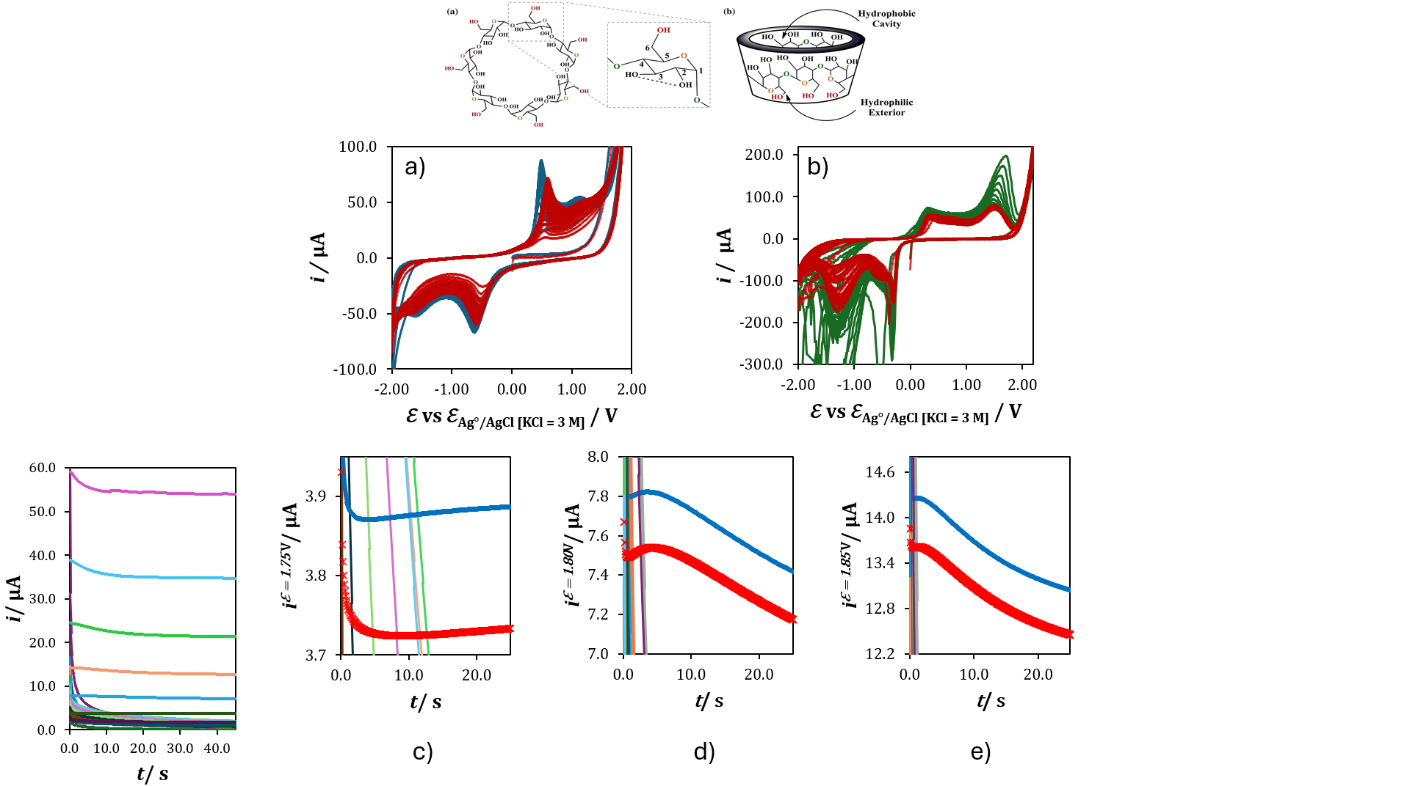

Figure 1. (a) Voltammetric profiles of 0.01 M PBS, pH = 7 (blue lines) and 0.01 M PBS + 6 mM β-CD, pH = 7 (red lines), (b) Voltammetric profiles of 0.1 M HClO₄, pH = 2 (green lines) and 0.1 M HClO₄ + 6 mM β-CD, pH = 2 (red lines). (c), (d) and (e) correspond to chronoamperometric transients in 0.1 M HClO₄, pH = 2 (blue lines) and 0.1 M HClO₄ + 6 mM β-CD, pH = 2 (red markers) at 1.75 V, 1.80 V and 1.85 V, respectively.

[1] Pereira, A.C., Oliveira, A.E.F. & Bettio, G.B. β-Cyclodextrin electropolymerization: mechanism, electrochemical behavior, and optimization. Chem. Pap. 73, 1795–1804 (2019). https://doi.org/10.1007/s11696-019-00732-x

