Linker-Free Electrochemical Detection of Salivary Immunoglobulins Using Single-Atom Iron Biointerfaces

Ivan Dědekª, Petr Jakubec^{a,*} David Panáčekª, Milan Raška^{c}, Leona Rašková^{c}, Radek Zbořilª, Michal Otyepka^{a, b,*}

ªRegional Centre of Advanced Technologies and Materials, Czech Advanced Technology and Research Institute (CATRIN), Palacký University Olomouc, Šlechtitelů 27, Olomouc 783 71, Czech Republic
^{b}IT4Innovations, VSB – Technical University of Ostrava, 17. listopadu 2172/15, Ostrava-Poruba 708 00, Czech Republic
^{c}Department of Immunology, Faculty of Medicine and Dentistry, Palacky University Olomouc, Hnevotinska 3, 779 00, Olomouc, Czech Republic

e-mail address: ivan.dedek@upol.cz

We present a linker-free biosensing approach based on single-atom coordination chemistry. While our previous graphene-based biosensors relied on EDC/NHS coupling, the present approach eliminates this linker chemistry and uses direct interaction between immunoglobulin A (IgA) and single-atom Fe centres.¹ The sensor uses iron single atoms attached to nitrogen-doped graphene acid (NGA-Fe), which acts as an active surface for biomolecule recognition. Unlike conventional methods that require EDC/NHS coupling or other bioconjugation steps, the iron centers interact directly with IgA and produce a measurable electrochemical signal. This platform enables rapid detection of salivary IgA within physiologically relevant concentration ranges. In both simulated and real saliva samples, NGA-Fe can distinguish healthy immunoglobulin levels from elevated levels using a simple workflow that takes less than 2 hours. Overall, this work shows that single-atom materials can serve as a new type of synthetic biointerface for simple and practical electrochemical biosensing. *
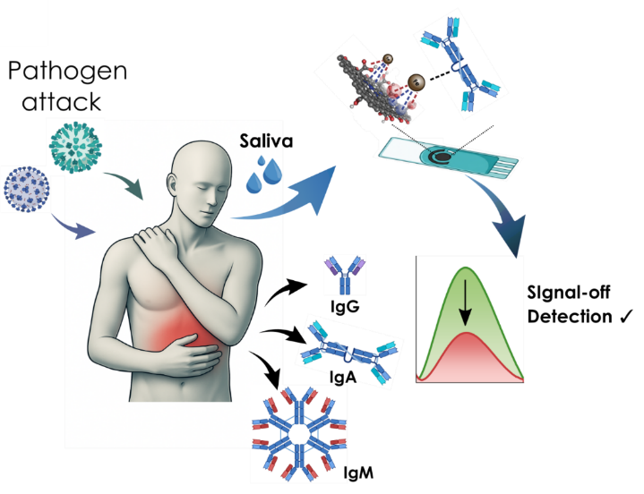

* This work is based on an unpublished manuscript currently in preparation; the presented data and graphical material should therefore be treated as confidential and not distributed further without the authors’ permission.
1. Dědek, I. et al. High-sensitivity EPCR detection using a G-Arg nanointerface: A new electrochemical platform targeting TNBC biomarkers. Sensing and Bio-Sensing Research 52, 101017 (2026).

