Ferrocene modified MIPs for (redox probe)-free electrochemical sensing

Patrycja Łach,ª Jakub Kalecki,ª Maciej Cieplak,^{a,}* Krzysztof Noworyta,ª Wojciech Nogala,ª Francis D'Souza,^{b} Wlodzimierz Kutner,ª and Piyush Sindhu Sharma^{a,}*
¹Institute of Physical Chemistry, Polish Academy of Sciences, Kasprzaka 44/52, 01-224, Warszawa, Poland
²Department of Chemistry, University of North Texas, 1155 Union Circle No. 305070, Denton, TX 76203-5017, USA
*mcieplak@ichf.edu.pl

Molecularly imprinted polymers (MIPs) are bio-mimicking recognizing materials used for sensors fabrication [1, 2]. Analytical parameters of these chemosensors, such as sensitivity, selectivity, and detectability, are almost as high as those of biosensors. MIP-based chemosensors are superior concerning their ease of fabrication, durability, and tolerance to harsh experimental conditions, including elevated or decreased temperature, high ionic strength, extreme pH values, the presence of heavy metal ions and organic solvents. Therefore, MIP-based chemosensors found numerous applications in environmental analysis [3], food quality control [4] and clinical analysis [5].
For the electrochemical determination of non-electroactive analytes, some external redox probe is usually added to the test solution [6, 7]. In our works we have proven that it is possible to immobilize redox probe inside of the MIPs’ polymer matrix by co-polymerization of monomers containing ferrocene groups [8, 9], or to introduce ferrocene moieties into MIP molecular cavities via post-imprinting modification [10]. Obtained redox active MIPs’ were characterized with electrochemical methods, including, cyclic voltammetry, differential pulse voltammetry, electrochemical impedance spectroscopy, scanning electrochemical microscopy and capacitive impedimetry as well as E-QCM (quartz-crystal microbalance) and E-SPR (surface plasmon resonance spectrometry).
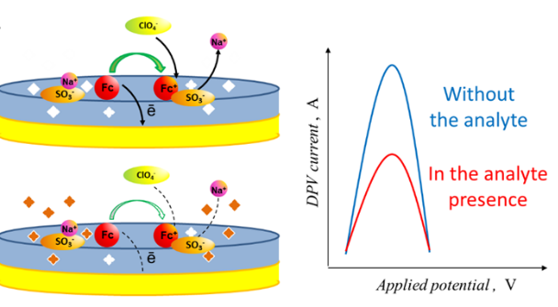
Figure 1. Application of ferrocene containing MIP in chemosensing.

Acknowledgments: The financial support from the National Science Centre, Poland Project No. 2022/47/B/ST5/02337 is acknowledged.
References
[1] P.S. Sharma, Z. Iskierko, A. et al., Electrochem. Commun. 50 (2015) 81.
[2] L. Chen, X. Wang, et al., Chem. Soc. Rev. 45 (2016) 2137.
[3] P. Rebelo, E. Costa-Rama, et al., Biosens. Bioelectron. 172 (2021) 112719.
[4] J. Ashley, M.-A. Shahbazi, et al., Biosens. Bioelectron. 91 (2017) 606.
[5] M. Feroz, P. Vadgama, Electroanalysis 32 (2020) 2361.
[6] Y. Yoshimi, A. Narimatsu, et al., J. Artif. Organs 12 (2009) 264.
[7] P.S. Sharma, A. Garcia-Cruz, et al., Curr. Opin. Electrochem. 16 (2019) 50.
[8] P. Lach, M. Cieplak, et al., Sens. Actuators B Chem. 344 (2021) 130276.
[9] P. Lach, A. Garcia-Cruz, et al., Biosens. Bioelectron. 236 (2023) 115381.
[10] J. Kalecki, M. Cieplak, et al., J. Mat. Chem. B 11 (2023) 1659.

