A strange case of Scott’s test and cocaine detection – when electrochemistry at liquid-liquid interface meets colorimetric assay

Grzegorz Kowalski^{1,2}, Karolina Kwaczyński¹, Grégoire Herzog³, Lukasz Poltorak¹
¹E@SI Team, Faculty of Chemistry, Univeristy of Lodz, Tamka 12, 91-403 Lodz, Poland
²BioMedChem Doctoral School of University of Lodz and Lodz Institutes of Polish Academy of Science, Matejki 21/23, 90-237 Lodz, Poland
³Université de Lorraine, CNRS, LCPME, F-54000 Nancy, France
grzegorz.kowalski@edu.uni.lodz.pl

One of the simplest methods frequently used for presumptive detection of cocaine (Fig. 1A) is Scott’s test. This assay utilizes two immiscible liquids: (i) acidic aqueous solution typically being 2% cobalt(II) thiocyanate Co(SCN)₂ solution, frequently mixed with glycerol in 1:1 ratio, and (ii) an organic phase being solvent immiscible with water (typically chloroform or other chlorinated solvent). In the presence of cocaine in the aqueous solution, an ionic pair is formed between two cocaine cations and [Co(SCN)4]²⁻ anion, which then partitions into the adjacent organic phase, ultimately producing a characteristic blue color (Fig. 1B). However, it is known for long time that other drugs frequently found in seized cocaine street samples, such as lidocaine, hydroxyzine or diltiazem [1] can generate false-positive readings, thus compromising the utility of the assay in real-life scenarios. Consequently, the development of modified methodologies capable of mitigating false-positive results remains an active area of research.

The presented study describes an attempt to perform the classical Scott’s using the electrified liquid-liquid interface as in the presence of the interfacial polarization ions can be transferred from one phase to another [2]. The aim was to combine colorimetric information with the electroanalytical resolution. Initial studies relied on available drug – lidocaine, due to its known ability to produce a false positive Scott test result. Following a series of countless control experiments (yielding rather unexpected results) focused on meticulous assessment of the role of aqueous and organic phase components, we have drafted very interesting results that will be presented during this presentation. Ultimately, electrochemical Scott’s test allowed for the extension of the system linear dynamic range, and can serve as the dual response analytical platform.

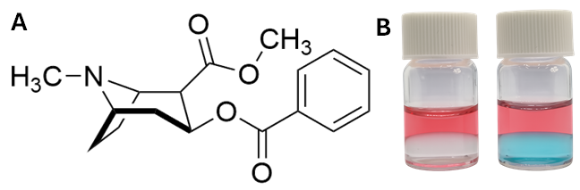
Figure 1. (A) Chemical structure of cocaine. (B) Negative (left) and positive (right) reading of the Scott’s test.

The authors are grateful to National Science Centre—Poland, for financing this work (project number UMO-2022/47/D/ST5/02523).

[1] A. Żubrycka, A. Kwaśnica, M. Haczkiewicz, K. Sipa, K. Rudnicki, S. Skrzypek, L. Poltorak, Talanta 237 (2022), 122904
[2] P. Borgul, K. Sobczak, M. Rizwan, G. Kowalski, M. Poltorak, P. Banatkiewicz, I. Walecka, K. Rudnicki, S. Skrzypek, L. Poltorak, Sensors and Actuators B: Chemical 414 (2024), 135895

