Investigation of Pd/Ni-Coated Titanium Felt Electrodes for Unitized Regenerative Fuel Cell Applications

Hung-Hao Liao¹, Yong-Ming Dai², Kai-Wei Chan³, Yean-Der Kuan^{4, 5*}
¹ Department of Refrigeration, Air Conditioning and Energy Engineering,
National Chin-Yi University of Technology, Taichung 411030, Taiwan
² Department of Chemical and Materials Engineering,
National Chin-Yi University of Technology, Taichung 411030, Taiwan
³ Ph.D. Program, Graduate Institute of Precision Manufacturing,
National Chin-Yi University of Technology, Taichung 411030, Taiwan
⁴ Graduate Institute of Precision Manufacturing,
National Chin-Yi University of Technology, Taichung 411030, Taiwan
⁵ Hydrogen and Fuel Cells Sustainable Development Center,
National Chin-Yi University of Technology, Taichung 411030, Taiwan
*Corresponding author: ydkuan@ncut.edu.tw

In recent years, Proton Exchange Membrane Unitized Regenerative Fuel Cell (PEM-URFC) have attracted considerable attention due to their ability to integrate energy conversion and energy storage systems. However, conventional PEM-URFC mainly rely on precious metal catalysts such as Pt, resulting in high system costs and limiting large-scale applications. Therefore, this study aims to reduce the usage of precious metals by employing a bimetallic catalyst approach to improve the electrochemical performance of electrode materials. Pd/Ni was selected as the bimetallic catalyst due to the excellent electrocatalytic activity of Pd and the ability of Ni to enhance electrical conductivity and water electrolysis performance. In this study, a polyol reduction method was employed to coat 1:1 Pd/Ni bimetallic catalysts with different weight percentages onto titanium felt substrates for PEM-URFC electrode applications. The prepared samples consisted of 10wt%, 20wt%, 30wt%, and 40wt% Pd/Ni-coated titanium felt electrodes. Fuel cell performance tests and water electrolysis hydrogen production tests were conducted. In addition, scanning electron microscopy (SEM) and X-ray diffraction (XRD) analyses were performed to investigate the surface morphology and material characteristics of the electrodes. The experimental results showed that the 10wt% Pd/Ni-coated sample exhibited the best electrochemical performance under both fuel cell and electrolysis modes. The 10wt% sample also exhibited the highest power density among all samples. SEM analysis revealed that the 10wt% sample possessed a more uniform catalyst distribution and preserved the original porous structure of the titanium felt, which facilitated reactant transport and water management. SEM analysis revealed that the 10wt% sample possessed a more uniform catalyst distribution and caused less influence on the original porous structure of the titanium felt, which facilitated reactant transport and water management. In contrast, increasing the catalyst loading to 30wt% and 40wt% resulted in particle agglomeration and pore blockage, leading to reduced mass transfer capability and consequently decreased hydrogen production and overall electrochemical performance. Furthermore, XRD analysis confirmed the successful deposition of Pd and Ni phases on the titanium felt substrate.
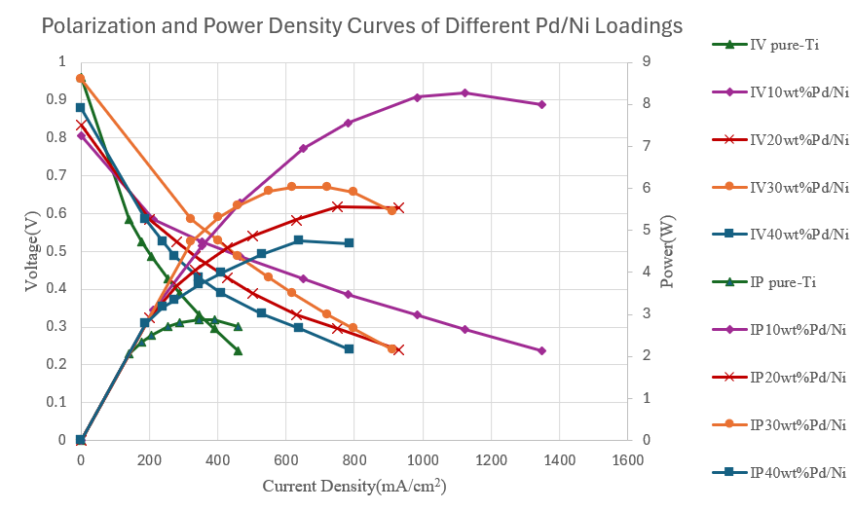
Figure 1. Polarization and power density curves of Pd/Ni-coated titanium felt electrodes with different catalyst loadings.

Acknowledgment
This research was successfully completed thanks to the financial and technical support from the National Science and Technology Council Project 114-2221-E-167 -020 -MY3.

