Integrated in situ Analyses of Valence Changes and Structural Transformation in Anodized Fe-Co-Ni Spinel Oxide Electrocatalysts

Tomoya Nagao¹, Sho Kitano², Takeharu Sugiyama³, Toshio Ishioka⁴, Mana Iwai², Koji Fushimi²,
Hiroki Habazaki²
¹Graduate School of Chemical Sciences and Engineering, Hokkaido University;
²Division of Applied Chemistry, Faculty of Engineering, Hokkaido University,
Sapporo, Hokkaido 060-8628, Japan
³Research Center for Synchrotron Light Applications, Kyushu University;
⁴Department of Advanced Materials Science and Engineering, Faculty of Engineering Sciences, Kyushu University, Kasuga, Fukuoka 816-8580, Japan
nagao.tomoya.d4@elms.hokudai.ac.jp
- Introduction
Alkaline water electrolysis is a promising technology for green hydrogen production, but it is limited by the sluggish kinetics and high overpotential of the oxygen evolution reaction (OER). Fe-Co-Ni-based spinel oxides exhibit high OER activity in alkaline media, and their structural transformation into metal oxyhydroxides under anodic polarization has been reported. However, the relationship among structural transformation, metal valence changes, and OER activity remains unclear. Conventional spinel oxide catalysts form a core-shell configuration consisting of an outer metal oxyhydroxide and a residual spinel oxide during OER. This coexistence obscures the relationship between structural and electronic changes, even when in situ measurements are applied. To address this issue, we focused on an OER electrocatalyst prepared by anodizing (ECPA) [1]. The ECPA film consists of low-crystallinity Fe-Co-Ni spinel oxides, enabling potential-dependent reconstruction to be tracked with limited interference from residual spinel oxides. In this study, we applied in situ Raman spectroscopy, in situ XRD, and in situ XAFS to the ECPA film to clarify the relationship among structural transformation, metal valence changes, and OER activity.
- Experimental
A Kovar alloy (Fe-16.3 wt% Co-29.7 wt% Ni) substrate was anodized at 10 V for 60 min in ethylene-glycol electrolyte containing 0.54 M NH₄F and 2.5 M H₂O. The anodized metal fluoride precursor was electrochemically activated by cyclic voltammetry in 1.0 M KOH to obtain the ECPA film. Potential-dependent structural and metal valence changes in the ECPA film during OER were investigated in 1.0 M KOH using in situ Raman spectroscopy, in situ XRD, and in situ XAFS.
- Results and Discussion
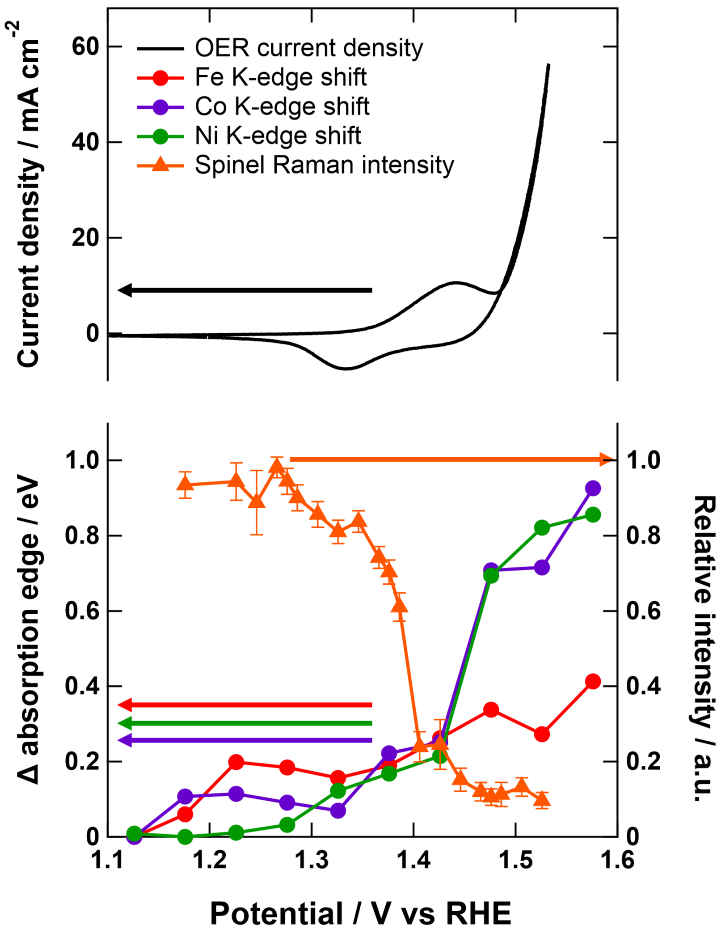
In situ Raman spectroscopy revealed the reversible transformation of spinel oxides in the ECPA film into γ-Ni_{1-x-y}Fe_{x}Co_{y}OOH, which functions as the OER-active phase under applied potentials. The Raman peak at 690 cm⁻¹, assigned to tetrahedral metal–oxygen vibrations in spinel oxides, decreased with increasing potential, whereas the peaks at 474 and 554 cm⁻¹, characteristic of γ-Ni_{1-x-y}Fe_{x}Co_{y}OOH, appeared and increased. In situ XRD revealed that the transformed γ-Ni_{1-x-y}Fe_{x}Co_{y}OOH was structurally distinct from conventional layered metal oxyhydroxides. A broad diffraction feature corresponding to in-plane ordering of edge-sharing octahedral sites was observed, whereas the diffraction peak associated with layered stacking was absent, indicating the formation of non-layered γ-Ni_{1-x-y}Fe_{x}Co_{y}OOH. Figure 1 shows the correlations among the OER current, the in situ Raman intensity of the spinel oxide peak, and the in situ XANES absorption edge positions. The Ni and Co K-edge positions shifted to higher energy as the spinel oxide Raman peak decreased, indicating that the oxidation of Ni²⁺ to Ni³⁺ and Co²⁺ to Co³⁺ drives the structural transformation into non-layered γ-Ni_{1-x-y}Fe_{x}Co_{y}OOH. At higher potentials, further oxidation of Ni and Co beyond their trivalent states correlated with the increase in OER current, indicating that Ni and Co act as OER-active sites. In contrast, Fe showed no comparable correlation with the OER current, suggesting that Fe likely stabilizes the γ-Ni_{1-x-y}Fe_{x}Co_{y}OOH structure.
Fig. 1. Correlation among OER current density, metal K-edge shifts, and spinel Raman intensity in the ECPA film during OER.
- Reference
[1] X. Zetao et al., Electrochim. Acta, 491, 1 (2024).

