Electrochemical impedance spectroscopy (EIS) coupled with distribution of relaxation times (DRT) analysis of fuel cells operating on alternative fuels

M. Dominów¹, J.Zdankiewicz¹, K.Kujawska¹, P. Błaszczak², A. Ducka¹, Y.L. Liao³, S.F. Wang³, B.Bochentyn², J.Karczewski¹, P.Jasiński²
¹Faculty of Applied Physics and Mathematics, Gdańsk University of Technology, Gdańsk, Poland
²Faculty of Electronics, Telecommunications and Informatics, Gdańsk University of Technology, Gdańsk, Poland
³National Taipei University of Technology, Taipei, Taiwan
michal.dominow@pg.edu.pl

Waste treatment, particularly of non-recyclable polymers and biogas mixtures, remains a subject of significant scientific and industrial interest [1]. Various approaches have been proposed to address this challenges, including biotechnological, photocatalytic, reforming and pyrolytic processes aimed at recycling/upcycling or decomposing such materials. In consequence, a significant amount of gases such as hydrogen, carbon dioxide, carbon monoxide and hydrocarbons may is produced. In this work possibility of using these specific gas mixtures (obtained from sources as polypropylene pyrolysis, or based on water waste treatment plants outlet biogas) directly as fuels for solid oxide fuel cells (SOFCs) will be examined. This allows to skip entirely pre-reforming stage, leading to interesting developments and cheaper operation. But to ensure process scalability and industrial viability, development of more efficient catalytic layers is required, and methods of accurate analysis of such layers during operation.
It is, however, a material design challenge, when SOFC works in a direct internal reforming (DIR-SOFC) configuration. Based on the materials and pyrolytic gas compositions previously investigated in our team, various combinations of fuel cell modifications and inlet gas compositions were tested. To achieve abovementioned goal the electrochemical impedance spectroscopy (EIS) was employed in various stages of cell operation (in hydrogen and after prolonged feeding with specific fuel mixture). To pinpoint exact electrochemical process number in each case distribution of relaxation times (DRT) analysis was employed. Exemplary comparison of such analyses between a conventional cell and one modified by deposition of additional (La_{0.3}Sr_{0.6}Ce_{0.1})_{0.9}Co_{0.1}Ti_{0.9}O_{3−δ} anode catalytic layer (both operating in 60% CH₄ 40% CO₂) is shown on Fig. 1 [2]. Such approach revealed non-trivial behavior and impact of applied layer on the reference cell.
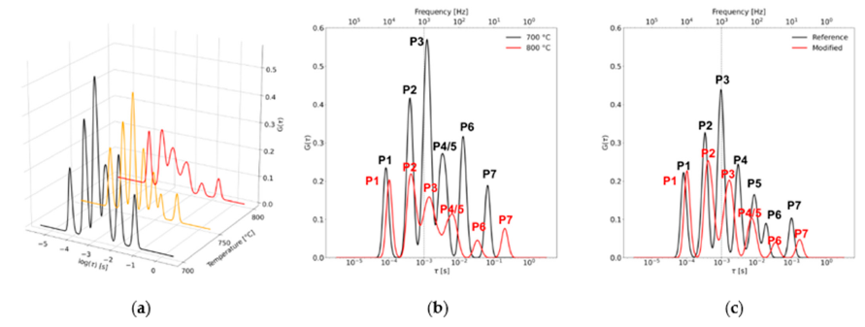
Fig. 1. DRT spectra of investigated cells in the temperature regime: (a) reference cell, temperature
comparison (where black, yellow and red line correspond to 700 ◦C, 750 ◦C and 800 ◦C, respectively),
(b) reference cell, 700 ◦C (black line) and 800 ◦C (red line) juxtaposition, (c) reference (black line)
and modified (red line) spectra obtained for 750 ◦C [2].

References
[1] Mishra, R. et al. Unveiling the potential of pyrolysis-gasification for hydrogen-rich syngas production from biomass and plastic waste. Energy Conversion and Management, 2024.
[2] Kujawska, K., et al., Surface Modification of Ni-YSZ Anodes with a Cobalt NPs-Exsolving Perovskite Layer to Improve the Stability of Biogas-Fed SOFC. Catalysts, 2026

