Ion transfer at an organogel|water µITIES – insights from combination with ex situ confocal microscopy

Martin Jönsson-Niedziółka¹, Julia Maciejewska-Komorowska¹, Angelika Holzinger¹,
Damien W. M. Arrigan²
¹ Institute of Physical Chemistry, Polish Academy of Sciences, Kasprzaka 44/52, 01-224 Warsaw, Poland
² School of Molecular and Life Sciences, Curtin University, GPO Box U1987, Perth, Western Australia, 6845, Australia.
Email: martinj@ichf.edu.pl

Ion transfer voltammetry with arrays of micro-interfaces between two immiscible electrolyte solutions (µITIES) has become a promising method for analysing environmental samples. Here, we demonstrate that a gelled organic phase enables the integration of µITIES electrochemistry with ex situ techniques, such as confocal fluorescence microscopy. In combination with computer simulations and both in situ and ex situ spectroscopy, we can gain a deeper understanding of processes at the liquid-liquid interface and within the organogel.

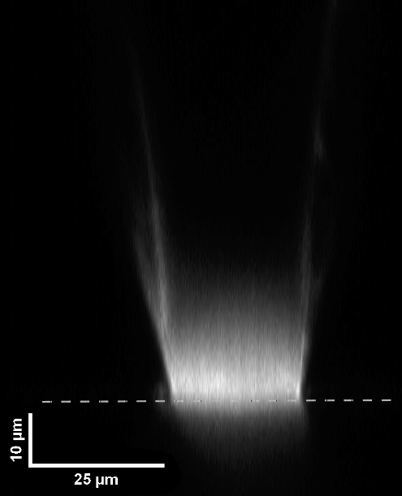
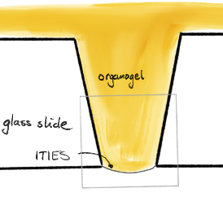
Here, we exemplify this by examining the transfer of the ionised fluorophore fluorescein. We use confocal fluorescence microscopy to assess ion distribution in the organic phase after transfer. Our results show that the fluorophore concentration near the ITIES, after applying a constant potential, is significantly higher than in the aqueous phase, even after brief transfer periods. [1] This indicates that a high-viscosity organic phase is highly promising for analysis and supports the combination of ITIES electrochemistry with various ex situ measurement methods.
a)
b)

Fig 1 a) Cross-section of a z-stacked laser-scanning fluorescence microscopy image of the organogel in a single pore of the glass membrane. The image shows fluorescence from FL²⁻ after 60s chronoamperometry. The surface of the membrane is marked by a dashed line. The inset shows a cartoon of the imaged part. b) Concentration profile of the ions in a single pore of the membrane filled with organogel after 60 s of applied potential.

[1] J. Maciejewska-Komorowska, D.W.M. Arrigan, M. Jönsson-Niedziółka, ChemRxiv (2026). https://doi.org/10.26434/chemrxiv.15003001/v1.

This work was supported by the National Science Centre, Poland, under grant number 2021/41/B/ST4/01324.

