Electrochemical CO₂ capture using conductive metal-organic frameworks: constant-potential simulations, in situ verification, and materials databases

Vladislav Ivanistsev,ª Anna Stepanova, ª Iuliia Vetik,^{b} Bruno Inácio da Silva Roux Leite,^{b}
Magarita Burunova,^{c} Nadezda Kongi^{b}
ª Department of Chemistry, University of Latvia, Riga LV-1004, Latvia
^{b} Institute of Chemistry, University of Tartu, Tartu 50411, Estonia
^{c} Tallinn University of Technology, School of Engineering, Virumaa College
vladislav.ivanistsev@lu.lv

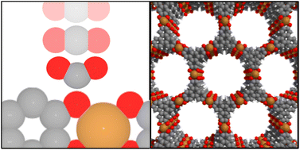
Electrochemical CO₂ capture is an emerging route carbon capture and utilization, yet its practical development requires materials that operate under specific electrochemical conditions and methods that can describe the interface under applied potential. Conductive metal-organic frameworks (MOFs) are promising candidates for this purpose because they combine porosity, modular chemical structure, and electronic conductivity within one electrochemical architecture.
We study CO₂ electrosorption in conductive MOFs as part of the broader problem of electrochemical interfaces, materials, and architectures. We modify a constant potential method for simulations of porous electrode materials and apply them to MOFs with variable metal centers: Cu, Ni, and Co. The calculations indicate that CO₂ electrosorption is strongly metal-dependent, with Cu-based MOFs showing adsorption while analogous Ni- and Co-based systems do not show comparable behavior. To quantify these computational predictions, we combine the simulations with electrochemical experiments and preliminary in situ electrochemical mass spectrometry measurements.¹ This approach allows us to connect calculated adsorption trends with experimentally observed CO₂ uptake and to test whether constant-potential models can describe electrosorption in porous conductive frameworks.
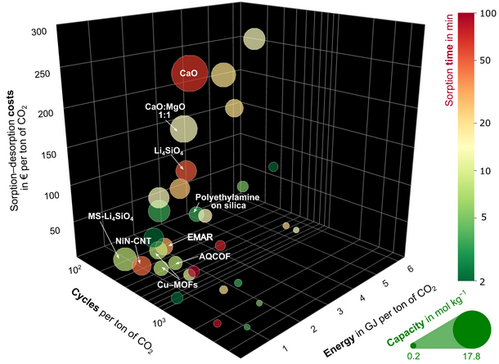
Beyond the individual materials, we also present a database of conductive MOFs for CO₂ electrosorption studies,² and a broader literature-derived database of CO₂ sorbents.³ These datasets include material properties along with operating conditions, process parameters, and reported performance metrics, allowing data-driven selection of various CO₂ sorbents for proper application contexts. Together, our works interlink molecular simulation, in situ electrochemical characterization, and data-driven materials selection.
Acknowledgements. This work was supported by the Estonian Ministry of Education and Research (TK210), the Estonian Research Council (PRG3174), The State Shared Service Centre Astra+ Grant (2021-2027.1.01.25-1076) and Project No. 1.1.1.8/1/24/I/003 “Strengthening the Research and Development Capacity of Doctoral Studies at the University of Latvia in the Fields of Smart Specialisation”.
References.
1. I. Vetik, N. Zoglo, A. Kosimov, R. Cepitis, V. Krasnenko, J. Leis, M. Käärik, A. Kons, H. Qing, P. Chandra, K.A. Mirica, R. Rizo, E. Herrero, J. Solla-Gullon, T. Trisukhon, J.W. Gittins, A.C. Forse, V. Grozovski, N. Kongi, V.B. Ivanistsev, Demonstrating Electrochemical CO₂ Capture with Redox-Active Metal-Organic Frameworks, J. Mater. Chem. A (2026). doi.org/10.1039/D5TA08870D.
2. V. Ivanistsev, T.-H. Pukk, R.L. Bruno Inácio, B.L. Nguyen, Database of electrically conductive metal-organic frameworks for CO₂ electrosorption, (2026). doi.org/10.5281/zenodo.18219290.
3. M. Burunova, I. Vetik, A. Stepanova, K. Kudelina, N. Kongi, V. Ivanistsev, An Open Data Approach for Comparing CO₂ Capture Materials, ChemRxiv (2026) doi.org/10.26434/chemrxiv-2026-g3zqr/v2.

