ORR electrocatalysis at phosphorus based hypercrosslinked polymers
Saira Fatima, Shumaila Razzaque, Alla Dyachenko, Katarzyna Wielondek, Marcin Opallo
Institute of Physical Chemistry, Polish Academy of Sciences,
Kasprzaka 44/52 01-224, Warszawa, Poland
saira.fatima@ichf.edu.pl
Abstract
The development of efficient and stable catalyst for the oxygen reduction reaction (ORR) is a one of standing challenge in sustainable energy conversion. To date, expensive noble metals show good activity but their high cost, less availability and low durability hindered their large scale applications ¹. Therefore, present work is focused on exploring easily synthesized, cost effective and scalable high surface area porous organic polymers in ORR electrocatalysis.
Herein phosphorus based hypercrosslinked polymer (HCP-PPh₃) was prepared from triphenyl phosphine via single step Friedel-Crafts strategy ². It exhibits high surface area (>700 m²g⁻¹) and hierarchical pores distribution. ORR electrocatalytic activity of HCP-PPh₃ particles, immobilized together with carbon nanoparticles (Vulcan XC-72) in Nafion film on glassy carbon (GC) electrode, was evaluated by cyclic voltammetry in O₂ saturated alkaline electrolyte. The positive onset potential shift (160 mV) along with a significant increase of cathodic current density as compared to bare GC is seen for this nonmetalated polymer. These findings inspired us to incorporate atomically dispersed palladium within phosphorus rich framework (HCP-Pd) from tetrakis(triphenylphosphine) palladium (0) via the same single step Friedel Craft method ³. Such change of structure produced further decrease of overpotential (50 mV) signifying the role of single atom catalyst. This work paves an avenue for designing low-cost, scalable phosphorus based non-metallic ORR electrocatalyst and further increase their catalytic activity by insertion of single metal atom via single step synthesis.

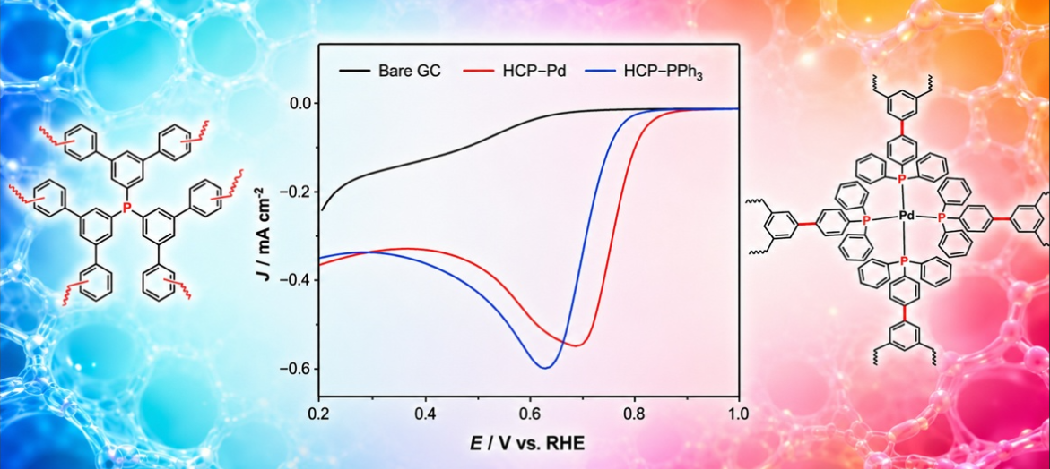

Figure 1: Linear sweep voltammogram obtained with bare GC electrode and modified with nonmetalated and Pd containing HCP particles encapsulated in Nafion together with Vulcan-XC72 in O₂ sat. 0.1 M KOH (aq.) at scan rate of 10 mV s⁻¹.
Acknowledgement The present research is financially supported by the National Science Center (Poland) through Grant Opus 27 Nr DEC-2024/53/B/ST4/01997 (MO).
References
- S. Razzaque, A. Dyachenko, A. Waqar, K. Dusilo, M. Opallo, Electrochem. Commun., 167 (2024) 107800. 10.1016/j.elecom.2024.107800
- K. Gokkus, A. Ozbal, M. Gür, S. A. Akalin, H. Sebli, V. Bütün, React. Funct. Polym., 217 (2025) 106480. 10.1016/j.reactfunctpolym.2025.106480
- X. Wang, S. Min, S. K. Das, W. Fan, K.-W Huang, Z. Lai, J. Catal., 355 (2017) 101-109. https://doi.org/10.1016/j.jcat.2017.08.030

