Boron Dimensionality as a Design Parameter for Carbon Electrocatalysts

Sonnur Kurtuluş^{1,2}, Jerzy P. Łukaszewicz^{1,2}, Piotr Kamedulski^{1,2}
¹ Faculty of Chemistry, Nicolaus Copernicus University in Toruń, Gagarina 7, 87-100 Toruń, Poland
² Institute of Advanced Studies, Wileńska 4, 87-100 Toruń, Poland
Corresponding author: s.kurtulus@umk.pl

Boron incorporation is widely employed to modify the electronic structure of carbon materials; however, the role of boron dimensionality remains poorly understood. In particular, the electrochemical consequences of incorporating two-dimensional borophene-like layers versus amorphous boron within otherwise identical carbon architectures have not been systematically compared. To address this question, liquid-phase-exfoliated borophene-like nanolayers and amorphous boron were incorporated into porous carbon matrices prepared under identical CaCO₃-templated synthesis conditions. Structural characterization by TEM, SEM-EDS, Raman spectroscopy, nitrogen physisorption, and XPS reveals that borophene incorporation preserves and enhances the porous architecture, yielding a specific surface area of 728 m²g⁻¹, whereas amorphous boron progressively collapses the pore network and promotes surface oxidation.

The influence of boron dimensionality on electrocatalytic performance was evaluated through the oxygen reduction reaction (ORR) in alkaline media and the hydrogen evolution reaction (HER) in acidic electrolyte. The borophene-containing composite exhibited the highest ORR activity, with an onset potential of 0.82 V vs. RHE and an electron-transfer number approaching n = 3.03, indicating enhanced reaction kinetics relative to boron-free and amorphous-boron counterparts. In HER measurements, the same material delivered an overpotential of 374 mV at 10 mA cm⁻² together with the lowest charge-transfer resistance, demonstrating more efficient interfacial electron transport. In contrast, increasing amorphous boron content led to higher oxidation levels, increased kinetic barriers, and inferior catalytic performance despite higher boron concentrations[1].

These findings demonstrate that boron dimensionality, rather than boron content alone, governs the electrocatalytic behaviour of boron-carbon composites. Borophene-like layers act as electronic-structure modifiers, simultaneously improving conductivity, preserving hierarchical porosity, and promoting charge transfer, providing a promising design strategy for next-generation carbon-based electrocatalysts.

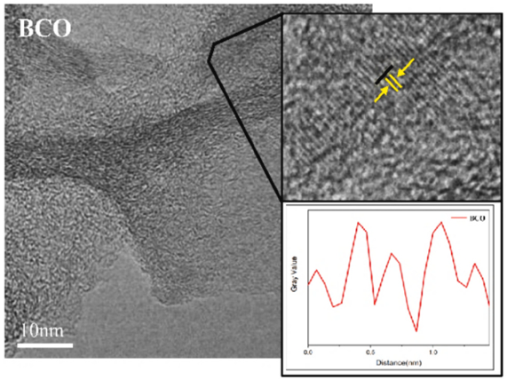
Figure 1. Schematic illustration of the borophene–carbon composite synthesis: (left) liquid-phase exfoliation of boron to obtain borophene-like nanolayers; (right) surfactant-assisted polymerisation and carbonisation yielding borophene-derived lamellar domains embedded in a porous carbon matrix.
Acknowledgements
This work was carried out as a result of the research project LIDER XIII no. LIDER13/0303/2022, financed by the National Centre for Research and Development (Poland).
References
[1] Kurtuluş, S., Lukaszewicz, J. P., & Kamedulski, P. (2026). Borophene layers embedded in a carbon matrix via a modified polymerisation strategy. FlatChem, 100994.

