Spectroscopic investigation of thin ionomer films on Pt interdigitated arrays during oxygen reduction reaction
Savio Moura Lopes^{1, *}, Jean-Blaise Brubach², Raphael Ramos¹, Arnaud Morin¹
¹Univ. Grenoble Alpes, CEA, Liten, 38000 Grenoble, France
²Synchrotron SOLEIL, L’Orme des Merisiers, BP 48-Gif-sur-Yvette CEDEX, F-91192, France
*Email: savio.mouralopes@cea.fr
Proton exchange membrane fuel cells remain limited by performance losses at the cathode, where nano-confined ionomer thin films (10-100 nm thick) govern both proton delivery and oxygen access to active sites. The molecular structure of these films under electrochemical conditions is a critical and unresolved question. We present a comparative in situ vibrational spectroscopy study of Nafion under oxygen reduction reaction (ORR) conditions, using platinum interdigitated array electrodes (Pt IDA) combined with synchrotron infrared and Raman spectroscopy in a humidity-controlled optical cell. This approach enables simultaneous electrochemical control and vibrational fingerprinting of thin ionomer films in a model system representative of the Pt/Ionomer interaction in the catalyst layer. We investigate the hydration mechanism of Nafion, and its possible structural response to electrochemical potential. Differential infrared reflectivity measurements provide spectroscopic access to potential-driven changes at the thin films. Key changes in the vibrational signatures of the ionomer are identified and discussed in terms of their implications for proton transport under ORR-relevant conditions.
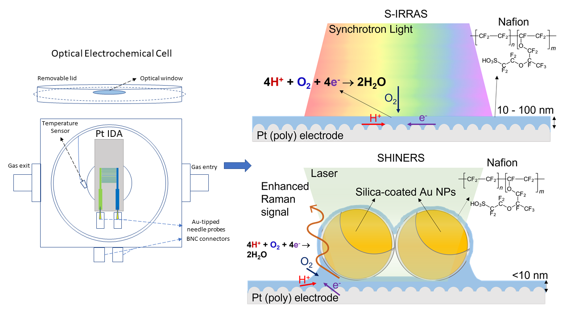
Figure 1: Operando Optical electrochemical cell for studying the Pt/Nafion interface under ORR conditions, combining S-IRRAS (synchrotron light, 10–100 nm Nafion films) and SHINERS (Au@SiO₂ nanoparticles, <10 nm films) on a polycrystalline Pt IDA electrode.

