Operando EC-STM Reveals Active Sites for Nitrate Reduction on Ag-Coated Au Nanocubes

Qingdian Liao,¹ Jian Zhou,^{1,2} Elena L. Gubanova,¹ Aliaksandr S. Bandarenka^{1,2}
¹ Physics of Energy Conversion and Storage, Department of Physics, Technical University of Munich, James-Franck-Str. 1, 85748 Garching bei München, Germany
² Catalysis Research Center TUM, Ernst-Otto-Fischer-Str. 1, 85748 Garching bei München, Germany
qingdian.liao@tum.de

Electrochemical nitrate reduction (NO₃RR) offers a promising route for wastewater treatment, sustainable nitrogen management, and the production of valuable fertilizers and nitrites (common food preservatives).¹ However, the catalytic active sites are still poorly defined, as different local surface structures can alter both the adsorption configuration and reaction pathway of NO₃RR.
Ag-coated Au surfaces are well-established model catalysts for NO₃RR, where strain, ligand, and electronic effects arising from the Ag–Au interface have been proposed to modulate the adsorption and reduction of nitrate.^{2, 3} Here, Au(111) and Au(100) single-crystal electrodes with well-defined Ag coverages were prepared via underpotential deposition,⁴ enabling a systematic investigation of structure–activity relationships in NO₃RR. Electrochemical measurements reveal a volcano-type dependence of activity on Ag coverage, with maximum activity near one monolayer. In addition, Ag_{ML}/Au(100) consistently exhibits higher activity than Ag_{ML}/Au(111).
Operando electrochemical scanning tunneling microscopy (n-EC-STM) is employed to visualize catalytic active sites under electrochemical conditions.⁵ n-EC-STM mapping directly captures reaction-induced fluctuations, revealing that catalytic activity is primarily located on Ag monolayer terraces. In contrast, undercoordinated Ag step sites do not exhibit enhanced activity, while the underlying Au surface remains largely inactive. Density Functional Theory (DFT) calculations further show that Ag monolayers strengthen nitrate adsorption, favor tridentate adsorption geometries, and facilitate the initial NO₃* → NO₂* elementary step. Extending these mechanistic insights to Ag-coated Au nanocube catalysts, which predominantly expose (100)-like facets, reveals a similar thickness-dependent activity trend, with thinner Ag shells exhibiting higher activity. Together, this study bridges mechanistic understanding from model surfaces to practical catalyst systems.
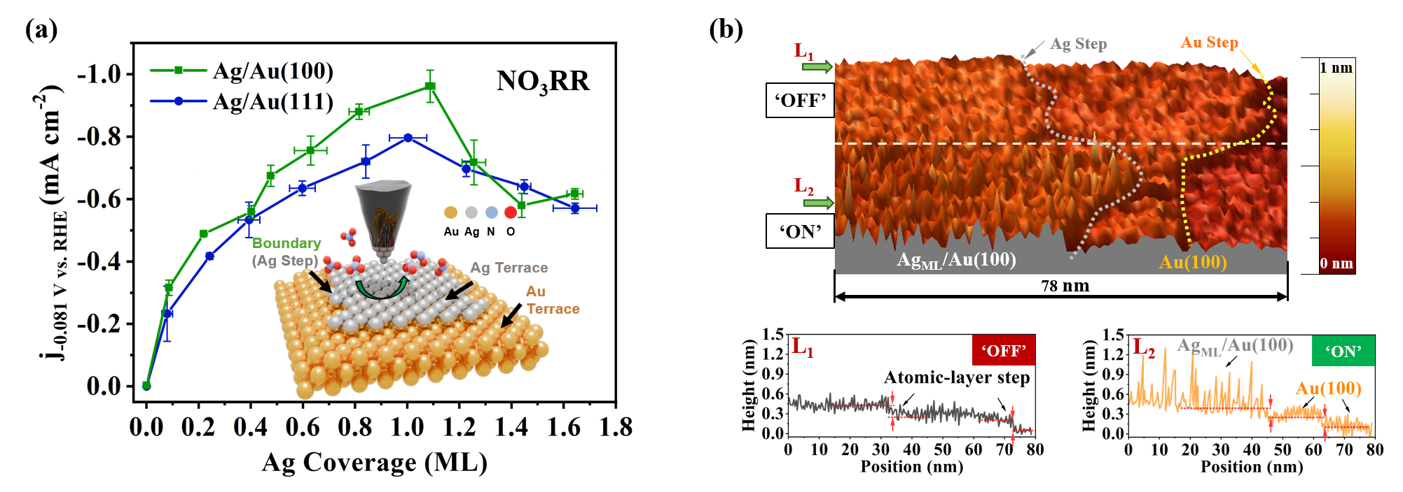
Figure 1. NO₃RR activity and n-EC-STM identification of active sites on Ag-coated Au single-crystal surfaces. (a) Schematic illustration of the n-EC-STM measurement, together with the dependence of NO₃RR activity on Ag coverage for Au(111) and Au(100). (b) n-EC-STM mapping of NO₃RR on Ag_{ML}/Au(100) and the corresponding line profiles, identifying Ag monolayer terraces as the primary active sites.

References
(1) Mo, Z.; et al., Green Chemistry 2025, 27 (45), 14478–14506.
(2) Calle-Vallejo, F.; et al., Phys. Chem. Chem. Phys. 2013, 15 (9), 3196–3202.
(3) da Silva, F. G.; et al., Small 2025, 21, e07525.
(4) Park, I.; et al., J. Electrochem. Soc. 2022, 169 (12).
(5) Pfisterer, J. H. K.; et al., Nature 2017, 549, 74–77.
Acknowledgements Financial support from EU project ICONIC (No. 101115204) is gratefully acknowledged.

