Operando Confocal Fluorescence Imaging of Electrochemically-Induced pH Gradients at Structured Electrified Interfaces
Xin Wuª, Bertrand Goudeauª, Patrick Garrigueª, Neso Sojicª , Guillaume Longatteª, Laurent Bouffier^{a*}
ª ISM, UMR-5255, Univ. Bordeaux, CNRS, Bordeaux INP, F-33400 Talence, France.
Abstract:
Local pH gradients and diffusion-layer thickness near electrochemical interfaces are closely associated with proton-coupled electrochemical reactions and mass-transport processes. However, conventional electrochemical measurements mainly provide global current responses, without spatial information on local interfacial processes ^{[1]}.
In this work, electrochemical control was combined with HPTS(8-Hydroxypyrene-1,3,6-trisulfonic acid trisodium salt)-assisted confocal fluorescence microscopy (CFM) to visualize electrochemically-induced local pH changes under operando conditions ^{[2]}. During benzoquinone reduction in acidic media, proton consumption increases the local pH near the electrode surface and enhances HPTS fluorescence, which can be resolved at defined focal planes by CFM.
The method was validated on Au-coated flat fiber electrodes and then extended to etched microstructured fibers ^{[3]}, where fluorescence responses at selected focal planes were correlated with local electrode geometry. AZ1518 photoresist was further used to define micrometer-scale access to the Au layer with controlled lateral dimensions and exposure depth, thereby confining the reaction to selected regions of the microstructure. Localized fluorescence enhancement near these openings confirmed spatially controlled reaction zones at the micrometer scale.
Overall, this work highlights HPTS-assisted operando CFM as a useful approach for visualizing local pH gradients and probing geometry-dependent mass transport at structured electrochemical interfaces, offering a basis for further analysis of spatially confined electrochemical reactions.
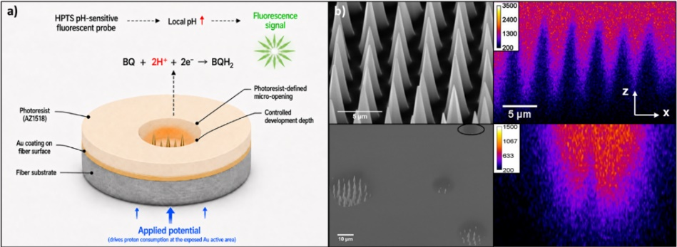
a) Schematic of the HPTS-assisted imaging configuration on a photoresist-confined Au-coated microstructured fiber electrode. b) Representative SEM images and CFM z-stack x–z reconstructions of the corresponding microstructured fiber electrode.
References:
[1] L. Bouffier, T. Doneux, Coupling electrochemistry with in situ fluorescence (confocal) microscopy, Current Opinion in Electrochemistry 2017, 6, 31–37.
[2] R. N. Andrews, C. J. Seliskar, W. R. Heineman, “Electrochemical and optical behavior of 8-Hydroxypyrene-1,3,6-trisulfonic acid at optically transparent electrodes” Electroanalysis 2010, 22, 1557–1565.
[3] T. Bombail, P. Garrigue, B. Goudeau, D. Talaga, L. Bouffier, S. Bonhommeau, L. Servant, D. Zigah, S. Arbault, N. Sojic, “Dual microelectrodes decorated with nanotip arrays: Fabrication, characterization and spectroelectrochemical sensing,” Electrochimica Acta 2019, 328, 135105.

