Electrochemical functionalization of copper foam for MOF (Metal Organic Framework) deposition
Marta Grotaª, Justyna Łuczak^{b}
ªDepartment of Process Engineering and Chemical technology, Faculty of Chemistry, Gdańsk University of Technology
^{b}Department of Process Engineering and Chemical technology, Faculty of Chemistry, Gdańsk University of Technology

marta.grota@pg.edu.pl
According to the latest data, global GHG (Greenhouse gases) emissions in 2024 reached 53.2 Gt CO₂eq. This marks an increase of 1.3%, or 665 Mt CO₂eq, compared to 2023.¹ The overproduction of carbon dioxide necessitates the development of technologies capable of reducing this amount. Heterogeneous photocatalysis appears to be a promising solution. Photocatalysis mimics natural processes occurring in nature, namely photosynthesis. In a semiconducting material under illumination, an electron–hole pair is generated, which then migrates to the surface of the material. There, reduction or oxidation reactions may occur, e.g., the reduction of carbon dioxide into less harmful species such as formic acid.
One of the promising semiconductor materials appears to be MOF ( Metal Organic Framework). A MOF is a hybrid material consisting of organic linkers and inorganic metal centers. Compared to powder MOFs, SURMOFs (Surface Coordinated Metal Organic Frameworks) offer several advantages. The main advantages include easier processability, greater control over the MOF structure, and higher photocatalytic activity. To obtain a SURMOF, a substrate must be functionalized with appropriate functional groups to ensure the formation of a uniform and stable film.
The functionalization of a substrate can be carried out using various methods, such as solvothermal synthesis, electrochemical treatment, or plasma treatment. In the present work, copper foam was functionalized electrochemically.² A three-electrode system (Hg/HgO as the reference electrode, Pt as the counter electrode, and copper foam as the working electrode) was immersed in an electrolyte solution (3 M NaOH). A constant current of 30 mA was applied for 1000 s. As a result, the color of the copper foam changed from orange to blue. XRD results and SEM images confirmed the presence of –OH groups, which serve as anchoring sites for MOF growth.³
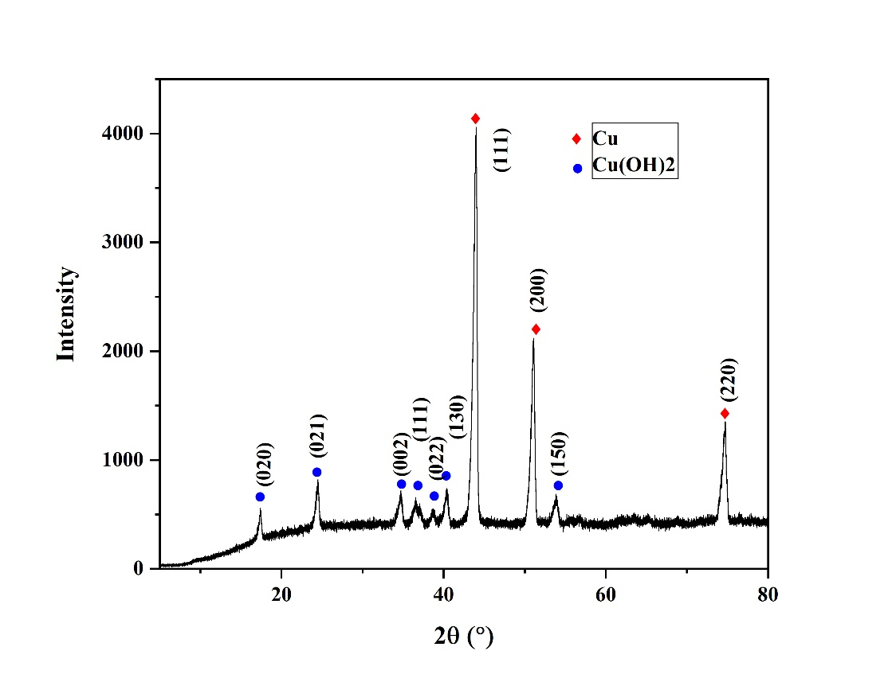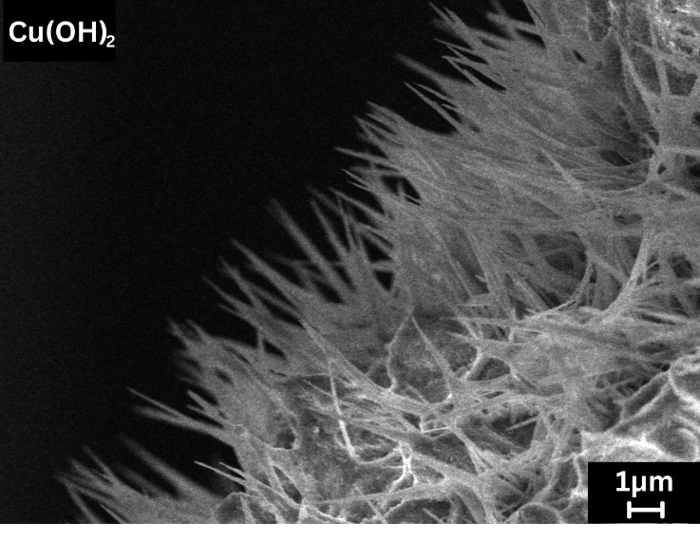
References:
1.Crippa, Monica. et al. GHG Emissions of All World Countries 2025. (Publications Office of the European Union, 2025).
2.Wei, C. et al. Layer-by-layer growth of Cu3(HHTP)2 films on Cu(OH)2 nanowire arrays for high performance ascorbic acid sensing. Biosens Bioelectron 255, (2024)
3.La, D. D., Thi, H. P. N., Kim, Y. S., Rananaware, A. & Bhosale, S. v. Facile fabrication of Cu(II)-porphyrin MOF thin films from tetrakis(4-carboxyphenyl)porphyrin and Cu(OH)2 nanoneedle array. Appl Surf Sci 424, 145–150 (2017)
Acknowledgements:
This work was supported by The National Science Centre (Poland) under project OPUS 30,
UMO-2025/57/B/ST11/00206

