Unraveling the potential of platinum in the detection of GHB derivatives

Weronika Góralª, Angelika Łepek^{b}, Aiswarya Manohar^{b}, Jacek Ryl^{b}, Emilia Witkowska Neryª

ª Institute of Physical Chemistry, Polish Academy of Sciences, Kasprzaka 44/52, 01-224, Warsaw, Poland
^{b} Division of Electrochemistry and Surface Physical Chemistry, Faculty of Applied Physics and Mathematics, Gdańsk University of Technology, Narutowicza 11/12, 80-233, Gdańsk, Poland

weronika.goral@ichf.edu.pl

According to the WHO report from 2025, about 840 million women have experienced sexual assault during their lifetime [1]. Victims of sexual assault are often ashamed to seek for medical or police assistance, and because of that, true scale of this phenomenon is not well known. Due to the variety of substances that can be present in date rape drugs, such as GHB and its derivatives or benzodiazepines, in combination with enormous variability of real samples (alcohol, alcohol free, energy drinks or food) in which such substances can be distributed, identification and prove of used molecules is very challenging. Moreover, half life in victim's body of such molecules is very short. The most promising approach to face mentioned challenges seems to be development of specialized sensor. In this research, the feasibility of GHB derivatives detection (25 mM) in buffer solution at different pH and further, in real samples, such as vodka, beer, energy drinks, coke, juice or milk was investigated, using platinum electrodes. It was revealed that only for measurements conducted with vodka, peak related to the presence of GHB precursor significantly increased after adding additional amounts of vodka, suggesting that the oxidation of alcohol also occurs. For the measurements conducted with beer and energy drink, even the slightest addition of samples resulted in almost no feasibility of the precursor's detection. Furthermore, LIG electrodes modified with platinum and iridium nanoparticles were also tested. Also, the addition of food supplements, such as caffeine or creatine was studied.

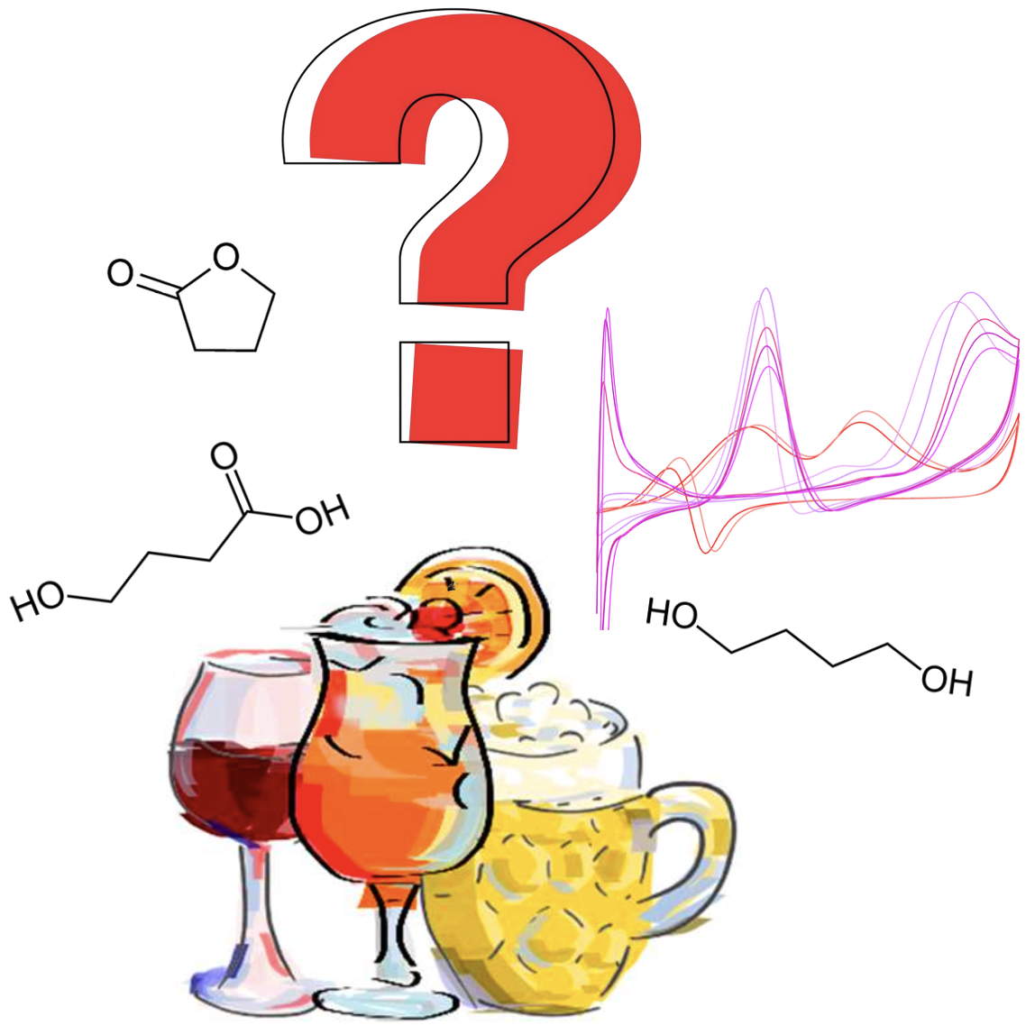
Figure 1. Graphic representation of research on the detection of GHB and its derivatives in real samples.

Acknowledgments
This research was funded by the National Science Centre under SONATA BIS 2023/50/E/ST4/00639 grant.

References
[1] https://www.who.int/news/item/19-11-2025-lifetime-toll--840-million-women-faced-partner-or-sexual-violence

