Supercritical Carbon Dioxide-assisted Electropolymerization of Pyrrole with Different Anionic Surfactants

Vinaisuratern Punvinai, Tomoyuki Kurioka, Gen Hikosaka, Chun-Yi Chen, Tso-Fu Mark Chang
Masato Sone
Institute of Integrated Research, Institute of Science Tokyo,
4259 Nagatsuta-cho, Midori-ku, Yokohama, 226-8501 Japan
email: vinaisuratern@ames.pi.titech.ac.jp

Polypyrrole (PPy) is one of the representatives conducting polymers (CPs) used in widespread applications, such as chemical sensors and energy storages, because of its unique characteristics.¹ Electropolymerization of pyrrole is a straightforward technique to prepare PPy films onto electrodes. Its morphology affects the performance of these applications. The electropolymerization with morphology control is important, while the morphology control often requires troublesome optimization of various parameters. To overcome this problem, the electropolymerization using supercritical carbon dioxide (scCO₂)-emulsified electrolytes is a promising way; called scCO₂-assisted electropolymerization (scCO₂-EP). The scCO₂-EP of pyrrole provides PPy films with various morphologies (e.g., nodular structures, and flower-like structures) by only changing the scCO₂ volume fractions.² In scCO₂-EP, surfactants play important roles not only to form scCO₂-micells, but also to affect the anodic oxidation of monomers. Anionic surfactants are beneficial for facilitating the anodic oxidation of monomers,³ while the effects of their chemical structures on the morphology of CP films prepared by scCO₂-EP are not investigated.
In this study, the scCO₂-EP of pyrrole was electropolymerized using anionic surfactants with different critical micelle concentration (CMC), and hydro-lipophilic balance (HLB). The effects of anionic surfactants on the morphology of the electropolymerized PPy are investigated.
scCO₂-EP of pyrrole was performed employing scCO₂/H₂O (C/W) of 20/80 volume fraction ratio at 15 MPa, and 40 °C. A current density of 1 mA/cm² was applied to a SUS304 plate used as an anode. The passage of charge was 1 C. The scCO₂-emulsified electrolyte contained 0.1 M pyrrole, 0.1 M p-toluene sulfonic acid, and CMC of anionic surfactants: sodium 1-dodecyl sulphate (SD-SO₄, CMC = 8 mM, HLB = 40), sodium 1-dodecanesulfonate (SD-SO₃, CMC = 11 mM, HLB = 30–40), and sodium dodecyl benzene sulphonate (SDB-SO₃, CMC = 1.2 mM, HLB = 10.6). The samples were air dried before characterization.
After the scCO₂-EP, the SUS304 was coated with the black PPy film. Its scanning electron microscope (SEM) images are shown in Fig. 1. As HLB of surfactants decreased, the PPy had smaller particles with higher density. Fig.2 shows the roughness and thickness of the PPy films evaluated by a laser microscope. Interestingly, their roughness and thickness decreased with the decrease in the HLB used in the scCO₂-EP of pyrrole. It was speculated that due to lower HLB, SDB-SO₃ produced more stable micelles with narrower distribution of micelle size, which facilitated the nucleation of the PPy. Therefore, the smoother and denser PPy film was prepared.
In conclusion, the effects of anionic surfactants on the morphology of the electropolymerized PPy by scCO₂-EP were discussed. It is confirmed that the anionic surfactants vary the morphology of the PPy, depending on HLB derived from their chemical structures.

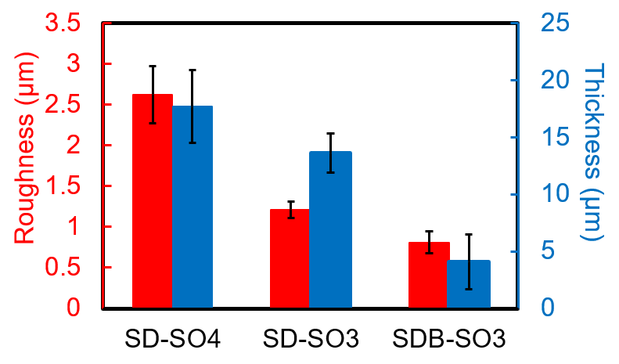
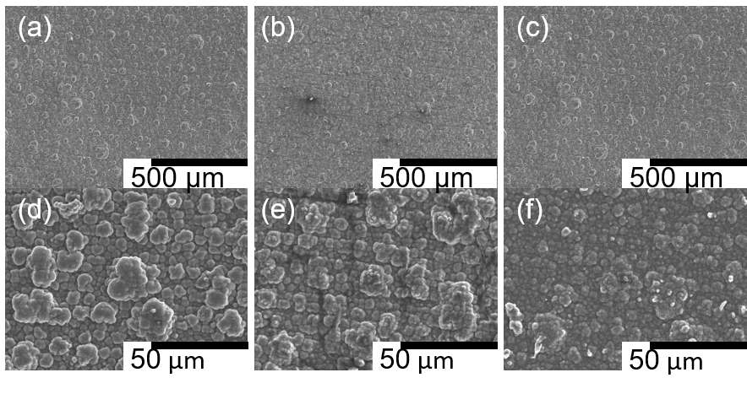
References: [1] J. Heinze et al., Chem. Rev. 110 (2010) 4724–4771; [2] P. Vinaisuratern et al., J. Electrochem. Soc. 171 (2024) 092504; [3] M. Fall et al., Synth. Met. 118 (2001) 149–155.
Fig. 2: Roughness (red) and thickness (blue) of PPy using different surfactants.
Fig. 1. SEM images of PPy prepared with different surfactants; (a, d) SD-SO₄, (b, e) SD-SO₃, and
(c, f) SDB-SO₃.

