From Anodization to Application: Hexagonal TiO₂ Nanotubes with Enhanced Electrochemical and Mechanical Properties
Katarzyna Arkusz, Aleksandra Jędrzejewska, Ewa Paradowska
Department of Biomedical Engineering, Faculty of Engineering and Technical Sciences, University of Zielona Góra
Licealna 9 Street, 65-417 Zielona Góra, Poland
k.arkusz@iimb.uz.zgora.pl

Engineering electrochemical interfaces with controlled nanoarchitecture is a promising strategy for improving the performance of titanium-based implants. While conventional TiO₂ nanotubes (TNTs) exhibit favorable bioelectrochemical properties, their limited mechanical stability often leads to coating degradation during implantation. In this work, we investigate a novel class of hexagonal TiO₂ nanotubes (hTNTs) possessing both hexagonal inner and outer geometry, which distinguishes them from the commonly reported cylindrical nanotube architectures. The influence of thermal treatment and implantation-induced mechanical stress on the electrochemical performance and structural integrity of hTNT layers was evaluated.

Hexagonal TiO₂ nanotubes were fabricated by sonoelectrochemical anodization and annealed at 550°C in argon atmosphere. Structural, electrochemical, physicochemical, and mechanical properties were characterized before and after ex vivo implantation into porcine mandibular bone. Annealing induced transformation of amorphous TiO₂ into a mixed anatase-rutile phase while preserving the ordered hexagonal nanotubular architecture. The resulting interface exhibited a significant increase in open-circuit potential, impedance modulus, phase angle, and critical adhesion force. The hTNT surface remained superhydrophilic. Ex vivo implantation studies demonstrated that the hTNT coating remained largely preserved on the implant surface despite localized deformation in regions exposed to the highest insertion stresses. Electrochemical impedance spectroscopy revealed only moderate degradation of the electrochemical interface after implantation.

These findings demonstrate that hexagonal TiO₂ nanotubes constitute a promising electrochemical interface architecture combining enhanced corrosion resistance, bioactivity, and mechanical durability. The work provides one of the first electrochemical assessments of implantation-induced degradation in hTNT-based implant coatings and highlights the role of nanotube geometry in designing mechanically resilient electrochemical interfaces for biomedical applications.

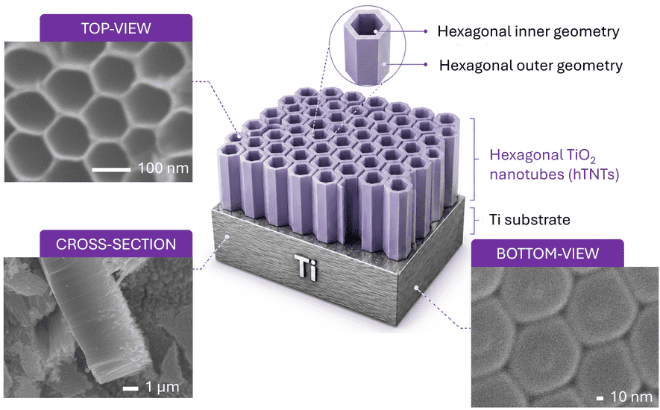
Figure 1. Schematic illustration of hexagonal TiO₂ nanotubes (hTNTs) on a titanium substrate together with representative SEM images showing the top-view, cross-sectional, and bottom-view morphology.

