Achieving sub-ms time resolution for operando spectroelectrochemistry

Luca D’Amario^{1,2}, Holger Dau³, Michael Chea², Kajsa Sigfriedsson-Claus⁴, Leonardo Rotondi^{1,2}

1-Department of Chemistry-Ångströmlab, Uppsala Unviersity, 75237 Uppsala, Sweden
2-Sectris AB, Båtvägen 6, 75591 Uppsala, Sweden
3-Freie Universitat Berlin, Arnimallee 14, Berlin, Germany
4-MAXIV Laboratory, Fotongatan 2, 224 84 Lund, Sweden

Mail to: luca.damario@kemi.uu.se

Transient electrochemical intermediates often exist on timescales far shorter than the temporal resolution accessible to conventional operando spectroscopic techniques. As a result, many key steps of electrocatalytic reaction mechanisms remain experimentally inaccessible. While substantial progress has been made in the development of in situ and operando methods over the past decade, the typical time resolution of structural spectro-electrochemical techniques remains limited to approximately 0.1 s.
In this talk, I will present a general approach for extending operando spectroscopy into the sub-millisecond regime through synchronized electrochemical reaction activation and spectroscopic probing. First, I will demonstrate how a conventional Raman spectroscopy setup can be adapted to perform time-resolved investigations of electrochemically driven processes. The method enables direct observation of bond formation and bond breaking events with a time resolution of 0.2 ms, representing an improvement of nearly two orders of magnitude over conventional operando Raman measurements.
I will then show how the same concept can be translated to hard X-ray absorption spectroscopy through the development of a transient spectro-electrochemical XAS setup implemented at the Balder beamline at MAX IV. By combining synchronized electrochemical excitation with time-resolved X-ray probing, the technique provides access to transient changes in the electronic and structural state of electrocatalysts on sub-millisecond timescales. The capabilities of the approach will be illustrated through studies of the oxygen evolution catalyst NiOOH.
Together, these developments represent the first step towards a systematic resolving of short-lived reaction intermediates of electrocatalytic processes.
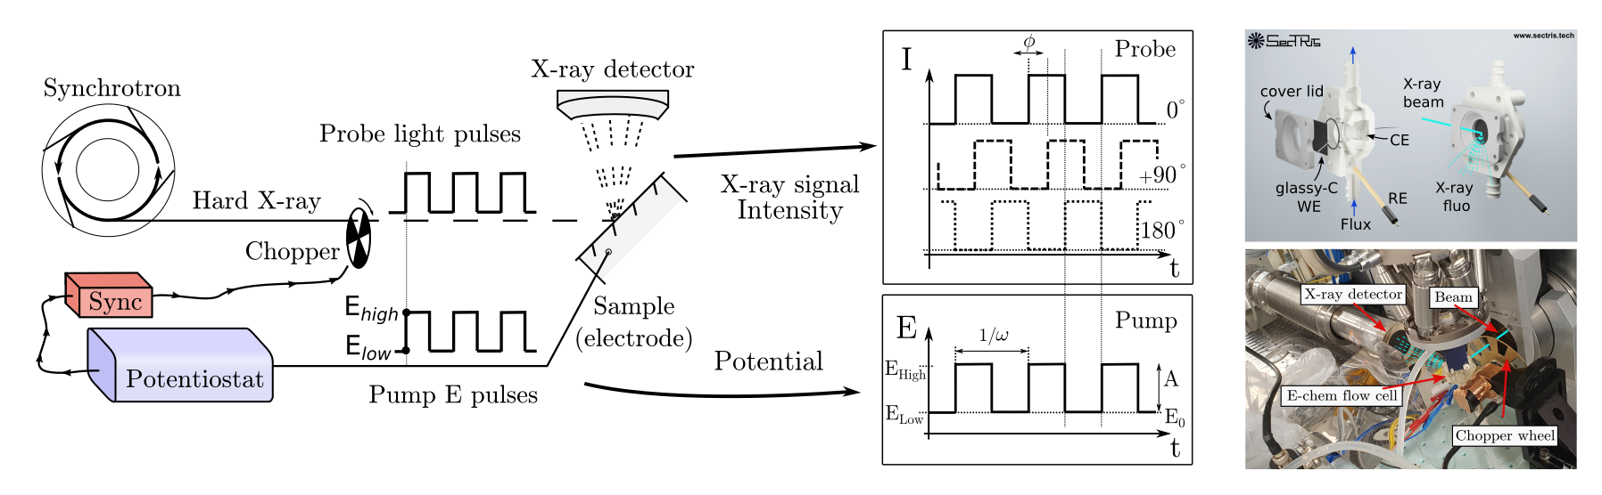

References:
-D'Amario, L., Stella, M. B., Edvinsson, T., Persico, M., Messinger, J., & Dau, H. (2022). Towards time resolved characterization of electrochemical reactions: Electrochemically-Induced Raman Spectroscopy. Chem. Sci., 2022,13, 10734-10742.
-Luca D'Amario, Silvia Nappini, Elena Magnano et al. Soft X-ray Operando Spectroscopy for Gas-Evolving Electrocatalysis at 100 mA/cm2, 01 April 2025, PREPRINT (V1) available at Research Square [https://doi.org/10.21203/rs.3.rs-6290166/v1]

