Decoding Iridium Dissolution in PEMWE Anode Catalyst Layers through Gradient Coating and Operando Analysis

D. Dworschak,ª N. C. Röttcher,^{a, b} G. Pätzold, ^{a, b} S. Thiele, ^{a, b} K. J. J. Mayrhofer ^{a, b}
a) Helmholtz Institute Erlangen Nürnberg for Renewable Energy
Cauerstr. 1, 91058 Erlangen, Germany
b) Department of Chemical and Biological Engineering, Friedrich-Alexander-Universität Erlangen Nürnberg, Cauerstr. 1, 91058 Erlangen, Germany.
d.dworschak@fz-juelich.de

Catalyst dissolution is one of the key challenges limiting the reduction of iridium loading in proton exchange membrane water electrolyzers. Although end-of-test analyses have shown that a large proportion of the dissolved iridium remains within the membrane-electrode assembly, such measurements provide only limited insight into the dynamics of dissolution, transport and potential redeposition during operation. Conversely, simpler aqueous model systems have improved mechanistic understanding but often overestimate dissolution rates compared to device-relevant catalyst layers.¹ This gap highlights the need for in-situ approaches that investigate catalyst degradation under realistic catalyst layer and transport conditions.

To address this challenge, we have developed an electrochemical half-cell platform that mimics the environment of the anode catalyst layer whilst enabling operation at application-relevant current densities above 1 A cm⁻².² Dissolved iridium species, transported either through the porous transport layer or through the membrane, are detected separately and in real time by coupling the setup to an ICP-MS. This approach revealed a strong preference for iridium transport through the membrane, accounting for up to 99.9% of the detected dissolved catalyst, and demonstrated that catalyst stability can decrease by approximately one order of magnitude at high current densities. These results underscore that catalyst degradation cannot be fully understood solely on the basis of measurements in aqueous half-cells, and that transport pathways within the catalyst-coated membrane play a crucial role.^{1,3}

In this contribution, I will present recent findings on the dynamics of iridium dissolution in PEMWE anode catalyst layers and discuss how dissolution depends on operating and fabrication conditions. In particular, catalyst layers produced by gradient coating⁴ are used to access a wide range of catalyst loadings within a single fabrication experiment, thereby enabling the evaluation of activity and stability trends with reduced material requirements. By combining scalable catalyst layer fabrication, in-line coating characterization, electrochemical testing, and operando dissolution analysis, this workflow enables rational optimization of durable, low-loading PEMWE anodes under realistic operating conditions.

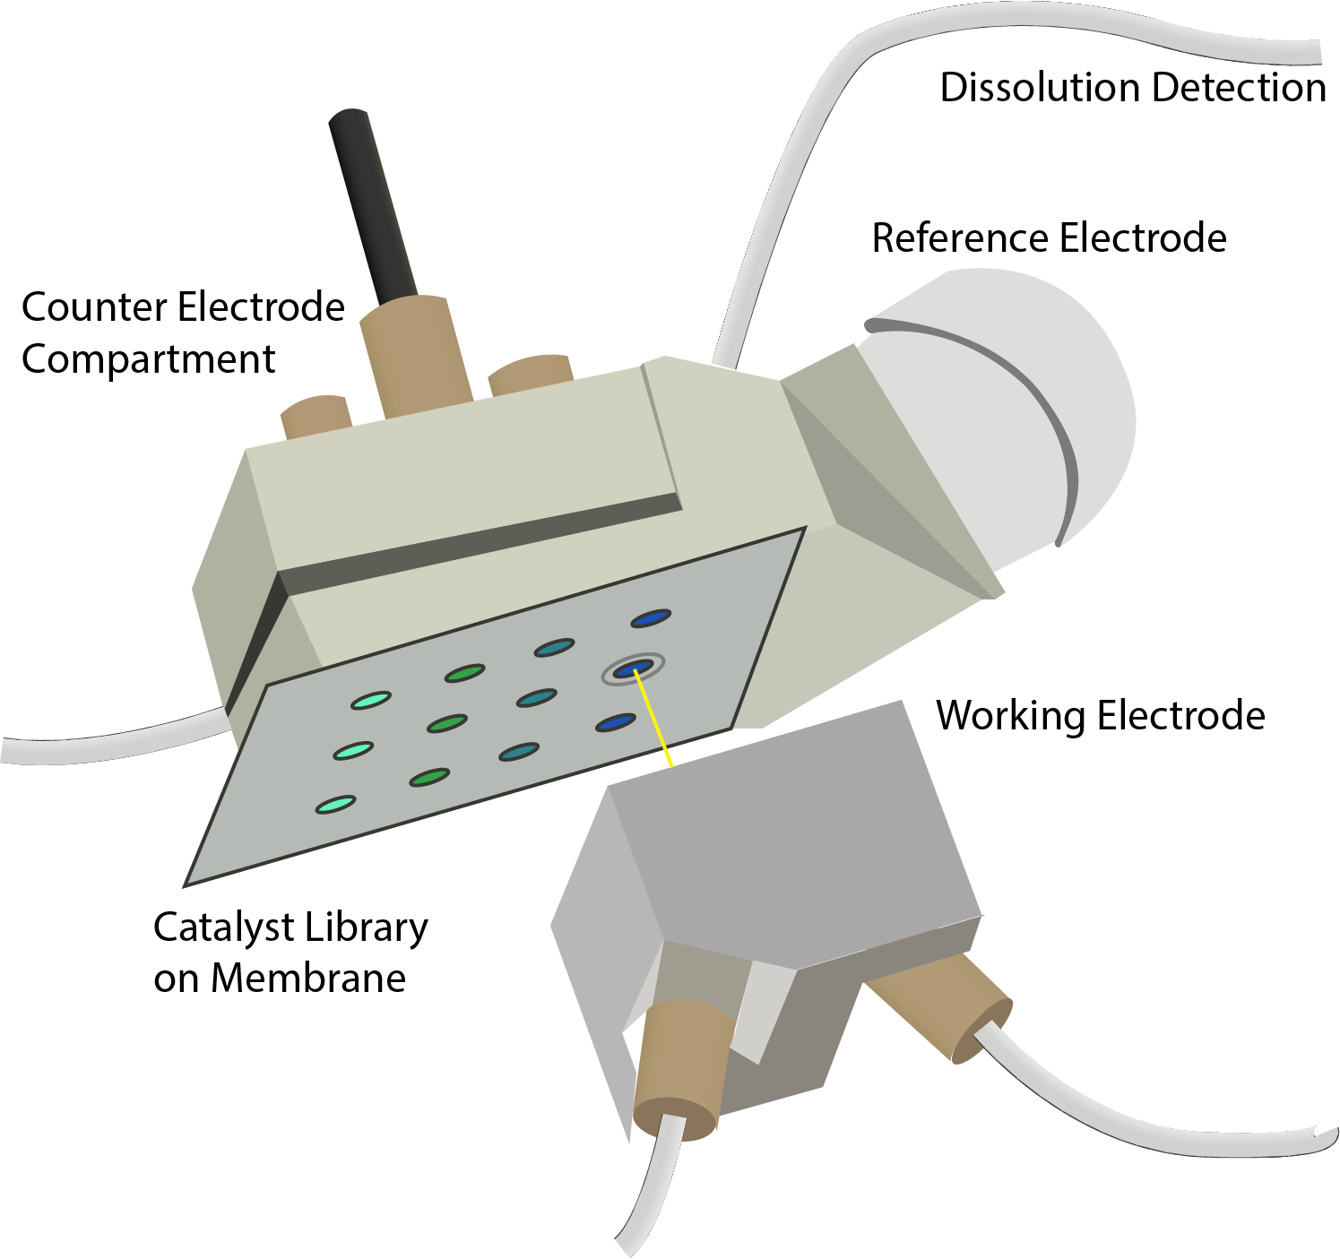
1 Geuß, M. et al. ACS Catal. 14, 11819–11831 (2024)
2 Röttcher, N. C. et al. ChemElectroChem 12, 2500098 (2025)
3 Milosevic, M. et al. ACS Energy Lett. 8, 2682–2688 (2023)
4 Pätzold, G. et al. ACS Appl. Energy Mater. 9, 4641–4650 (2026)

