Watching Molecules Move: Revealing Diffusion and Retention Mechanisms in Eutectogels Using Electrochemistry and Multivariate Statistics

Tomasz Swebocki¹, Grzegorz Kowalski², Angelika Łepek¹, Clémence Le Coeur^{3,4}, Karolina Kwaczyński², Łukasz Półtorak², Jacek Ryl¹
Gdańsk University Of Technology, Faculty of Applied Physics and Mathematics, Institute of Nanotechnology and Materials Engineering
11/12 G. Narutowicza St., 80-233 Gdańsk, Poland
tomasz.swebocki@pg.edu.pl

Eutectogels are emerging as promising soft materials for biomedical applications, including drug delivery and antimicrobial therapies. Despite growing interest in these materials, the mechanisms governing molecular transport and retention within eutectogels remain poorly understood.

To address this challenge, molecular permeation through gelatin-based eutectogels containing glyceline and reline was monitored using time-resolved electrochemical measurements. Transport parameters, including diffusion coefficients, uptake rates, lag times, and diffusion efficiencies, were extracted from cyclic voltammetric data and correlated with structural characteristics obtained from microscopy and scattering techniques.

The results revealed that the choice of DES strongly influences transport behavior. Glyceline-based eutectogels exhibited sponge-like characteristics, promoting analyte retention, whereas reline-containing systems behaved as diffusion barriers that delayed transport while maintaining effective permeation. These findings demonstrate how electrochemical monitoring can provide mechanistic insight into mass transport in eutectogels and contribute to the rational design of next-generation soft materials for biomedical applications. After all, when does a hydrogel behave as a sponge, and when does it become a barrier?

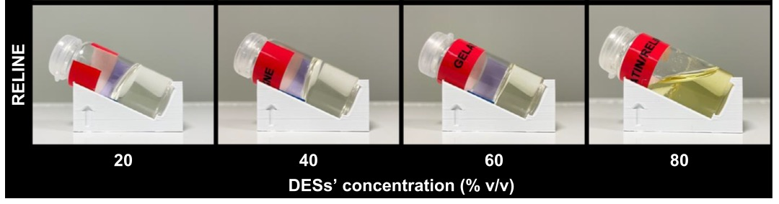
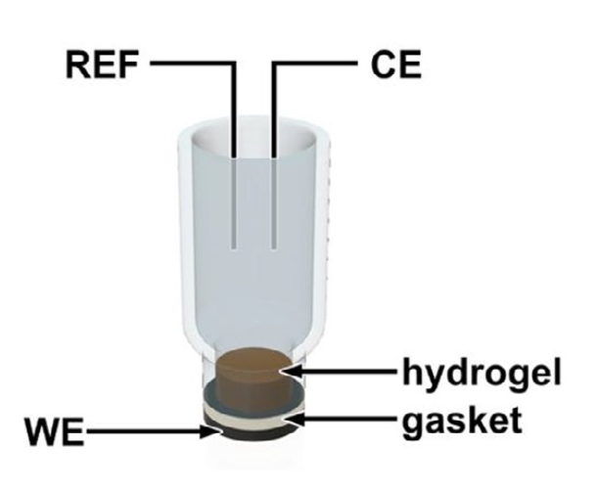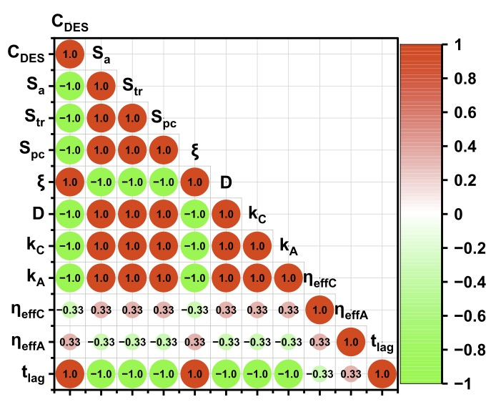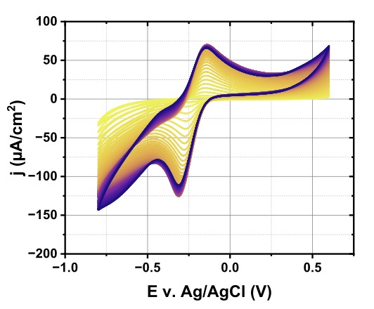
Figure: (top): Set of reline-based eutectogels; (bottom left) A 3D project of the “flow-through” cell used in the studies of permeation; (bottom middle) a correlation matrix used to discriminate different transport patterns; (bottom right) a time-resolved cyclic voltammetry of the redox probe permeation through the gel[1].

References
1. T. Swebocki et al., Advanced Functional Materials (2026) 36(41)

