Simple paper-based systems utilizing interactions at the liquid-liquid interface
Martyna Durka¹, Aldona Jelińska², Justyna Kalisz², Krzysztof Maksymiuk², Agata Michalska², Emilia Witkowska Nery¹
¹ Institute of Physical Chemistry, Polish Academy of Sciences, Kasprzaka 44/52, 01-224 Warsaw, Poland
² University of Warsaw, Faculty of Chemistry, Pasteura 1, 02-093 Warsaw, Poland
ewitkowskanery@ichf.edu.pl

Paper-based microfluidic analytical devices (µPADs) have emerged as versatile, cost-effective, and rapid analytical platforms widely deployed in clinical diagnostics and environmental monitoring of hazardous substances. Although signal transduction in these devices was originally limited to visual inspection, the field has transitioned toward advanced imaging modalities that offer superior precision and eliminate user-dependent bias. Recent literature documents a proliferation of diverse detection techniques tailored for a broad spectrum of target analytes, with novel methodologies continuously emerging. Modern µPADs facilitate qualitative, semi-quantitative, and highly accurate quantitative assessments of various compounds. Over the past few decades, evolution in the fabrication methodologies of paper-based systems has effectively eliminated the requirement for external pumping mechanisms and complex fluid-handling hardware. Fluid transport within the porous matrix is inherently driven by capillary action; consequently, mere sample introduction at the designated inlet initiates automated, on-chip sample pretreatment, homogenization, and directional transport toward the detection zone without requiring user intervention. Historically, signal transduction within paper-based platforms was predominantly restricted to visual methods. However, because a significant number of target analytes cannot be readily or directly quantified via colorimetry, extensive research has shifted toward the development of analytical platforms utilizing electrochemical detection methods.

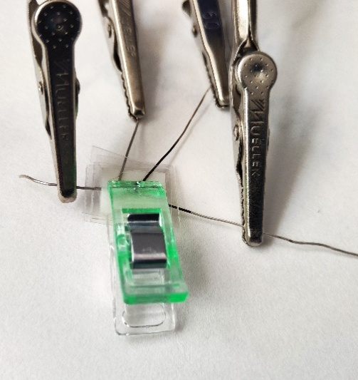
The primary advantage of electrochemical detection over its spectroscopic counterparts lies in its inherent immunity to optical interferences caused by ambient light, suspended solid particulates, and insoluble matrices. While the electrochemical determination of ionic species is predominantly executed via potentiometric sensors - owing to their ease of miniaturization and compatibility with high-throughput manufacturing - the resulting signal remains susceptible to interfacial phenomena occurring at the membrane-sample boundary. Conversely, voltammetric ion detection offers distinct advantages by providing critical diagnostic information regarding interfering species and background fluctuations, while simultaneously enabling the multiplexed detection of target ions. Nevertheless, conventional voltammetric systems suffer from limited portability and have yet to be successfully miniaturized while maintaining optimal electrochemical performance.

In this project, we propose a novel solution designed to miniaturize the conventional four-electrode cell typically employed in ITIES electrochemistry. This microfluidic platform yields a simplified, planar, and highly portable device, ideally suited for point-of-care (POC) diagnostics and on-site environmental monitoring.

Fig.1 Photograph of the device

Authors would like to thank National Science Centre Poland (NCN) SONATA BIS 2023/50/E/ST4/00639 project.

