Potential of Acoustic Emissions in combination with AFM measurements to characterize the surface evolution of different electrodes

Valentin Rueß, Daniel Schröder
Technische Universität Braunschweig, Institute of Energy and Process Sytsems Engineering
Langer Kamp 19b, 38106 Braunschweig, Germany
valentin.ruess@tu-braunschweig.de

Understanding the surface evolution of battery electrodes during electrochemical cycling is essential for improving performance, lifetime, and safety of next-generation energy storage systems. In this work, we investigate the potential of complementary characterization methods with the acoustic emission (AE) analysis and atomic force microscopy (AFM) to monitor the mechanical and morphological changes occurring in different electrode materials during operation.

Acoustic emission measurements provide real-time insight into dynamic processes such as particle cracking, interfacial degradation, and stress-induced structural changes like gas evolution.^{[1,2]} Complementary AFM investigations enable nanoscale characterization of surface morphology and roughness evolution,^{[3]} By correlating these techniques, a combined understanding of electrode degradation mechanisms could be achieved.

Different electrode chemistries, including graphite- and silicon-based anodes for Lithium-Ion-Batteries (LIB) as well as cathode materials for Zinc-Oxygen-Batteries (ZOB),^{[4]} are examined under controlled cycling conditions. The study focuses on identifying characteristic AE signatures and linking them to specific surface and volume changes observed by AF. Particular attention is given to the onset of mechanical degradation, gas evolution and its dependence on electrode composition and cycling parameters.

The combined methodology demonstrates strong potential as an operando and post-mortem diagnostic approach for investigating degradation in battery electrodes. The results contribute to a deeper understanding of degradation-mechanism and may support the development of more durable electrode architectures for also next-generation batteries.

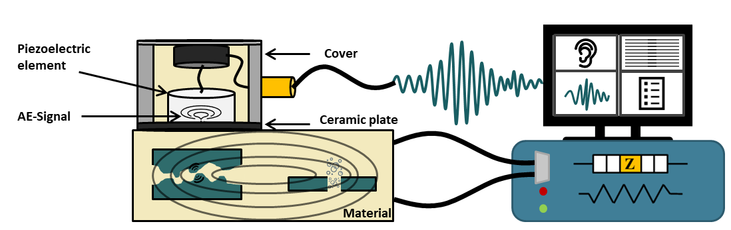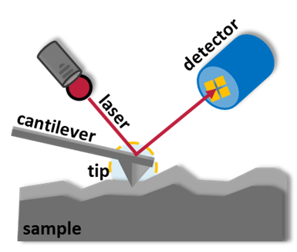

Figure 1: (Left) Schematic representation of the acoustic emission setup used for operando monitoring of electrochemically cycled materials (e.g., LIBs and ZOBs). Acoustic signals are detected by an AE sensor, converted into electrical signals, and analyzed. (Right) Schematic illustration of the working principle of an atomic force microscope.

[1] L. Noll, J. Mrowetz, K. Kretschmer, D. Schröder, J. Power Sources 2025, 629, 235978.
[2] L. Noll, V. Rueß, D. Schröder, J. Power Sources 2026, 668, 239370.
[3] B. Breitung, P. Baumann, H. Sommer, J. Janek, T. Brezesinski, Nanoscale 2016, 8, 14048–14056.
[4] V. Rueß, N. Mohamed, L. Kösters, M. Heere, P. Novák, D. Schröder, Electrochemistry 2026, 94, 25–73161.

